|  |
| --- |
| AIG_PRI_pms2995.jpg |
| Model Development Document |
| Javah Flex Interest Rate Curves |
| **Re-validation of Cross-currency Basis Model** |
| **American International Group** |
| **7/3/2015**  **Revised version** |

09/03/2015

Prepared by

Kaushal Ajitabh

Quantitative Development Group

AIG Corporate Business IT

Model Profile

|  |  |
| --- | --- |
| Model Name | Javah Flex Interest Rate Curves |
| Model ID | 2013011657 (OIS Curves)  2013011658 (ICB Curves)  2013040611 (Cross Currency Basis) |
| Model Class | Pricing and Risk |
| Profit Center | Global Capital Markets |
| BU Executive | Jonathan Liebergall |
| Model Owner | Kaushal Ajitabh |
| Model Developer(s) | Quantitative Development Group |
| Current Model Version | Javah version 6.10 |
| Financial Impact | High |
| Model Status | In Development |
| Target Production Date |  |

**Model Description**

This submission is for the re-validation of *Javah Flex Interest Rate Curves – Cross-Currency Basis* model. Note that *Javah Flex Interest Rate Curves* model is a new interest rate curves framework in Javah which has three component models – OIS Curves (Model ID 2013011657), Intra-currency Basis Curves (MARS ID 2013011658) and Cross-currency Basis Curves (MARS ID 2013040611). All three component models were implemented and validated in 2014. Please see [11] (resp. [12]) for a combined *Model Development* (resp. *Model Implementation*) document for all three models. Please see [13] for the *Independent Validation Report* of the OIS Curves and Intra-currency Basis Curves models, and [14] for that of the Cross-currency Basis Curves model. Currently, these models are in “parallel” production. To be precise, the models are available in the current production version of the Javah platform and can be used by anyone to do valuation or risk calculation; however, the business is not using them for the *official* calculation of value or risk of the portfolio, due to certain system constraints (namely, some downstream applications and end user tools need to be made compliant with the new curves model).

While the go-live requirements for the new Flex curves model are actively being worked upon, the three component models have already come up for re-validation. It turns out that while there are no significant changes in the OIS and Intra-currency Basis components, the Cross-currency Basis model has undergone a fundamental change, hence the decision to submit the Cross-currency Basis model for re-validation. Note that the main purpose of the Cross-currency Basis component model is to build the discounting curve for a foreign (non-USD) currency using certain cross-currency basis swap instruments. The change in Cross-currency Basis model is driven by a fundamental shift in the market place regarding the nature of the cross-currency basis instruments, namely, the market has shifted dramatically over the last year or so to use *resetting* cross-currency basis swaps rather than *non-resetting* ones. Cross-currency Basis model implemented and validated in 2014 used non-resetting basis swaps. A new Cross-currency Basis model has been implemented this year which replaces the non-resetting cross-currency basis swaps by the resetting ones in the instrument set used to build the discounting curve for a foreign (non-USD) currency. It is this new implementation of the Cross-currency Basis model that is the focus of this submission. We provide several tests to check the new implementation.

Internal Review / Validation Signoff

The internal review/ validation should verify the accuracy, integrity and soundness of model development and implementation. Include reviewer’s qualifications to render the review/validation. It is expected that reviewers will need to identify the following model components (add additional tests if appropriate). A summary report to document review/validation process is recommended and should be appended to the Model Development Documentation, if available.

**Model Components Verified**

□ Model development procedures are thoroughly/accurately documented

□ Model assumptions are reasonable/valid and thoroughly documented

□ Model is consistent with intended scope & purposes

□ Mathematical/Statistical/Financial/Econometric theories are properly applied in the model construction

□ Alternative methodologies were considered and documented

□ Data used in model construction/development/calibration is accurate & reasonable (including upstream model outputs)

□ All mathematical calculations are accurate

□ Model outputs are reasonable and in line with intended business uses

□ Model testing is sufficient and accurate

□ Model / Data access & change controls are appropriate

□ List other components verified or any unresolved issues, if any

**Signature of Peer Reviewer**

Name of Peer Reviewer

Title of Peer Reviewer

Date of Signoff

Table of Contents

[1. Model Use 5](#_Toc370886825)

[2. Model Scope 7](#_Toc370886826)

[3. Business Impact of Model Usage 11](#_Toc370886827)

[4. Model Description 12](#_Toc370886828)

[4.1 Model Theory & Logic 12](#_Toc370886829)

[4.2 Key Risk Drivers 28](#_Toc370886830)

[4.3 Key Assumptions 29](#_Toc370886831)

[5. Data 32](#_Toc370886832)

[5.1 Modeling Data Characteristics & Processing 32](#_Toc370886833)

[5.2 Data Limitations 33](#_Toc370886834)

[5.3 Required Model Inputs & Sources 34](#_Toc370886835)

[6. Model Specification Process 34](#_Toc370886836)

[6.1 Model Calibration & Parameter Estimation 34](#_Toc370886837)

[6.2 Variable Selection 34](#_Toc370886838)

[6.3 Data Transformations 35](#_Toc370886839)

[6.4 Alternative Model Specifications 35](#_Toc370886840)

[6.5 Process overview 36](#_Toc370886841)

[7. Model Outputs 37](#_Toc370886842)

[8. Model Testing Results 38](#_Toc370886843)

[8.1 Sensitivity/Stress/Back-testing 42](#_Toc370886844)

[8.2 Benchmarking 48](#_Toc370886845)

[8.3 Statistical Measures of Model Goodness-of-Fit 52](#_Toc370886846)

[8.4 Performance Testing 52](#_Toc370886847)

[9. Model Limitations 52](#_Toc370886848)

[9.1 Methodological Limitations 52](#_Toc370886849)

[9.2 Process Limitations 53](#_Toc370886850)

[10. Fitness for Purpose Assessment 53](#_Toc370886851)

[11. Appendices 53](#_Toc370886852)

# Model Use

This submission is for the re-validation of *Javah Flex Interest Rate Curves – Cross-Currency Basis* model. Note that *Javah Flex Interest Rate Curves* model is a new interest rate curves framework in Javah which has three component models – OIS Curves (Model ID 2013011657), Intra-currency Basis Curves (MARS ID 2013011658) and Cross-currency Basis Curves (MARS ID 2013040611). All three component models were implemented and validated in 2014. Please see [11] (resp. [12]) for a combined *Model Development* (resp. *Model Implementation*) document for all three models. Please see [13] for the *Independent Validation Report* of the OIS Curves and Intra-currency Basis Curves models, and [14] for that of the Cross-currency Basis Curves model. Currently, these models are in “parallel” production. To be precise, the models are available in the current production version of the Javah platform and can be used by anyone to do valuation or risk calculation; however, the business is not using them for the *official* calculation of value or risk of the portfolio, due to certain constraints (namely, some downstream applications and end user tools need to be made compliant with the new curves model).

While the go-live requirements for the new Flex curves model are actively being worked upon, the three component models have already come up for re-validation. It turns out that while there are no significant changes in the OIS and Intra-currency Basis components, the Cross-currency Basis model has undergone a fundamental change, hence the decision to submit the Cross-currency Basis model for re-validation. Note that the main purpose of the Cross-currency Basis component model is to build the discounting curve for a foreign (non-USD) currency using certain cross-currency basis swap instruments. The change in Cross-currency Basis model is driven by a fundamental shift in the market place regarding the nature of the cross-currency basis instruments, namely, the market has shifted dramatically over the last few years to use *resetting* cross-currency basis swaps rather than *non-resetting* ones. Cross-currency Basis model implemented and validated in 2014 used non-resetting basis swaps. A new Cross-currency Basis model has been implemented this year which replaces the non-resetting cross-currency basis swaps by the resetting ones in the instrument set used to build the discounting curve for a foreign (non-USD) currency. It is this new implementation of the Cross-currency Basis model that is the focus of this submission. Please see section 2.2 for further background on the scope of the cross currency basis adjustment (specifically, that it is in line with the company’s policy to post collaterals).

To make this re-validation document as much self-contained as possible, we present here a substantial part of the material from the original submission in [11], and add or modify the sections to describe the changes in the new Cross-currency Basis model.

To recall, the interest rate curves model in a derivatives system plays a crucial role, not just for pricing and hedging of interest rate products, but for almost all products in the system and across all asset areas. To be clear, here are the specific usages across the whole spectrum of products and asset classes:

* Almost all products involve some cash flows in future and as such the present value calculation of the cash flow involves a discounting curve which is provided by this model.
* If a cash flow is a function of a floating interest rate, the projection of that rate involves a forwarding curve which is produced by this model. In a product that depends on a future fixing of an interest rate index (such as 3 month LIBOR or 6 month EURIBOR), the model will ensure that the right forwarding curves are used for the projection of those rates.
* The evolution of an asset price (such as equity or FX) in a risk-neutral world also involves one or more interest rate curves. For example, the FX parity used in the calculation of the FX forward involves the discounting curves for the domestic and the foreign currencies.
* Since almost every product depends on one or more interest rate curves, it is exposed to the market risk of the interest rate instruments used in those curves. The calculation of the interest rate sensitivities (change in the value of the product with respect to the market instruments) is also part of this model.

An interest rate curves model in the Javah system is called *YC (Yield Curve) Solver*. It is used for the following purposes:

* To generate, or solve for, various interest rate curves (used for discounting and forward rate projections) from a specified set of market instruments.
* To calculate the risk sensitivities of a given position with respect to interest rate instruments.
* To ensure proper discounting and forwarding curves are used when computing the value and hedges of an interest rate product.

The interest rate curves model currently used in Javah for the official reporting of value and risk is labeled as the *Legacy Solver* and is the default model. The *Javah Flex Interest Rate Curves* model (labeled as *Flex Solver*) is a new interest rate curves model in Javah which will replace the *Legacy Solver*. The *Legacy Solver* will still exist ‘behind the scenes’ when the business goes live with the new *Flex Solver* but it will cease to be the default model, rather the *Flex Solver* will become the default choice and all valuations and risk calculations for the official books and records will be based on the *Flex Solver*.

The existing model *Legacy Solver* has several critical shortcomings: most importantly, it does not support discounting with OIS (Overnight Index Swaps) which is now the market standard nor does it support intra-currency basis (e.g., 3 month vs. 6 month LIBOR basis). In addition, it has limited flexibility in terms of the coverage of interest rate instruments. With the implementation of *the Flex Interest Rate Curves*, we achieve the following:

1. Support for OIS discounting; or, more generally, the support for multiple curves in a given currency, e.g., OIS curve for discounting, and index-specific curves for forward rate projections.
2. Support for intra-currency and cross-currency basis.
3. Ability to build interest rate curves with a flexible set of instruments (where flexible means both in terms of the type as well as the tenor of the instruments). Specifically, it would allow one to use the deposits, domestic vanilla swaps, cross-currency basis swaps, intra-currency basis swaps and OIS (overnight index swaps) instruments.

When it goes live, *Javah Flex Interest Rate Curves* model will be called in the calculation of value and risk sensitivities of almost all positions in the Javah system (please see section 2 below for details). As such, it will be used in

* *Financial reporting* (to the extent that the model is used for positions in the Javah system).
* *Pricing* of all positions in the Javah system.
* *Risk management* of all positions in the Javah system.
* *Stress testing including CCAR (currently using spot stresses)*
* Cash flow monitoring using DIB/GCM Liquidity Management Tool[[1]](#footnote-1).

We provide the details below.

* **Financial reporting:**

The values produced by the individual pricing models that call the Javah *Flex Interest Rate Curves* model will be used by DAG (Derivatives Accounting Group) in preparing their 10-Q report. Please note that DAG may apply some adjustments to the values produced by Javah.

* **Pricing:**

The model will be used in the daily valuation of the official portfolio. These values, in turn, will be used in collateral management. The usage of *Javah Flex Interest Rate Curves* model would be via the calls from individual pricers. The model will also be used by Front Office for any intra-day purposes, such as P/L reconciliation of an existing trade, possible booking of a new trade, or a new trade inquiry.

* **Risk Management:**

The model will be used for daily risk management. The risk sensitivities are calculated for all positions during the nightly cycle and stored in a database. These results are then published in certain Risk reports which are reviewed and monitored by Risk Management group for any breach of the risk limit. The usage of *Javah Flex Interest Rate Curves* model in calculating the risk sensitivities will be via the individual pricers that are called to compute the “bumped” values corresponding to the bumped values of the risk parameters.

* **Stress tests:**

The model will be used for stress tests under various scenarios. The usage of *Javah Flex Interest Rate Curves* model in stress tests would be via any call to discounting or forwarding curves, especially via the individual pricers that are called during the stress tests for the calculation of the stressed values. The stress tests for OIS and intra-currency were done in 2014 as part of the original model. The stress tests for cross-currency have been added as part of this validation. Please see section 8.1.4 for details where we have used CCAR-type scenarios. To be clear, in an actual CCAR run, the model would accept scenarios for various basis but the scenario generation team currently does not provide the basis shocks. The CCAR-type scenarios used in the tests in section 8.1.4 were provided by ERM IVG for testing purposes.

* **Cash flow monitoring**

The model will be used for cash flow monitoring using DIB/GCM Liquidity Management Tool[[2]](#footnote-2). The usage of the *Javah Flex Interest Rate Curves* model in this tool would be via the individual pricers that are called to calculate the amount (and sometimes the probability) of the projected cash flow.

# Model Scope

As mentioned in section 1, the *Flex Interest Rate Curves* model plays a central role in the Javah system. It will be used for pricing and hedging of not just the interest rate products, but for almost all products in the system covering all asset types. This model will be called by almost any valuation or risk calculation in the system, the exceptions being very limited such as: valuation of a product in the boundary case when it has no remaining cash flow or has cash flow which does not require discounting (e.g., in valuation by so-called accrual pricers in Javah), or the calculation of accrued interest.

This model supports OIS discounting, cross-currency and intra-currency basis. Below we describe the scope of the model in regards to these three aspects.

2.1 Scope of OIS Discounting

It is now the standard market practice to use OIS discounting for the collateralized derivatives. For non-collateralized derivatives, the practice is less clear but the trend is to use some form of credit-adjusted curve (such as LIBOR plus a possible spread). Please note that while it is ultimately up to the business units to decide for which currencies and/or which trades they want to use OIS, the *Javah Flex Interest Rate Curves* model will allow one to use OIS discounting or LIBOR discounting via a switch. [Please see section 4.1.2.7 for exact meaning of the difference between OIS discounting and LIBOR discounting.] In fact, Javah provides a switch called “*OIS Discounting*” at the application level. If the switch *OIS Discounting* is set to YES (resp. NO), then the position(s) running in that instance of the application will be valued with OIS discounting (resp. LIBOR discounting). As to how various positions will use *OIS Discounting* flag is determined as follows. It should be noted that the procedure described below has emerged out of the agreement among various stakeholders, but it is subject to modification based on the evolving market practice for collateralized and non-collateralized products.

A number of discussions with Front Office in GCM, Finance, Enterprise Risk Management, Analytics and Technology have occurred regarding the usage of the *OIS Discounting* flag. Based on these discussions, the proposal is to use OIS discounting for derivatives only, not for cash assets or liabilities; and further, only for the population of derivatives which are either internal trades with AIG affiliates or are “subject to collateral” (see below for precise definition of this term). To be clear, OIS discounting would be applied to the derivatives only (which are generally used as hedges against assets or insurance liabilities), whereas the original assets or insurance liability positions are not subject to the collateral, hence not subject to OIS discounting. The precise implementation is as follows.

**Definition:** For the purposes of this submission**,** we define that a **position is “subject to collateral”** if and only it meets the following criteria:

1. Position is a Derivative (this is determined by the trade level field called “*Javah Position Type*” set to “*Derivative*”.)
2. Position is not a hedge security. [A hedge security is a listed option or future or a treasury cash security. They all have CUSIP’s and are valued by DAG based on an exchange or vendor price.]
3. Position satisfies the following condition:
   * It is a trade with an AIG affiliate, OR
   * It has a zero threshold CSA, OR
   * It has a CSA (possibly with some thresholds or triggers) and the collateral is being posted.

A position-level Boolean field which is currently also called “*OIS Discounting”* is set according to whether the position is “subject to collateral”. To be clear, the position-level *OIS Discounting* flag is set to YES if and only if the position is “subject to collateral” according to the definition given above. Also note that the setting of this position-level flag occurs via an automated job in the end-of-day valuation process after the job for CSA updates is done.

The valuation of derivatives portfolio will be done in two steps:

Step 1 (“Main Run” for all positions):

Irrespective of whether a position is “subject to collateral”, i.e. irrespective of the position-level *OIS Discounting* flag, all derivatives will be valued using application-level flag *OIS Discounting* set to YES. This will produce a “risk-free” collateralized valuation for all derivatives. For a given position *P*, let’s denote this by . This will be reported as the DPV of the position.

Step 2 (“Adjustment Run”):

All derivatives which are not “subject to collateral”, i.e. whose position-level flag *OIS Discounting* is set to NO, an adjustment process will be run to calculate their value with the LIBOR discounting. This is done by running the subset of these positions with the application-level *OIS Discounting* flag set to NO. For a given derivative position *P* which is not “subject to collateral”, let’s denote this by . For all derivatives not subject to collateral, the adjustment will be calculated and reported as an adjustment to the DPV. For all derivatives which are subject to collateral, this adjustment will be set to zero. The adjustment run will be part of the end-of-day valuation process.

For all derivatives, DAG will report the valuation as the sum of DPV, i.e. and the adjustment if any. Effectively, then, this amounts to DAG reporting the OIS-discounted value for derivatives which are subject to collateral and LIBOR-discounted value for derivatives which are not subject to collateral.

Please note that the main motivation for this approach is that in the going forward business, all derivatives will be fully collateralized (with zero threshold), thus having zero adjustment in Step 2 above, at which point Step 2 would be redundant. However, there remains a small number of positions from legacy portfolios that have either no CSA or a CSA with threshold or triggers. According to the above logic, among these positions, the ones with no CSA would be valued without OIS discounting and the ones which have a CSA with threshold or trigger would be valued with OIS discounting if and only if the collateral is being posted. Please see the following spreadsheet provided by the Front Office for details of these positions:

[\\usapps\prod\release\mv\Flex IR Curve Tests\Third party positions with No OIS Discounting.xlsx](file:///\\usapps\prod\release\mv\Flex%20IR%20Curve%20Tests\Third%20party%20positions%20with%20No%20OIS%20Discounting.xlsx)

2.2 Scope of cross-currency basis

The model also provides the support for the cross-currency basis. The cross-currency basis affects the discounting curve for the non-USD currency (please see section 4.1.2.5 for details). Currently, the cross-currency basis is marked in the system by the Front Office for 11 major currencies (namely, USD, CAD, EUR, GBP, JPY, CHF, AUD, NZD, DKK, SEK, and NOK). Out of these 11 currencies, OIS is currently being supported for USD, GBP, EUR and JPY. Please note that if there is a need to use the cross-currency basis model or OIS for a currency other than the ones mentioned above, adding that support would generally speaking *not* require a model change (unless the cross-currency or OIS instruments for that currency are significantly different from the ones used in the model) and only require that the additional data for the cross-currency basis or OIS for that currency be added in the system. Appendix 11 provides the market quotes for resetting cross-currency basis swaps for some of the currencies, taken from Bloomberg as of September 01, 2015.

The *Javah Flex Interest Rate Curves* model provides a choice to use or ignore the cross-currency basis, via a switch called “Use CCB” which is at the application level. When the switch is ON, the modelwill take the cross-currency basis into account in constructing the discounting curve for the non-USD currency.

Similar to the scope of OIS discounting described above in 2.1, whether to use cross-currency basis for the valuation is ultimately a business decision. The Front Office in AIG Global Capital Markets, after checking with several banks, has determined that the use of cross-currency basis is a function of the CSA. Specifically, if a business unit such as GCM trades a vanilla Fixed/Float swap in EUR, and this trade is covered by a USD CSA, it should use the cross-currency basis swap to derive EUR discounting curve, even if the trade is a pure EUR domestic swap.

It seems then that, similar to OIS Discounting, a flag for the usage of the cross-currency basis is also needed at the position (trade) level. The rationale for the position level cross-currency basis flag is simply that the position should be valued using cross-currency basis if it is covered by a USD CSA. Please note that this trade level cross-currency basis flag is not implemented right now. There have been, however, a series of discussions on this involving Risk, Finance, Front Office and IVG. In the short term, the intent is to use cross-currency basis for all positions (in fact this is also done in current production model with *Legacy Solver*), but implement the trade-level cross-currency basis flag in the second phase depending on the business need for this. The only major exception where the trades should *not* use cross-currency basis is the case of non-USD cleared trades at an exchange and, according to the traders, that exposure at this point is minimal (less than $50K impact on value in using cross-currency vs. not using it, as of August 31, 2015). The table below summarizes the impact and the following spreadsheet provides the details including the results a query run to get such trades.

|  |  |  |  |  |
| --- | --- | --- | --- | --- |
|  | **Impact of using cross-currency basis for cleared trades**  **Using Flex Curve Model (in USD)** | |  |  |
|  | With cross-currency basis | Without basis | impact |  |
| AUD | (869,946) | (867,544) | 2,402 |  |
| EUR | (839,597) | (1,091,775) | (252,178) |  |
| GBP | (14,066,272) | (13,803,948) | 262,324 |  |
| JPY | 390,051 | 341,605 | (48,446) |  |
|  | (15,385,764) | (15,421,662) | (35,898) |  |

[\\usapps\prod\release\mv\Flex IR Curve Tests\Resetting CCB Model\Cleared\_non\_usd\_trades.xlsm](file:///\\usapps\prod\release\mv\Flex%20IR%20Curve%20Tests\Resetting%20CCB%20Model\Cleared_non_usd_trades.xlsm)

Given that most of GCM’s CSA’s are USD based, having the position-level cross-currency flag is not a business priority for going live with the new curves model.

We should also note that at the current time there is a small number of trades in GCM which reside in the older system called VH that does not support any basis. But the VH system is retiring (targeted completion is by Q1 of next year) and these trades are in the process of being migrated to Javah.

2.3 Scope of intra-currency basis

The model also provides the support for the intra-currency basis, i.e. swaps with two floating legs in the same currency but with different indices such as 3 month vs. 6 month LIBOR. The intra-currency basis causes the forwarding curves to be different for different indices in the same currency. Please note that the *Javah Flex Interest Rate Curves* model provides the choice, via a switch called “Use ICB”, to use intra-currency basis or ignore it. When the switch is ON, the modelwill take the intra-currency basis into account. This is an application level flag and unlike the OIS Discounting or cross-currency basis flags described earlier, the usage of the intra-currency basis flag at the position level is not warranted. The default and the intent is to have the flag ON.

Calibration of the forward curves for non-benchmark indices (e.g. 3m EURIBOR for EUR) relies on intra-currency basis term structures, which do not necessarily have quoted data points for short (under 1 year) and long (over 30 years) tenors. The pricing for those points is modeled under flat forward absolute extrapolation, which may cause theoretical arbitrage between forward curves in those ranges under certain scenarios. However, we ran a query to show that in the current business context, the impact of this is small. To do so, we looked at the ICB01 (sensitivity to various intra-currency basis curves) for all buckets for all intra-currency basis curves. The details are in this spreadsheet:

[G:\release\mv\Flex IR Curve Tests\Resetting CCB Model\Bucketed ICBs.xlsx](file:///G:\release\mv\Flex%20IR%20Curve%20Tests\Resetting%20CCB%20Model\Bucketed%20ICBs.xlsx)

As one can see in the above spreadsheet: First, there is no exposure beyond 30 years, and second, for tenors less than 1 year, the intra-currency basis (ICB) risk is 51,670 which is small compared to the total ICB risk which is (1,658,374). Thus, the issue of not having quoted data points for short (under 1 year) and long (over 30 years) ends of the curve is not critical.

# Business Impact of Model Usage

The *Javah Flex Interest Rate Curves* model will be used in the calculation of value and risk sensitivities of all positions in the Javah system which includes about 200 billion notional worth of derivatives as well as certain assets and liabilities. A breakdown in terms of the products can be found in a regression spreadsheet in Appendix 8. The business purposes of the usage are provided in sections 1 and 2 above.

The fact that this model will be called by almost any calculation in the Javah system makes it a high impact model. It will impact the present value of all future cash-flows in the system as well as the projections of all future flows that depend on an interest rate. It will also impact the risk sensitivities of all positions in the system.

AIG Global Market Markets (GCM) is the primary business user of the Javah system and will therefore be the unit most impacted by the usage of this new interest rate curves model. To the extent that trades for other business units are currently booked in the Javah system (mostly as a pass through via GCM), they will also be affected in terms of the values and risk sensitivities. As to whether, and to what extent, other business or corporate units will eventually use the new curves model remains to be decided, depending on the business context. For example, AIG Investments does not use cross-currency basis for assets, as most securities are traded in price.

Appendix 12 provides the risk exposure from GCM perspective in terms various 01’s by currency, as being monitored by the Risk team in their Daily Risk report based on the Flex Curves model. Specific to the submission of cross-currency basis model, the following figure provides the risk exposure in terms of cross-currency basis 01 by currency:

**Cross-currency basis 01 by currency (in USD)**

**(Under Flex Curves model, as of 09/01/2015)**

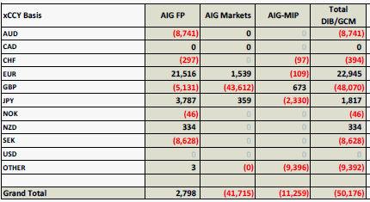

Please note that the above table as well as the ones in Appendix 12 represent the risks from GCM perspective, which includes both the internal trades with AIG affiliates as well as external trades with third parties (many of which being back-to-back trades will contribute zero to risk for GCM). If we were to exclude the internal trades within AIG, the risk profile would increase substantially. As a comparison, here is the table which shows the risk profile for trades including internal trades vs. those excluding internal trades:

**Interest Rate Risks for GCM trades excluding vs. including internal trades (in USD)**

|  |  |  |
| --- | --- | --- |
| **Total** | **Excluding Internal** | **Including Internal** |
| IR01 | (14,960,517) | (275,454) |
| CCB01 | (207,599) | (10,388) |
| ICB01 | (2,093,576) | (1,708,829) |
| OIS Spread01 | 1,738,229 | (828,532) |

For detailed statistics, please see this spreadsheet for the risk profile for trades *excluding* internal trades

[\\usapps\prod\release\mv\Flex IR Curve Tests\IR Risk Profile for GCM trades excluding internal trades.xlsm](file:///\\usapps\prod\release\mv\Flex%20IR%20Curve%20Tests\IR%20Risk%20Profile%20for%20GCM%20trades%20excluding%20internal%20trades.xlsm)

and please see the following for the trades *including* the internal trades:

[\\usapps\prod\release\mv\Flex IR Curve Tests\Flex vs Old Summary 20150903.pdf](file:///\\usapps\prod\release\mv\Flex%20IR%20Curve%20Tests\Flex%20vs%20Old%20Summary%2020150903.pdf)

Before going live with this model for official purposes, regression tests will be done (many of these tests are already being run) to calculate the impact of the model change on the P/L and risk sensitivities. These changes will be communicated to the senior management, Front Office, Risk Management and other stakeholders for a sign off. To be clear, the regression tests to capture the impact on P/L and risk have been running for quite some time and results are available under [\\uscommon\data\trading\Regression\](file:///\\uscommon\data\trading\Regression\). A sample result spreadsheet is also available in Appendix 8. Further, the Market Risk group has been running “Daily Risk” comparison for past few days and a recent one is available here:

[\\usapps\prod\release\mv\Flex IR Curve Tests\Resetting CCB Model\Flex vs Old Summary 20150901.pdf](file:///\\usapps\prod\release\mv\Flex%20IR%20Curve%20Tests\Resetting%20CCB%20Model\Flex%20vs%20Old%20Summary%2020150901.pdf)

The *Javah Flex Interest Rate Curves* model will make the system compliant with certain regulatory and audit issues. For example, this will make the system compliant with the already established market practice of using OIS discounting for collateralized trades, a practice that emerged after the financial crisis of 2008 and one that most major financial institutions have adapted to in the last few years.

# Model Description

## Model Theory & Logic

The model theory presented below is based on the specification documents [1] and [2] where the methodology was presented in detail. Please also see the references [3]-[10] for additional background and market practice.

## 4.1.1 Instruments

First, we describe the interest rate instruments to be used by this model. They include vanilla domestic deposit and swap instruments, OIS instruments, intra-currency basis swaps and cross-currency basis swaps (resetting and non-resetting).

**Note**:

* We will use m for month and y for year. For example, 3m stands for 3 month and 2y for 2 year.
* We will use the term LIBOR generically to denote the benchmark for the inter-bank term rates for any currency (e.g., in EUR, the term would stand for EURIBOR).

**4.1.1.1 Vanilla instruments**

These include the deposit instruments and vanilla (fixed vs. float) swap instruments. A deposit instrument is a one-period instrument in which one earns the specified rate for the given tenor. A vanilla swap is a fixed vs. float swap whose floating leg has the benchmark index (we will also refer to that index as a standard or default floating index). Table 1 below shows the benchmark floating index and its tenor for major currencies.

**Table 1: Default (benchmark) floating rate index for major currencies**

|  |  |
| --- | --- |
| **CCY** | **Benchmark Floating Index and Tenor** |
| USD | LIBOR 3m |
| GBP | LIBOR 6m |
| EUR | EURIBOR 6m |
| DKK | CIBOR 6m |
| CHF | LIBOR 6m |
| NOK | NIBOR 6m |
| JPY | LIBOR 6m |
| SEK | STIBOR 3m |
| AUD | BBR 3m to 3yr maturity; 6mo thereafter |

**4.1.1.2 OIS Instruments**

An OIS (overnight indexed swap) is a derivative contract on the total return of a reference rate that is compounded daily over a set time period. In the U.S. dollar market, the reference rate is the effective FED FUNDS rate. It is calculated and released by the Federal Reserve each day in its H.15 Report and is the weighted average of brokered trades between banks for overnight ownership of deposits at the Fed (i.e., bank reserves). Note that the *effective* fed funds rate is not necessarily equal to the *target* rate set by the Federal Open Market Committee (FOMC) and announced at regularly scheduled FOMC meetings. The Fed merely aims to keep the effective rate close to its target via open market operations of buying and selling securities. In the Euro-zone, the OIS reference rate is EONIA (Euro Overnight Index Average), which essentially is the 1-day interbank rate. In the U.K., the reference rate is SONIA (Sterling Overnight Index Average). We will simply call the OIS reference rate for any currency the “OIS index”, irrespective of the currency. Table 2 below shows the OIS index for major currencies.

**Table 2: OIS index for major currencies**

|  |  |
| --- | --- |
| **CCY** | **Benchmark Overnight Index** |
| USD | FED FUNDS |
| GBP | SONIA |
| EUR | EONIA |
| DKK | DIKKOIS |
| HKD | HONIX |
| CAD | CORRA |
| JPY | TONA |
| SEK | SIOR |
| AUD | AONIA |

We describe the OIS instruments in more detail. We are mainly concerned with two types of instruments, namely OIS and OIS-LIBOR basis swaps.

* **OIS Outright Swaps:**

An OIS outright swap (simply called an OIS swap) in a currency C is a fixed vs. floating rate swap where the floating rate index is the reference OIS index for that currency. On the fixed leg side, the rate is a simple rate and normally the interest is paid once at maturity for swaps with tenors less than 1 year and periodically (frequency is governed by the market convention for that currency) for swaps with tenors larger than or equal to 1 year. On the floating leg side, the interest amount for a period is based on the *daily compounding* (or more appropriately, *business-day compounding*) and is given by

… (1a)

where *N* is the notional, *d* is the day count fraction for that period based on the market convention of that OIS index (e.g., 360 or 365), and is the effective compounded rate for the period, defined as

… (1b)

Here *n* is the number of *business* days in the period (including the start date but excluding the end date of the period), is the day count fraction for the number of days between the period from and including the *i*th business day to and excluding the next business day (e.g., for a Friday, with ACT/360 convention and assuming that both Friday and Monday are business days), and is the reference OIS rate for the *i*th business day.

* **OIS-LIBOR basis swaps**:

Note that we use the term LIBOR to denote the benchmark for the inter-bank term rates for any currency (e.g., in EUR, the term would stand for EURIBOR). An OIS- LIBOR basis swap in currency C is a contract between two parties A and B where the party A pays periodic floating interests based on the OIS index over that period plus a spread (please see below for a precise specification) and the party B pays periodic floating interests based on the benchmark rate (e.g. LIBOR) for that currency. The interest amount for a calculation period on the OIS leg could be based either on the *weighted average* of the rates over that period or it could be *compounded*, depending on the currency. For example, in USD market, the Fed Funds leg in a Fed Funds – LIBOR basis swap pays with weighted average convention where as in most other currencies (including EUR, GBP and JPY) the convention is to use compounding. Table 3 lists the market conventions for various currencies (the list is illustrative and not exhaustive).

**Table 3: Market conventions for major currencies**

|  |  |  |  |  |  |
| --- | --- | --- | --- | --- | --- |
| **Currency** | **Vanilla Swap** | **OIS Swap** |  | **OIS-LIBOR Basis Swap** |  |
|  | **Floating Index** | **OIS Index** | **Interest Calc Method** | **OIS Leg** | **LIBOR Leg** |
|  |  |  |  |  |  |
| USD | 3m LIBOR | FED FUNDS | Compounded | Weighted Average, paid annually | 3m LIBOR, paid quarterly |
| EUR | 6m EURIBOR | EONIA | Compounded | Compounded, paid annually | 3m EURIBOR, paid quarterly |
| GBP | 6m LIBOR | SONIA | Compounded | Compounded, paid annually | 3m LIBOR, paid quarterly |
| JPY | 6m LIBOR | TONA | Compounded | Compounded, paid annually | 3m LIBOR, paid quarterly |

To be precise, consider a calculation period for the OIS leg of an OIS-LIBOR basis swap. Suppose the day count fraction for that period is *d*, the notional is *N* and the spread is *S*. The interest amount for that period of the OIS leg will be

* in case of “Compounded”
* in case of “Weighted Average” … (2a)

where is defined in (1a) and

… (2b)

and is the effective weighted average rate for the period, defined as follows (using the same notations as in (1b)):

… (2c)

Note that if, for a given currency, the OIS-LIBOR basis swap market convention is not aligned with the conventions for vanilla (LIBOR) swaps or OIS swaps, then that leads to a complexity in the bootstrapping of the OIS discounting curve which we will elaborate in the analytics and methodology sections below. Examples of such “*misalignment*” are:

1. *LIBOR Leg of OIS-LIBOR basis swap has non-standard tenor*: Examples are GBP, EUR, JPY and many other non-USD currencies where the floating index in the LIBOR leg of OIS-LIBOR basis swap has 3m tenor whereas the floating index in the standard swap has 6m tenor. This would imply that we will have to include 3m vs. 6m intra-currency basis instruments while constructing the OIS discounting curve. Please see the methodology section below for details.
2. *OIS Leg of OIS-LIBOR basis swap is weighted average*: An example is USD where OIS-LIBOR basis swaps use weighted average where as OIS swaps use compounding. This would imply that the parity of the OIS leg in the OIS-LIBOR basis swap would not hold. Please see the methodology section below for details.

If the calendars for currencies are not joint, then holiday differences could also create misalignment.

**4.1.1.3 Intra-currency basis swaps**

An intra-currency basis swap is a swap with two floating legs in the same currency but with different indices. To be precise, it is a contract between two parties A and B where the party A pays periodic floating interests based on a floating rate index X in the currency C plus a fixed spread and the party B pays periodic floating interests based on another floating rate index Y in the same currency. In theory, an intra-currency basis swap could be either due to difference in the market convention of the index (e.g. LIBOR vs. EURIBOR) or the tenor (such as 3 month vs. 6 month LIBOR) or both. In practice, however, in most of the transactions which involve the intra-currency basis, the basis comes from the tenor difference.

**Examples of intra-currency basis:**

* *Tenor basis*: 3 month USD LIBOR vs. 6 month USD LIBOR, or 3 month GBP LIBOR vs. 6 month GBP LIBOR.
* *Market basis*: 6 month EUR LIBOR vs. 6 month EUR EURIBOR.
* *Market and tenor basis*: 6 month EUR LIBOR vs. 3 month EUR EURIBOR.

Please note that the spread (or the basis) in an intra-currency basis swap with same market convention is generally added on the floating leg which has the index with smaller tenor; e.g., in a USD 3m LIBOR vs. 6m LIBOR basis swap, the spread is added on the 3m leg. In an intra-currency basis swap with floating legs with different market conventions, the spread is generally added on the floating leg which has the non-standard index; e.g., in EUR EURIBOR vs. EUR LIBOR it is added on the EUR LIBOR leg. Though the analytics implementation will be able to cover any intra-currency basis, for the purpose of specifying the model validation scope, Table 4 lists the applicable cases for which this will most likely be used.

**Table 4: Intra-currency basis for major currencies**

|  |  |
| --- | --- |
| **CCY** | **Applicable usage** |
| USD | 1m vs. 3m, 3m vs. 6m, 3m vs. 12m (all indices are in LIBOR) |
| GBP | 1m LIBOR vs. 6m LIBOR, 3m LIBOR vs. 6m LIBOR, 6m LIBOR vs. 12m LIBOR |
| EUR | 1m EURIBOR vs. 6m EURIBOR, 3m EURIBOR vs. 6m EURIBOR,  6m EURIBOR vs. 12m EURIBOR, 6m LIBOR vs. 6m EURIBOR. |
| DKK | 3m LIBOR vs. 6m LIBOR |
| CHF | 1m LIBOR vs. 6m LIBOR, 3m LIBOR vs. 6 m LIBOR |
| JPY | 1m LIBOR vs. 6m LIBOR, 3m LIBOR vs. 6 m LIBOR, 6m LIBOR vs. 12m LIBOR |

**4.1.1.4 Cross-currency basis swaps**

Please note that in the previous validation of the *Javah Flex Interest Rate Curves* model in 2014, non-resetting cross-currency basis swaps were used. Since then, the market practice has shifted dramatically towards using the resetting basis swaps. A new Cross-currency Basis model has been implemented this year which replaces the non-resetting cross-currency basis swaps by the resetting ones in the instrument set used to build the discounting curve for a foreign (non-USD) currency. It is this new implementation of the Cross-currency Basis model that is the focus of this submission. Here, we present the description of both resetting and non-resetting cross-currency basis swaps.

**A. Non-resetting cross-currency basis swaps**

A non-resetting cross-currency basis swap is a swap with two floating legs in two different currencies with initial and final exchange of the notional amounts. In the Javah system, it will be mostly used in the context of USD vs. a non-USD currency.

To be precise, a non-resetting cross-currency basis swap with maturity T in USD vs. a foreign currency CCY is a contract between two parties A and B in which the following cash flows occur. At the start of the contract, A borrows N·F USD from B, and lends N units of CCY to B where N is a notional amount and F is the FX spot rate as of the start of the contract (F = 1 unit of CCY in USD). During the contract term, every three months, A receives the 3m floating rate index in CCY plus a fixed basis spread s from B on a notional of N, and pays USD 3M LIBOR on a notional of N·F to B. At the maturity of the contract, A returns N·F USD to B, and B returns N units of CCY to A, where F is the same FX spot rate as of the start of the contract. Note that the basis s could be negative. Also note that the 3m index in CCY may not be the benchmark index of CCY. For example, in EUR the benchmark index is 6m EURIBOR, but in the cross-currency basis swap against USD the index on the EUR leg is 3m EURIBOR.

**B. Resetting cross-currency basis swaps**

A resetting cross-currency basis swap is a swap with two floating legs in two different currencies where in each calculation period the notional of one of the floating legs is reset as per the FX rate between the two currencies at the start of the period, and an exchange of principal occurs to reflect the change in the notional. Although a resetting basis swap can also exist between two non-USD currencies, in the *Javah Flex Interest Rate Curves* model, it will be used in the context of USD vs. a non-USD currency.

To be precise, a resetting cross-currency basis swap with maturity T in USD vs. a foreign currency CCY is a contract between two parties A and B in which the following cash flows occur. At the start of the contract, A receives N·F(0) USD from B, and pays N units of CCY to B where N is a notional amount and F(0) is the FX spot rate as of the start of the contract (1 unit of CCY in USD). During the contract term, every three months, A receives the 3m floating rate index in CCY plus a fixed basis spread s from B on a notional of N. The party B receives from A a variable notional floating leg in USD with notional amount for the *i*th calculation period being where is the quoted Foreign Exchange rate (1 unit of CCY quoted in USD) on the specified fixing date , which is typically on or a few days before the start date of the calculation period. A principal cash flow occurs with each change in the notional amount, i.e., on the payment date of the *i*th period, the party B receives from A the principal amount (which could be positive or negative). At the maturity of the contract, A pays N·F(T) USD to B, and B pays N units of CCY to A, where F(T) is the FX spot rate as of the maturity T of the contract. Note that the basis s could be negative. Also note that the 3m index in CCY may not be the benchmark index of CCY. For example, in EUR the benchmark index is 6m EURIBOR, but in the cross-currency basis swap against USD the index on the EUR leg is 3m EURIBOR.

Please note that the foreign currency (CCY) floating leg has the same cash flows in both the non-resetting and resetting basis swaps. It is only the USD floating leg whose cash flows are different in the two cases. Also, section 8.2.4 provides a test to show the difference in rates for non-resetting basis swaps vs. resetting basis swaps.

## 4.1.2 Analytics

**4.1.2.1 Notations**

We will use the following notations.

* : Currency
* : Market convention for a floating rate index such as LIBOR, EURIBOR.
* : Tenor of a floating rate index, e.g. 3 month, 6 month. We will simply use m or M instead of month to shorten the notation.
* : Floating index with tenor , the market convention and the currency, e.g. represents 3 month USD LIBOR.
* For a given currency , let denote the market convention and the tenor of the benchmark floating rate index of that currency (please see Table 1 for the benchmark indices for the major currencies). Let denote the benchmark index for the currency . For example: for USD, = 3M USD LIBOR; for EUR, = 6M EUR EURIBOR.
* We will use to denote the present value of an arbitrary cash flow (indicated by ) where the discount factor is calculated using the discount curve labeled X.

**4.1.2.2 Discounting and Forwarding curves**

In a sense, as discussed in [3], different market indices for a given currency represent different swap sub-markets. Each sub-market is characterized by a distinct “bank account”:

… (3)

where is the corresponding short rate. Correspondingly, we also have multiple “zero curves” in the form of a continuous term structure of “zeroes”:

… (4)

where represents the reference date of the curves which is the same as the GSD (Global Settle Date) in the JAVAH system and denotes the associated zero factor from *T* to .

The core of the analytics is characterized by the following.

* For a given currency , there will be a zero curve called “discounting” curve which will be used to calculate the discount factors and present values of all cash flows in that currency.
* For every floating index in a given currency , there will be a zero curve called “forwarding” curvewhich will be used to calculate the projected forward rates for that index (and, hence, cash flows based on that index). Please see (5) for how the forward rates are calculated from a given forwarding curve.

Note that, in practice, a zero curve (which could be a discounting of forwarding curve) is represented as a discrete set of pairs of times and zeroes, i.e., , where are typically the end dates (maturities) of the instruments involved in the construction of the curve and *n* is the number of those instruments. Note that an interpolation scheme is used to get the zero at a point other than . Please note that the interpolation used in the *Javah* *Flex Interest Rate Curves* is flat forward rates, i.e. appearing in (3) is a step function with time poles at . As such, please note that a zero curve can be described equivalently either in terms of the zeroes or in terms of the flat forward rates.

**4.1.2.3 Cash flows and Forward Rates**

Suppose a cash flow is based on the projected rate for a floating index ). The projected rate for the index is calculated off the relevant “forwarding Curve” . To be clear, suppose the forward rate for the floating index is to be calculated over a period . It will be given by

… (5)

where, as mentioned above, denotes the zero factor from the curve and denotes the day count fraction for the period under the market convention for the given index.

Below we describe how the discounting and forwarding curves (or, rather their discrete versions) are obtained. In general terms, the instruments in various markets (domestic vanilla swaps, OIS swaps, intra-currency basis swaps, cross-currency basis swaps) provide equations for the “curves” and to be solved for. The actual solution can be obtained either via a recursive process such as bootstrapping or via an n-dimensional root solver.

As an example, for USD, suppose we have interest rate products which use OIS, 1 month, 3 month and 6 month USD LIBOR rates. The standard USD LIBOR swaps have 3 month floating index. The discounting curve is obtained based on the OIS instruments. In addition, there will be three more curves , and , which will be used to project the forward rates of tenors 1 month, 3 month and 6 month respectively.

For the non-USD currencies, the matter is somewhat more complicated if cross-currency basis is taken into account. It is better to consider two cases separately depending on the absence or presence of the cross-currency basis and we do so below when we present the details of the methodology.

### **4.1.2.4 Constructing Discounting and Forwarding Curves (no cross-currency basis)**

* **Discounting Curve:**

First, we construct the OIS discounting curve. For this, two approaches were discussed in the proposal document [2].

1. Using OIS outright instruments
2. Using benchmark LIBOR instruments and OIS-LIBOR basis swaps

We provide the details on both below. But, first, we would like to point out that the choice of the method depends primarily on two things: (a) availability of the liquid instruments up to a long horizon and (b) the way risk managers like to see the risk and traders intend to use the instruments for hedging. Based on our communication with risk management and trading groups, it seems that the business intent is to hedge with benchmark LIBOR swaps and OIS-LIBOR *basis* swaps (as opposed to using the OIS outright swaps). Therefore, the approach for implementation in the *Javah* *Flex Interest Rate Curves* is the second one, even though it seems that some market practitioners use the first approach or a combination of the two.

We denote the OIS discounting curve for a currency C by

***Method A. Using OIS Outright swaps:***

This approach is similar to the usual bootstrapping of a discount curve from deposit and swap instruments. The floating leg of a spot starting OIS swap, together with the exchange of notional at the start and the end of the swap, values at par (similar to what happens in a LIBOR swap),[[3]](#footnote-3) i.e. using the notation 1a,

… (6a)

Consequently, the fixed leg with exchange of notional should also value to zero. Thus, each OIS instrument provides an equation of the form:

… (6b)

We solve the set of equations (6b), either recursively or by an n-dimensional solver, to get the curve Please note that the existence and uniqueness of solution to these nonlinear equations were discussed in the model validation report [13].

Note that, similar to the construction of the LIBOR curve, the solution of OIS curve would also involve a choice of the interpolation scheme because the OIS instruments of tenors more than a year would involve multiple fixed coupon payments and hence multiple unknown discount factors to be solved for.

***Method B. Using benchmark LIBOR instruments and OIS-LIBOR basis swaps:***

Recall that here we use the term LIBOR generically to denote the benchmark index for any currency C (e.g., in EUR, the term would stand for EURIBOR). We also note that the OIS-LIBOR basis swaps may not be available for short maturities (say, less than 1 year), but they can be implied from the OIS and LIBOR instruments, both of which are available for the short maturity. In principle, it may be more accurate to use OIS instruments directly for the short end (up to say 6m) and then OIS-LIBOR basis swaps after that. But, in practice, from system implementation point of view, it is rather cumbersome and confusing to switch between different sets of instruments. In the Javah model, the input curve to capture the OIS discounting will be based on OIS-LIBOR basis swaps, i.e.: (a) for the short end (specifically, the buckets: 2d, 7d, 1m, 2m, 3m and 6m), although the OIS-LIBOR basis swap quotes are not available in market, they will be implied from OIS and LIBOR swaps; and (b) for the longer maturities the inputs will be the actual market quotes for OIS-LIBOR basis swaps. This approach was agreed with the trading desk and risk management.

Hereon, we will assume that we are given a LIBOR curve and an OIS-LIBOR basis curve covering all maturity buckets. To describe the bootstrapping of the OIS discounting curve, we will consider two cases depending on the interest calculation method of the OIS leg of OIS-LIBOR basis swaps.

**Case-1: *OIS Leg of OIS-LIBOR basis swap is compounded***

First, note that we allow the possibility that the index tenor of the LIBOR leg of the OIS-LIBOR basis swap is different from the index tenor of the LIBOR leg of a standard LIBOR fixed vs. float swap. As mentioned above, this can happen in certain currencies such as EUR where the benchmark index is 6m EURIBOR but the OIS basis swap is 3m EURIBOR vs. EONIA. Let denote the benchmark index for a given currency C (e.g., will be 3m LIBOR in USD, and 6m EURIBOR in EUR) and an arbitrary index.

Let *T* denote a fixed but arbitrary swap tenor *T* (e.g. 1 year). Consider entering into the following three swaps of the same tenor *T*, one each of the following:

1. A benchmark fixed vs. float swap in currency C in which we pay fixed and receive benchmark LIBOR index .
2. An OIS-LIBOR basis swap in currency C in which we pay the index (which could be different from ) and receive OIS floating rate plus a spread
3. An intra-currency basis swap in currency C in which we pay benchmark LIBOR index and receive the index plus a basis spread .

Since there is no cost to enter into the swaps at time 0, by taking the sum of the above three, we get equations of the following form, one for each swap tenor *T*:

… (7a)

Now the OIS floating leg with exchange of notional would value at par with respect to the compounded method (equation 6a). Using the parity, the equation (7a) would simplify to

… (7b)

Since all terms in this system of equations are known except for the curve , we would be able to solve these equations (either recursively or by an n-dimensional solver) with a flat forward interpolation scheme to get the curve Please note that the existence and uniqueness of solution to these nonlinear equations were discussed in the model validation report [13].

**Case-2: *OIS Leg of OIS-LIBOR basis swap is weighted average***

Note that we can use the same argument as in Case-1 to get an equation identical to (7a) except that will be replaced by , i.e.,

… (8)

However, while the OIS floating leg with exchange of notional values at par with respect to compounding (equation 6a); it does not value at par with respect to the weighted average method, i.e. the following equation will not be satisfied:

Hence, the analogue of equation (7b) with replaced by would not hold.

As to how do we deal with this issue, it seems that there are various approaches being followed in the marketplace. We cite a few below and then describe the Javah approach.

1. **Exact approach:**

One is to base the bootstrapping on the equation (8c) with weighted average calculation. This will be an “exact” method and is the one described as Method 1 in Bloomberg note [6]. Clearly, it is somewhat expensive in terms of the computational time.

1. **Bloomberg Approximation:**

Another approach (called Method 2 in Bloomberg note [6]) is to calculate an approximate value for the implied OIS rate and then use the bootstrapping with OIS instruments.

1. **Convexity approximation:**

Yet another approach is to use some approximate convexity adjustment formula, as mentioned in the paper [8], but the convexity calculation depends on the choice of the model (such as Hull-White) or a replication with caplets/floorlets. This would add quite a bit of additional complexity and would involve the mark for the volatility and would still be just an approximation.

The *Javah* *Flex Interest Rate Curves* model provides the choice between the exact approach and the Bloomberg approximation via a switch called “OIS Approximation”. When the switch is OFF, it will use the exact approach (i) above, and when it is ON, it will use the Method 2 of Bloomberg note [6]. To be self-contained, below we describe the steps in this method. Please note that there is a significant cost of using exact method (due to the daily fixing schedule). In the Javah implementation, the curve construction with the exact method takes about 7 seconds whereas that with the approximate method is almost instantaneous. Please note that the plan is to use the exact method in the nightly official valuation of the portfolio. On the other hand, the approximate method may be a preferable choice for intra-day pricing and risk runs. Note that the risk sensitivities are always computed with the approximate method else the completion time for the risk sensitivities would be huge (due to the significant cost in building the curve in each bump of the node on the curve).

*Step -1*: Given the LIBOR swap instruments and OIS-LIBOR basis instruments, we construct the “implied” OIS instruments. Specifically, for a given maturity *T*, let denote the LIBOR swap rate and the OIS-LIBOR basis swap rate. The approximate value of implied rate for the OIS instrument of the same maturity *T*, denoted by can be obtained as a simple function of and . For example, in the case of USD, the formula is the one given on page 3 in Bloomberg note [6] which in our notations is given by:

where

, and

We may generalize this somewhat, i.e. provide the formula for any currency C in which, similar to USD, OIS leg of OIS-LIBOR basis swaps is based on the weighted average method. The formula is based on the following market conventions which are standard, but can be relaxed, if necessary: (a) in the OIS-LIBOR basis swaps, both the OIS and LIBOR legs pay quarterly; (b) in the OIS swap, the fixed leg pays annually. Let denote the frequency of the fixed leg payments in the standard LIBOR fixed vs. float swaps, where =1, 2 and 4 denotes annual, semi-annual and quarterly frequency, respectively. Let denote the day basis adjustment factor from the day basis of the fixed leg of the standard LIBOR fixed vs. float swaps to ACT/365 basis (e.g., = 360/365 in USD). Then the implied OIS rate is given as above with given by

.

*Step -2*: Once we have the implied OIS rates for all maturities, then use the *Method A* described earlier which bootstraps the OIS discounting curve from OIS instruments.

We tested the validity of the Bloomberg approximation in Tables 5 and 6 as follows. We compute the implied OIS rate from the formula given above using quotes for the LIBOR swaps and OIS-LIBOR basis swaps (Table 6), and then compare them against the market quotes of OIS rates. We do so for maturities 1, 2, 3, 4, 5 and 10 years (for which we have the quotes for the OIS rates). The results are given in Table 6, and the difference between the implied OIS rates and market OIS rates is a fraction of a basis point and well within the bid-ask spread. But that is for the low interest rate environment as of April 09, 2013 and the same level of accuracy is not guaranteed to hold in high interest rate environments as can be seen easily. In any case, the trading desk required to have the exact solution and not depend on an approximation. That prompted us to implement the exact method in the Javah model as the default choice. As mentioned earlier, the Javah model also provides the Bloomberg approximation method.

**Table 5: Market Quotes for OIS and LIBOR swaps**

**(As of Tuesday, April 09, 2013)**

|  |  |  |  |  |  |  |  |  |  |  |
| --- | --- | --- | --- | --- | --- | --- | --- | --- | --- | --- |
|  |  | **LIBOR** |  | **LIBOR-OIS Basis** |  |  |  | **OIS** |  |  |
|  | **bid** | **ask** | **mid** | **bid** | **ask** | **mid** | **bid** | **ask** | **mid** | **bid\_ask\_spread** |
| **Unit--->** | **%** | **%** | **%** | **bps** | **bps** | **%** | **%** | **%** | **%** | **bps** |
| **Maturity** |  |  |  |  |  |  |  |  |  |  |
| 1 | 0.31786 | 0.32314 | 0.3205 | 17.625 | 18.25 | 17.9375 | 0.135 | 0.14 | 0.1375 | 0.50000 |
| 2 | 0.37539 | 0.38061 | 0.378 | 20.125 | 20.75 | 20.4375 | 0.167 | 0.172 | 0.1695 | 0.50000 |
| 3 | 0.47877 | 0.49323 | 0.486 | 21.625 | 22.25 | 21.9375 | 0.237 | 0.287 | 0.262 | 5.00000 |
| 4 | 0.65601 | 0.66599 | 0.661 | 23.25 | 23.88 | 23.5625 | 0.388 | 0.438 | 0.413 | 5.00000 |
| 5 | 0.86751 | 0.90249 | 0.885 | 24.5 | 25.13 | 24.8125 | 0.599 | 0.649 | 0.624 | 5.00000 |
| 10 | 1.91793 | 1.94306 | 1.930495 | 24.125 | 24.75 | 24.4375 | 1.65 | 1.69 | 1.67 | 4.00000 |

**Table 6: Implied OIS rates (using Bloomberg Approximation)**

|  |  |  |  |  |
| --- | --- | --- | --- | --- |
|  | **X(T)** | **Y(T)** | **Implied OIS (Bloomberg formula)** | |
|  | **mid** | **mid** | **mid** | **diff vs. mid OIS** |
| **Unit--->** | **%** | **%** | **%** | **bps** |
| **Maturity** |  |  |  |  |
| 1 | 0.3159848 | 0.1366798 | 0.1367029 | -0.079712481 |
| 2 | 0.3726483 | 0.1683795 | 0.1684146 | -0.108540057 |
| 3 | 0.4790556 | 0.2599336 | 0.2600171 | -0.198287895 |
| 4 | 0.6514148 | 0.4164385 | 0.416653 | 0.365297306 |
| 5 | 0.8719264 | 0.6252621 | 0.6257456 | 0.174564849 |
| 10 | 1.8995395 | 1.6654663 | 1.6688997 | -0.110033881 |

* **Forwarding Curves**

First, note that the forwarding curve for the OIS index is the same as the OIS discounting curve obtained above (this is what the OIS swaps valuing to par imply, please see footnote 1).

The next question is how to get the forwarding curves for the various other indices. First, the forwarding curve for the benchmark index of the currency *C* is obtained by solving the parity equations satisfied by the benchmark fixed vs. float swaps in that currency. Let denote the benchmark index for C (e.g., will be 3m LIBOR in USD, and 6m EURIBOR in EUR). Mathematically, the swap equations are:

… (9)

All terms in this equation are known except for the floating coupons of the LIBOR swap which involve the projected rates for the index *,* which in turn are expressed in terms of the forwarding curve for the index . Thus, the system of equations (9) can be solved using a specified interpolation scheme to obtain the forwarding curve (the Javah model uses the flat-forward interpolation).

Next, the forwarding curve for a non-standard index is obtained by solving the equations satisfied by the intra-currency basis swaps between the index and the benchmark index , namely:

… (10)

By this time, all terms in this equation are known except for the values of the which involve the projected rates for the index *,* which in turn are expressed in terms of the forwarding curve for the index *i* . [Note that are known because the forwarding curve for the index is known by now.] The system of equations (10) can be solved using a specified interpolation scheme to obtain the forwarding curve (again the Javah model uses the flat-forward interpolation).

### **4.1.2.5 Constructing Discounting and Forwarding Curves (cross-currency basis)**

In this section, we will consider USD as the base currency, and use *C* to denote a non-USD currency. This means that for USD, the discounting and forwarding curves will be the same as the respective curves obtained in section 4.1.2.4 without any reference to cross-currency basis. In particular, we assume that the OIS discounting curve for USD has been obtained and we denote that by . We will denote by the OIS discounting curve for the non-USD currency *C* taking into account the cross-currency basis between *C* and USD, and it will no longer be the same as the OIS discounting curve (obtained in section 4.1.2.4) without reference to the cross-currency basis. Below we will describe how to get the cross-currency-adjusted OIS discount curve and the various forwarding curves for the currency *C*.

Please note that the approach described here is what was described as Approach 1 in the proposal document [2]. Roughly speaking, the approach is that cross-currency basis market should not affect the domestic swap market for the non-USD currency *C*. Specifically, the forwarding curves should not depend on the cross-currency basis, the argument being that the cash flows of a swap in the currency *C* (which are functions of the forward rates) should depend only on the swap market native to that currency *C* and not on the cross-currency basis between *C* and USD. It should be pointed out that the domestic swaps in the currency *C*, i.e., vanilla fixed vs. float, or OIS or any intra-currency basis swaps in *C* will not value at par when using the cross-currency-adjusted discount curve (they will instead value at par using the discounting curve , obtained without reference to the cross-currency basis). In other words, the idea under this approach is: The domestic swaps in currency C should price to market under the discounting curve (not adjusted for cross-currency basis) and the cross-currency basis swaps should price to market under the discounting curve (adjusted for cross-currency basis).

In terms of analytics, it means that the forwarding curves for various indices in the currency *C* (e.g., in the EUR case, the forwarding curves for EONIA, 3m EURIBOR and 6m EURIBOR etc.) should continue to be obtained as described in section 4.1.2.4 without any reference to cross-currency basis. They are therefore considered known in what follows. As for the yet unknown cross-currency-adjusted discounting curve , that would be obtained by solving for the discounting curve in the system of equations provided by the cross-currency basis market. We now elaborate on how to do that. Please note that the equations would be different for non-resetting and resetting basis swaps since their cash flows are different (see section 4.1.1.4). So, we consider the two cases separately.

**A. Non-resetting cross-currency basis swaps**

In this case, the cross-currency instrument set consists of *non-resetting* cross-currency basis swaps in USD vs. *C* for various maturities. Based on the cash flows in such a swap (please see section 4.1.1.4.A), it is easy to see that these instruments satisfy the following system of equations:

… (11A)

Hereand denote the cash flow in the notional amount N in the currency *C* at the start and the end date of the swap, respectively. Similarly and denote the cash flow in the amount N.F in USD at the start and the end date of the swap, respectively, where F is the FX rate at the start of the swap (F = one unit of *C* in USD). Now note that all terms in the equations (11A) are known except for the discounting curve X for the currency *C*. Indeed, all forwarding curves, and in particular the ones for 3m index in the currency *C* and 3m index in USD are known as is USD OIS discounting curve With a choice of the interpolation scheme one can then solve the system (11A) to get the OIS discounting curve . The Javah model uses the flat forward rate interpolation.

**B. Resetting cross-currency basis swaps**

In this case, the cross-currency instrument set consists of *resetting* cross-currency basis swaps in USD vs. *C* for various maturities. Consider a resetting cross-currency basis swap of a fixed maturity T. Please note that the foreign currency floating leg has the same cash flows in both resetting and non-resetting basis swaps. It is the USD floating leg which is different in that the cash flows are linked to FX rates at certain fixing dates (usually start of the period). Based on the cash flows in such a swap (please see section 4.1.1.4.B for details), it is easy to see that resetting basis swaps satisfy the following system of equations:

… (11B)

Here, *X* is the unknown discounting curve for *C* to be solved; , , and are the corresponding cash flows on a *unit* notional; *N* is the notional in the foreign currency *C;*and denote the cash flow in the amount *N* in the currency *C* at the start and the end date of the swap, respectively; is the FX rate (value of 1 unit of *C* in USD) for the *i*th period; denotes the USD cash flow at the end of the *i*th period*;* and denote the cash flow in the amount and in USD to be made at the start and the end date of the swap, respectively, where is the FX rate at the start of the swap and the FX rate at the maturity. Now note that each FX factor appearing in (11B) can be expressed in terms of the ratio of discount factors of *C* and USD: indeed, by FX parity, for an arbitrary time *t*, where is the FX rate at time 0, is the discount factor for the currency *C* coming from the yet unknown curve X and is USD discount factor coming from the known USD OIS discounting curve Putting these all together, we see that all terms in the equations (11B) are known except for the discount factors for the currency *C*.. Indeed, all forwarding curves, and in particular the ones for 3m index in the currency *C* and 3m index in USD are known as is USD OIS discounting curve With a choice of the interpolation scheme one can then solve the system (11B) for *X*, which would give us the discounting curve for the currency *C*. The Javah model uses the flat forward rate interpolation.

**Note on convexity issue in resetting basis swaps:**

In the context of resetting basis swaps, “convexity” between resetting and non-resetting basis swaps, if any, is ignored. This means that the cross-currency-adjusted discounting curves for non-USD currencies solved using the resetting basis swap model will be used as discounting curves uniformly for all purposes as long as the flag to use cross-currency basis is set to true. After checking with a few banks, and our own back of the envelope calculation, it appears that (a) this convexity is small, at least in the normal rate environments and (b) the general market practice seems to be to ignore the convexity for construction of the curves. Given that this is not critical, we will review this issue in the next re-validation of the model. For now, we plan to monitor the convexity via an exogenous tool to be developed.

In general, this completes the description of the construction of the discounting and forwarding curves in all cases. Appendix 13 provides a complete list of instruments used in the construction of these curves.

Below we describe certain specific details about the short end of the curve.

#### 4.1.2.6 Construction of Discounting and Forwarding Curves in the short end

First note that although it is not a requirement for the analytics part of the model, the official system curve will consist of the buckets 2d, 7d, 1m and 2m in the very short end. The primary reason for this is Javah-specific: namely, to be consistent with the current curves model and to satisfy the requirement from several downstream applications or reports that rely on the existence of these buckets. In future the downstream dependencies on these buckets may be revisited.

The LIBOR instrument set consists of deposit rates for 2d, 7d, 1m and 2m. In addition, the *Javah* *Flex Interest Rate Curves* model requires that in the input instrument set, the LIBOR instruments and OIS-LIBOR basis swaps are in one-to-one correspondence. The OIS-LIBOR basis swaps for very short tenors such as less than 3m are generally not quoted. In those cases, the Javah model will require implied rates for these basis swaps (which could be implied from LIBOR instruments and OIS outright swaps for those tenors). It is also important to note that the LIBOR index in the OIS-LIBOR basis swaps for the short tenors such as 1m and 2m are going to 1m LIBOR and 2m LIBOR respectively and would be different from the LIBOR index in the OIS-LIBOR basis swaps for other tenors (the latter is generally a 3m index, see Table 3).

With 1m deposit rate and 1m basis swap between OIS vs.1m LIBOR, one can solve for the 1m points on the OIS discounting curve and 1m LIBOR forwarding curve. Similarly, with 2m deposit rate and 2m basis swap between OIS vs.2m LIBOR, one can solve for the 2m points on the OIS discounting curve and 2m LIBOR forwarding curve. Note that the equations used for 1m and 2m are exactly the same as, and in fact special cases of, the ones mentioned in (7b) or (8), depending respectively on whether the OIS leg of the OIS-LIBOR basis swap is compounded or weighted average. To be precise, please note the following in the usage of the equations (7b) and (8) for 1m (resp. 2m) point: (a) 1m (resp. 2m) deposit is thought of as a one period swap, so the *LIBORSwapFixedCoupon* in those equations is the interest amount based on the deposit rate, (b) the unknown to be solved is 1m (resp. 2m) discount factor, and (c) any discount factor for a time T before 1m (resp. 2m) point is either known by previous iteration of the equations for 2d and 7d points, or is interpolated between T and 1m (resp. 2m) point. Beyond the 2 month time point, the solution of discounting curve and forwarding curves for 1m LIBOR and 2m LIBOR will depend on what other instruments are in the instrument set and would equations (7b) or (8) for tenors longer than 2m. Please also note that the 1m and 2m points are not used for any forwarding curve other than 1m LIBOR and 2m LIBOR.

Similarly, in the case of cross-currency basis, the instruments shorter than 3m tenor are not normally quoted in the market. The model will, however, allow them. Specifically, 1m cross-currency basis swap will be 1m USD LIBOR vs. 1m EURIBOR; 2m cross-currency basis swap will be 2m USD LIBOR vs. 2m EURIBOR. These are implied from a combination of FX forwards and interest rate swap market. Using eq. (11A or 11B) for these cross-currency basis swaps for short tenor would produce the short end of the cross-currency-adjusted discounting curve. Please note that the model does *not* take the FX forwards as inputs, rather it takes the cross-currency basis implied from FX forward. These implied quotes are calculated by the Front Office using the standard FX parity equations and are provided as part of all the curve data inputs.

### **4.1.2.7 Interpretation of OIS Discounting ON/OFF**

**(Difference between “OIS Discounting” and “LIBOR Discounting”)**

Earlier, we have mentioned that the model provides the choice of using OIS discounting or LIBOR discounting via a Boolean flag called “*OIS Discounting*”. While the meaning of using the OIS discounting is clear (it simply means using the discounting curve derived in sections 4.1.2.4 and 4.1.2.5, depending on the absence or presence of cross-currency basis, respectively), the meaning of *LIBOR discounting* is as follows.

* In the absence of cross-currency basis:

In this case, *LIBOR discounting* means using the forwarding curve for the benchmark index as the discounting curve e.g. use 3m LIBOR curve in case of USD and 6m EURIBOR curve in EUR as the discounting curve. To be absolutely clear, these benchmark forwarding curves are the ones as in section 4.1.2.4 (fitted relative to the presence of OIS instruments), and not the “classical” benchmark curves fitted directly from LIBOR swaps without any reference to OIS.

* In the presence of cross-currency basis:

In this case, recall that we use the cross-currency swaps (eq. (11 A-B)) to get the discounting curve for the non-USD currency. Note that eq. (11 A-B) involves a USD discounting curve (to discount the USD cash flows on the right hand side). When that USD discounting curve is set to OIS discounting (as in (11 A-B)), and we solve for the non-USD discounting curve, what we get is the cross-currency and OIS-adjusted discounting curve for non-USD, the one we saw in section 4.1.2.5. Now, instead if we use USD 3m LIBOR curve as the discounting curve for USD flows on the right hand side of (11 A-B), or in other words, turn off the “OIS Discounting” for USD in (11 A-B), and solve for the non-USD discounting curve, we would get a curve that would be cross-currency-adjusted but not OIS-adjusted, and that is what we call the *LIBOR discounting* curve for the non-USD currency in the presence of cross-currency basis.

**Note:**

It should also be emphasized that for any currency there are **only two choices for discounting curve**, namely OIS discounting curve (obtained in 4.1.2.4 and 4.1.2.5) or the LIBOR discounting curve described here in this section. There is no curve other than these two that can be used for discounting. For example, in USD the only two curves that can be used as discounting are OIS discounting or 3m LIBOR forwarding curve. There will never be a case where, say, a 1m or 6m LIBOR forwarding curve will be used as a discounting curve. Similarly, there will never be a case where 3m EURIBOR forwarding curve will be used as a discounting curve.

### **4.1.2.8 Interest Rate Risk Sensitivities**

The *Flex Interest Rate Curves* model is called in the calculation of the interest rate sensitivities for a given product by a given pricer. This is achieved by a generic hedging loop which only takes the pricer name as an input and is otherwise agnostic to the details of the pricer. The hedging loop calculates the *bucketed* interest rate sensitivities (i.e., sensitivities with respect to each interest rate instrument that the product in question is exposed to) by

* Bumping the rates of these instruments cumulatively (see below for details) by 1 basis point,
* Calling the pricer in question to re-value the product, and
* Taking the difference between the bumped value and the base value.

The model calculates the following kinds of sensitivities:

* Sensitivities with respect to the vanilla instruments native to the currency (deposits or fixed vs. float swaps). These sensitivities are referred to as IR01’s.
* In case of a non-USD currency, the sensitivities with respect to the resetting cross-currency basis instruments. These sensitivities are referred to as CC01’s or CCB01’s.
* Sensitivities with respect to intra-currency basis instruments (if there are any exposures to these), such as OIS-LIBOR basis swaps and tenor basis swaps (e.g., 3m vs. 6m; 6m vs. 12m). These sensitivities are referred to as ICB01’s.

Since any of these sensitivities is defined as change in the value of the product with respect to +1 basis point change in the rate of the respective market instrument, they are generically also called DV01. Also, note that the model uses “cumulative bumping” starting from the front and proceeding to the end of the curve. The rationale is as follows. Since the discounting/forwarding curve is a nonlinear function of the underlying rates of the market instruments, the total change in the value due to individual bumps of the input instruments will not add up to the resulting change in the value due to bumping all the input instruments at once (called “parallel shift”). This would lead to an unexplained part in the P/L contribution from interest rate 01’s. To stabilize the computation, the model chooses to define the sensitivity at the bucket *i* in terms of the difference in the value due to bumping buckets 1, 2, …, *i* by one basis point vs. the value due to bumping the buckets 1, 2, …, i – 1 by one basis point. This is what is called cumulative bumping. With this method, the total change as a result of +1 basis point parallel shift in an entire curve is equal to the sum of the DV01 at each individual buckets.

To be precise, suppose the base value of the product is V[0]. Suppose the buckets on an interest rate curve are T[1], T[2], T[3],….T[n]. The model would bump the rate for the first bucket T[1] by 1 basis point, and re-value the position, say the new value is V[1]. Then it will bump the rate for the second bucket T[2] by 1 basis point, while keeping the previous T[1] bucket bumped, and re-value the product, say the new value is V[2]. Then it will bump the rate for the third bucket T[3] by 1 basis point, while keeping the buckets T[1] and T[2] bumped, and re-value the product, say the new value is V[3]. And so on…Then the 01’s are given by:

01 for Bucket T[1]         V[1] - V[0]

01 for Bucket T[2]         V[2] - V[1]

01 for Bucket T[3]        V[3] - V[2]

..

01 for Bucket T[n]          V[n] - V[n-1]

For example, a DV01 to USD interest rates is derived by cumulatively shifting the interest rates on 7d, 1mo, 2mo, 3mo, 6mo and 1y time deposits, and on 2y, 3y, 4y, 5y, 6y, 7y, 8y, 9y, 10y, 12y, 15y, 20y, 25y, 30y, 35y, 40y, 45u, 50y, 75y, 100y swaps. The process of rate shifting starts at the nearest time bucket (i.e. 7-day deposit rate in the case of USD) by +1 basis point. The DV01 at this bucket is the value change in USD as a result of the shift at this bucket. Next, it shifts the market rate at the second time bucket (i.e. 1-month deposit rate in the case of USD) by +1 basis point in addition to the shift in the previous bucket. The DV01 at the second bucket is the incremental change of the value in USD as a result of the additional shift at this bucket. Then, it shifts the market rate at the next time bucket in addition to the shifts at the previous buckets. The DV01 at this bucket is the incremental change of the value in USD as the result of the additional shift at this bucket. The process continues to shift market rates and calculate DV01 at other buckets until all buckets are shifted by +1 basis point in parallel. The total DV01 as a result of +1 basis point parallel shift in an entire curve is equal to the sum of the DV01 for each individual buckets. The motivation for this cumulative bumping methodology is that it leads to a smooth P&L impact, as evident from a P&L attribution test for OIS and intra-currency basis mentioned in the validation report [13]. Please see section 8.1.2 and Appendix 6 for the test, and [15] for a theoretical justification.

## Key Risk Drivers

Risk drivers in the *Javah* *Flex Interest Rate Curves* model are the various interest rate instruments which are inputs to the model. In general, the risk drivers are the following instruments:

* + Vanilla instruments (deposit instruments and fixed vs. float swaps)
  + OIS-LIBOR basis swaps
  + Intra-currency basis swaps
  + Resetting Cross-currency basis swaps

As mentioned above, the model produces a discounting curve and various forwarding curves. The risk drivers for various curves and currencies are as follows.

**In USD:**

* The OIS discounting curve is a function of LIBOR (fixed vs. float) swaps and OIS-LIBOR basis swaps.
* The forwarding curve for the benchmark 3m LIBOR index is a function of vanilla LIBOR swaps (fixed vs. float) and OIS-LIBOR basis swaps. The forwarding curves for other indices (such as 1m, 6m, 12m) are functions of appropriate intra-currency basis swaps, in addition to vanilla LIBOR swaps and OIS-LIBOR basis swaps. For example, the 1m forwarding curve will depend on 1m vs. 3m basis swaps, in addition to vanilla fixed vs. float swaps and OIS-LIBOR basis swaps.

**In a non-USD currency:**

First, to be clear, please recall that we use the term LIBOR generically to denote the benchmark for the inter-bank term rates for any currency (e.g., in EUR, the term would stand for EURIBOR).

* The forwarding curve for the benchmark index will be a function of vanilla fixed vs. float swaps, OIS-LIBOR basis swaps and possibly some intra-currency basis swaps (if the index in the LIBOR leg of the OIS-LIBOR basis swap is different from the benchmark index). For example, in EUR, the forwarding curve for the benchmark 6m EURIBOR index will be a function of fixed vs. float EURIBOR swaps, EONIA vs. 3m EURIBOR swaps and 3m EURIBOR vs. 6m EURIBOR swaps. The forwarding curves for other indices will in addition depend on the appropriate intra-currency basis swaps. For example, in EUR, the forwarding curve for 1m EURIBOR will, in addition, depend on 1m vs. 6m EURIBOR basis swaps.
* The risk drivers for the discounting curve will depend on whether cross-currency basis is ON (used) or OFF (not used). If the cross-currency basis is *not* used, then it will be a function of vanilla fixed vs. float swaps, OIS-LIBOR basis swaps and possibly some intra-currency basis swaps (if the index in the LIBOR leg of the OIS-LIBOR basis swap is different from the benchmark index). For example, in EUR, the OIS discounting curve will be a function of fixed vs. float EURIBOR swaps, EONIA vs. 3m EURIBOR swaps and 3m EURIBOR vs. 6m EURIBOR swaps. If the cross-currency basis is used, then it will, in addition, be a function of resetting cross-currency basis swaps as well as the FX spot rate.

As for the risk drivers for a given product, the model would produce the risk sensitivity with respect to the interest rate instruments that product is exposed to. For example, in a product that has fixed cash flows in future (cash flows are not tied to floating rates), the only curve that matters is the discounting curve. On the other hand, for a product with cash flows tied to a floating rate, the appropriate forwarding curve(s) will also be among the risk drivers. Specifically, for a vanilla fixed vs. float USD swap, the only risk drivers will be vanilla fixed vs. float swaps and OIS-LIBOR basis swaps. But for a 3m vs. 6m basis swap in USD, the additional risk drivers will be 3m vs. 6m LIBOR basis swaps. As another example, for a swap containing a 3m EUR floating leg vs. a 3m USD floating leg, the risk drivers will be: vanilla fixed vs. float swaps and OIS-LIBOR basis swaps in USD, FX spot rate for EUR in USD, vanilla fixed vs. float swaps and EONIA- 3m EURIBOR basis swaps in EUR, 3m vs. 6m EURIBOR basis swaps and resetting cross-currency basis swaps in USD vs. EUR. For a pictorial representation of these dependencies in terms of a tree diagram, please see the validation report for the earlier version of the model ([13]).

## Key Assumptions

Thekey assumptions in the *Javah* *Flex Interest Rate Curves* model are regarding the choice of the interpolation scheme, the choice of the instruments and the choice of certain numerical approximations. Here are the details regarding each.

### **4.3.1 Interpolation scheme**

Since the market provides only a discrete set of instruments, a zero curve (which could be a discounting or forwarding curve) can be constructed only as a discrete set of pairs of times and zeroes, i.e., , where are typically the end dates (maturities) of the instruments involved in the construction of the curve and *n* is the number of those instruments. A specification of an interpolation scheme is required to get the zero at a point other than . This is required in order to solve the curve because some of the instruments may have cash flows which do not fall on the times The interpolation used in the *Javah* *Flex Interest Rate Curves* is that of a step function (also called flat forward) in zero rates, i.e. the rates appearing in equation (3) are assumed to be right-continuous step functions with poles at the times . As such, please note that a zero curve can be described equivalently either in terms of the zeroes or in terms of the flat forward rates. In other words, the unknowns to be solved for are the flat forward rates or zeroes at the specified time poles. All other discount factors or rates are expressed in terms of these unknowns using the specified interpolation scheme. That leads to a system of n equations in n unknowns which, except in some boundary cases, lends itself to a unique solution.

For example, suppose a discount curve for USD is to be constructed out of an instrument set consisting of vanilla instruments (deposit rates and fixed vs. float swaps) of tenors 3m, 6m, 1y, 2y, 3y etc. The unknowns to be solved for are the zeroes at the maturities of these instruments. However, some of these instruments have cash flows at times other than the time poles given above; e.g., a 2 year swap will have a cash flow at 1.5 year. In order to solve the equations represented by these instruments, a zero will be needed at the 1.5 year point and that’s where the interpolation scheme will be used.

In the industry, other interpolation schemes are used such as linear in the zero rates, or a cubic spline in zero rates. There are limitations of each scheme. For example, linear interpolation in the zero rates leads to unexpected kinks in the curve. On the other hand, although a cubic spline interpolation leads to a smooth curve but sometimes it has an undesirable percolation effect, namely that the input instruments up to say tenor T also affect the curve beyond time T (which does not go well with risk management and trading desk). Section 8.1.2 and Appendix 6 provide certain comparison tests for flat forward vs. cubic splines, and as can be seen there the differences are small.

### **4.3.2 Choice of the instruments**

The choice of the instruments is driven primarily by the trading and risk management perspective. For example, here are the key points:

#### 4.3.2.1 Use of OIS-LIBOR basis swaps vs. OIS outright swaps:

For OIS discounting, the *Javah* *Flex Interest Rate Curves* model uses LIBOR instruments and OIS-LIBOR basis swaps (rather than outright OIS outright swaps). As discussed in 4.1.2.4 this is because the primary business user (GCM) of the model would use the LIBOR instruments and OIS-LIBOR basis swaps (and not the OIS outright swaps) for hedging. But note that for the shorter tenors, OIS outrights are more liquid. Thus, sometimes the OIS/LIBOR basis swap rate would have to be implied from OIS outright swaps and LIBOR fixed vs. float swaps.

The *Javah* *Flex Interest Rate Curves* model requires that in the input instrument set, the LIBOR instruments and OIS-LIBOR basis swaps are in one-to-one correspondence; to be precise, for every tenor T, if one uses a LIBOR instrument one also has to supply an OIS-LIBOR basis of the same tenor T and vice versa. This assumption can be relaxed in future via the use of implied or interpolated rates for the missing instruments.

Also, in those currencies where the index in the LIBOR leg of the OIS-LIBOR basis swap is different from the benchmark index, the model assumes that the appropriate intra-currency basis swaps will be provided in the instrument set; however, if they are not provided, it will use zero basis for those intra-currency basis swaps. For example, in EUR, the model would expect to have these instruments in the input instrument set: vanilla swaps against the benchmark 6m EURIBOR index, EONIA vs. 3m EURIBOR basis swaps and 3m EURIBOR vs. 6m EURIBOR swaps.

**4.3.2.2 Use of interpolated (synthetic) swaps:**

The *Javah* *Flex Interest Rate Curves* model allows one to use certain synthetic or interpolated instruments. This is useful when the available instruments in the market are not enough to provide a curve which has sufficient granularity desired by the trading desk. For example, consider USD where the standard vanilla swaps quoted in the market are 1y, 2y, 3y… etc. If we use these, the flat forward buckets will be 1y to 2y, 2y to 3y etc. For trading desk, it is more desirable to have the flat forward rate in more granular buckets such as 1y to 1.5y, 1.5y to 2y, and 2y to 2.5y etc. To achieve that, one can use synthetic instruments (such as 1.5y and 2.5y tenors) as part of the instrument set to be passed as an input to the Javah model. The par rates for these swaps are calculated internally by the model based on the linear interpolation of the market instruments of neighboring tenors, e.g. 1.5y swap rate will be linearly interpolated from 1y and 2y market rates.

The model uses synthetic instruments only if it is asked to do so (based on a flag). It is not mandatory to use the interpolated instruments described above. However, note that if one uses interpolated LIBOR instruments for certain tenors, the model will internally also create interpolated OIS-LIBOR basis swaps for the same tenors. Please see Appendix 9 for the list of the interpolated swaps used by the official system curves. Please also note that the list is extremely static and can only change in rare cases, after approvals by Front Office and Risk.

One can argue that the usage of synthetic swaps for mid-year points may potentially introduce theoretical arbitrage in that the linearly interpolated rates used for these may not be the same as ones in the market (if one were to ask for the dealer quotes for these non-standard swaps). Also, it can create some erratic effects (such as saw-tooth pattern) as noted in the validation report from last year ([13]).

The alternative to using interpolated swaps could be embedded smoothness curve constraints to produce smoother discounting curves, i.e. instead of adding the synthetic swaps, one can add some smoothness conditions on the curve being solved (in other words, interpolation should be embedded in the forward curve itself, not in the input swaps). In this regard, we have done a few tests (see section 8.2.5) to capture the impact of using interpolated swaps vs. replacing them by a smoothness condition (namely, cubic splines), and we have found that the impact is small, at least on the vanilla swaps. The tests were done for 7.5 year and 12.5 year swaps as of Settle Date = Friday, August 28th and Data Date = Thursday, August 27th. The difference in the PV of 7.5 year swap is about 1.5 basis points and that of 12.5 year swap is less than a quarter of a basis point. Also, note that in future we would like to develop a tool to track whether interpolated swap rates are significantly off from true market by comparing the interpolated rates to the dealer quotes for these synthetic swaps.

**4.3.2.3 Use of certain “implied” instruments:**

The *Javah* *Flex Interest Rate Curves* model allows one to use certain instruments which are implied from market instruments. Specific examples are given below. Please note that the rates for implied instruments are calculated outside the model in the rate capture process by the Front Office, and are then saved in the database after flowing through the usual operational controls and processes around the Javah system. The Front Office generally uses analytical formula in their rate capture tool to calculate the rates for the implied instruments.

* In some currencies, where benchmark index is 3m and the vanilla swap for 6m tenor (based on 3m floating index) does not exist or is not one of the standard swaps quoted in the market, the model will allow one to use 6m *implied* swap rate. This is the case when 6m is normally quoted as a deposit rate and not a swap rate. One should not use 6m deposit rate for building a 3m curve. On the other hand, one would prefer to have a 6m point on the curve to make it granular enough. This could be done if we use an instrument expiring in 6m but references 3m floating index rather than 6m deposit. One way to do that is to use the 6m implied swap. The rate for this 6m swap can be implied or approximated from 3m and 6m deposit rates.
* As mentioned earlier, the *Javah* *Flex Interest Rate Curves* model requires that in the input instrument set, the LIBOR instruments and OIS-LIBOR basis swaps are in one-to-one correspondence. The OIS-LIBOR basis swaps for very short tenors such as less than 3m may not be quoted or liquid. In those cases, the Javah model will require implied rates for these basis swaps (which could be implied from LIBOR instruments and OIS outright swaps for those tenors). Please also note that the LIBOR index in the OIS-LIBOR basis swaps for the short tenors 1m and 2m are going to 1m and 2m LIBOR respectively and would be potentially different from the LIBOR index in the OIS-LIBOR basis swaps for other tenors (the latter is generally a 3m index, see Table 3).
* Similarly, in the case of cross-currency basis, the instruments shorter than 3m tenor are not normally quoted in the market. The model will, however, allow them, Specifically, 1m cross-currency basis swap will be 1m USD LIBOR vs. 1m EURIBOR; 2m cross-currency basis swap will be 2m USD LIBOR vs. 2m EURIBOR. These will all be marked as implied from a combination of FX and interest rate swap market.
* Please note that the LIBOR rates are generally as of 11 AM fixing; however, if there is a significant market move between 11 AM and 3 PM, Front Office will mark the 3m LIBOR rates to the expected current fixing (e.g., by getting a quote for 0x3 FRA for tomorrow’s fixing date, or the front Eurodollar futures contract). This is done because, for official valuation, the Javah system captures the end of day prices and rates. Note however that this happens very rarely and according to the Front Office, the last occurrence was several years ago.

**4.3.2.4 Use of resetting vs. non-resetting cross-currency basis swaps:**

To construct the cross-currency-adjusted discounting curve for a non-USD currency, one needs cross-currency basis swaps. The *Flex Interest Rate Curves* model submitted and validated in 2014 assumed, in accordance with the prevailing market standard as of that time, that non-resetting cross-currency basis swaps were standard market instruments in cross-currency world. The market standard has changed dramatically since then, in favor of resetting basis swaps. The model being submitted here for re-validation uses resetting basis swaps as cross-currency instruments.

### **4.3.3 Numerical approximations**

* **N-dimensional Newton-Raphson solver:**

As mentioned in the analytics section 4.1.2, the construction of various curves involves solution of a system of equations (which are non-linear). This implies a choice of a numerical scheme. The Javah model uses n-dimensional Newton-Raphson method with certain refinements and optimizations. Any choice of a numerical method in solving non-linear equations involves the choice of a certain tolerance. In the Javah model, the tolerance is 1.0e-12. To be precise, when all input instruments are used with a unit notional an equation is considered solved when it evaluates to less than 1.0e-12.

* **Bloomberg approximation in weighted average case:**

As mentioned in section 4.1.2.4, in the case when the OIS floating leg of the OIS-LIBOR basis swap uses weighted average method as opposed to compounding method in the OIS floating leg of the OIS outright swap, the exact model is expensive in terms of computation time. The Javah model provides the choice to use the Bloomberg approximation (given in 4.1.2.4) in those cases. The default setting in Javah is to use the exact method.

# Data

## Modeling Data Characteristics & Processing

The inputs to the model are the market conventions and the rates for various interest rate instruments. These instruments can be classified as follows:

* + Vanilla instruments (deposit instruments and fixed vs. float swaps)
  + OIS-LIBOR basis swaps
  + Intra-currency basis swaps
  + Resetting Cross-currency basis swaps
  + FX spot (in case of a non-USD curve using cross-currency basis)

These instruments and their market conventions were described in section 4.1.1. To emphasize, the model inputs are not just the rates for these instruments but also their *market conventions*.

* **Market Conventions:**

By a market convention for a class of instruments, we mean a collection of fields which specify how an instrument of that class is traded. This includes the following fields for each of the two legs of the swap:

* + - Payment frequency
    - Date convention (e.g., Following, Mod Following)
    - Business day cities (e.g., New York-London for USD legs)
    - Day count fraction (e.g., ACT/360 or 30/360)
    - Settlement lag (e.g. 2 day lag between the swap trade date and the swap effective date)

In addition, for a floating leg of a swap the following fields are part of the market conventions:

* + - Reset frequency (which could be different from payment frequency)
    - Reset lag (e.g., 2 day for LIBOR fixings)
    - Interest formula (e.g., Weighted average or compounded)

Further, in the case of a basis swap (intra-currency or cross-currency), the specification of the spread involves:

* Convention regarding which leg is the spread added on
* Interest formula for spread (e.g., Weighted average or compounded)

Please note that the market conventions are static inputs (they do not change or rarely change). These are created once in the database using the market convention fields specified by the Front Office, who in turn use standard platforms (such as Bloomberg) or dealer markets to confirm these conventions.

* **Market rates:**

The market rates for the various instruments are dynamic data. They change daily and in most cases intra-day as well. For the official valuation and risk calculation, the Javah platform uses the end of day marks for the rates. These rates are provided by the Front Office in the AIG Global Capital Markets to the *Operations* who in turn are responsible to save these in the Oracle database. The process of marking these curves is controlled by the general operational controls that exist around the Javah platform (please see section 10.2 of the masker document). The *Javah* *Flex Interest Rate Curves* model reads the rates from the Oracle database and does not make any adjustments. The model does however in some cases create synthetic or implied rates for certain missing instruments. They were described in detail in section 4.3.2 above.

The Javah model will also work with any intra-day marks or, for that matter, any overrides of the rates, but they have to be passed via one of the user override mechanisms in Javah; namely, either via the user inputs in the Risk Screen or via a pricing environment saved with those overrides.

Please note that the *Javah* *Flex Interest Rate Curves* model allows negative rates for the deposits and swaps (in addition to the possible negative rates for the basis instruments). See section 8.1.5 for a few tests which confirm this.

## Data Limitations

Most of the instruments that are inputs to the *Javah* *Flex Interest Rate Curves* model (specified in section 5.1 above) are highly liquid market quoted instruments and they trade on a tight bid-ask spread, thereby providing a very robust set of inputs.

As mentioned earlier, the *Javah* *Flex Interest Rate Curves* model does use certain instruments which are synthetic or implied from the market instruments. They were described in detail in section 4.3.2 above. But please note that the use of these instruments is not always a requirement, rather in many cases these are added to provide more granularities.

As for the inputs regarding the market conventions of these instruments, they are highly standardized and very well-specified, for example, by the various ISDA documents.

## Required Model Inputs & Sources

The model inputs are the market conventions and the rates for various instruments which were described in detail in section 5.1 above. The market for these instruments is highly liquid. Most of the instruments used by the *Javah* *Flex Interest Rate Curves* model are market-traded instruments. The rates for the market-traded instruments are captured by the Front Office using Reuters or Bloomberg pages and the regular time for the rate capture process is 3pm. Please note that the LIBOR rates are generally as of 11 AM fixing; however, if there is a significant market move between 11 AM and 3 PM, Front Office implies the LIBOR from Euro Dollar futures at 3 PM.

Here are the sources for specific classes of instruments:

* Vanilla Instruments:
  + Deposit Rates from Reuters page such as Libor01,
  + USD Swaps rates/spreads from Reuters page SMKR99 or equivalent
* OIS-Libor Swaps: Bloomberg
* Intra-Currency Basis swap: Bloomberg
* Resetting Cross Currency basis Swaps: Reuters or Bloomberg
* FX Spot:  Reuters mid price (average of bid/ask)

The model may use certain implied instruments (as described in section 4.3.2 above). The rates for the implied instruments are calculated by the Front Office using the quoted rates for market-traded instruments and captured in the system through the same operational process as for the market-traded instruments.

# Model Specification Process

## Model Calibration & Parameter Estimation

## The *Javah* *Flex Interest Rate Curves* model can be thought of as a calibration model itself (as opposed to a valuation model such as Black-Scholes that needs certain curves or parameters to be calibrated before the model can be called). It takes the rates for various interest rate instruments in a given currency and calibrates the discounting curve and forwarding curves for various indices in that currency. These curves are in turn passed to valuation models to calculate the value and risk sensitivities.

## The inputs to the model are the rates of the vanilla instruments (deposits and swaps), OIS-LIBOR basis swaps, resetting cross-currency basis swaps and intra-currency basis swaps. Most of the inputs are direct quotes from the market and there is no calibration or estimation required for those. Please see section 5.3 above for the details of the rate sources.

## The model may, in some cases, have a few synthetic or implied instruments (described in detail in section 4.3.2). Examples are synthetic swaps for intermediate tenors (1.5y, 2.5y etc.) or implied OIS-LIBOR basis swaps for short end of the curve. The rates for these are estimated based on the interpolation or are implied from the market-traded instruments.

## Variable Selection

The *Javah* *Flex Interest Rate Curves* model takes a wide range of interest rate instruments of various types to ultimately derive a discounting curve and a set of forwarding curves. A discrete set of “zeroes” or “discount factors” to represent these curves are the true variables of the model and that we are trying to solve. It is well-known that these can equivalently be expressed in several other forms, such as: (a) short rates (see eq. (3) and (4)); (b) zero rates (defined as log(“discount factor”)/maturity); (c) instantaneous forward rates; or (d) flat forward rates. One can always transform from one to the other, but the flat forward rates are generally easy to understand and work with.

## Data Transformations

The data inputs to the model are the rates for various interest rate instruments and the FX spots. These data are ultimately transformed to produce a discounting curve and a set of forwarding curves for each currency in question. In fact, the whole purpose of the *Javah* *Flex Interest Rate Curves* model is to do this transformation from the market observed rates to the curves, or rather the flat forward rates which represent these curves in discrete form. Please see section 4.1.2.2 for details.

## Alternative Model Specifications

There exists a substantive literature on the construction of interest rate curves, both in the classical framework (before OIS discounting became the industry standard) as well as in the modern practice of using multiple curves (OIS discounting and index-specific forwarding curves). Some of these can be found in the references [3]-[10].

As for the alternative model specifications, we have already discussed these under the analytics section 4.1.2 above. Here is a summary of some of the alternative choices that were considered during the model development process:

* ***Choice of instruments:***

As mentioned in 4.1.2.4 we debated using OIS outright swaps vs. OIS-LIBOR basis swaps. The decision to use OIS-LIBOR basis swaps was driven by the risk management and trading considerations; namely, the business wants to use OIS-LIBOR basis swaps for hedging. It is worth pointing out, however, that the curve analytics library does support the choice of OIS outrights as well; but due to Javah system-specific limitation (user interface, database and risk engine, etc.) we have not exposed the support of OIS outrights to the user. Based on the future business requirement to use OIS outrights, the system may be extended to take OIS outrights in the instrument set.

The choice of using interest rate futures in the discounting instrument set, in addition to deposits and swaps, was also considered. Based on the estimate that more infrastructure and system work would be required to support these instruments (due to rolling nature of the futures, convexity adjustment, etc.), the business decision was to use only deposits and swaps for now and consider adding futures in a later phase. The usage of interest rate futures may bring further adjustments into the framework as convexity adjustments due to interest rate volatility will need to be added.

As described in section 4.3.2.2, the model uses certain interpolated (synthetic) swaps, which can potentially make the solved curves erratic. One of the alternatives to using interpolated swaps is to add some smoothness conditions on the curve being solved (in other words, interpolation should be embedded in the forward curve itself, not in the input swaps). This approach has not been fully explored but a test was done (section 8.2.5) to see the impact and it seems the difference is small, at least on the vanilla swaps.

* ***Treatment of discounting curve in case of cross-currency basis:***

Please note that the approach used by the Javah model for the discounting curve in the case of cross-currency basis is what was described as Approach 1 in the proposal document [2]. We had considered an alternative approach (Approach 2 in the proposal document [2]). In short, Approach 1 is based on the requirement that the domestic swaps in a non-USD currency C should price to market under the discounting curve not adjusted for cross-currency basis and the cross-currency basis swaps should price to market under the discounting curve adjusted for cross-currency basis (this ensures that the forwarding curves, and hence cash flows in domestic swaps for C, are not affected by cross-currency). Approach 2 is based on the requirement that the domestic swaps in currency C as well as the cross-currency basis swaps should price to market under the discounting curve adjusted for cross-currency basis (this leads to one discounting curve but an undesirable situation where the forwarding curves, and hence cash flows in domestic swaps, will change by the presence of cross-currency basis). The decision to use the Approach 1 was made by business and driven by the market standard that cross-currency basis market should not affect the forwarding curves for the domestic swap market for the non-USD currency. Please see [2] for a detailed discussion of this topic.

* ***Resetting vs. non-resetting cross-currency basis instruments:***

To construct the cross-currency-adjusted discounting curve for a non-USD currency, one needs cross-currency basis swaps. There are two alternative choices for the cross-currency instruments, namely resetting and non-resetting basis swaps. The *Flex Interest Rate Curves* model submitted and validated in 2014 assumed, in accordance with the prevailing market standard as of that time, that non-resetting cross-currency basis swaps were standard market instruments in cross-currency world. The market standard has changed dramatically since then, in favor of resetting basis swaps. The model being submitted here for re-validation uses resetting basis swaps as cross-currency instruments.

* ***Exact vs. approximate method in case of weighted average:***

In the case where the OIS leg of the OIS-LIBOR basis swap uses weighted average as opposed to compounding, the exact solution of the OIS discounting curve is complex and expensive (in terms of computation time). In section 4.1.2.4 above, we have discussed in detail the choice between the exact and approximate methods that were considered. The *Javah* *Flex Interest Rate Curves* model provides the choice between the exact approach and the Bloomberg approximation via a switch called “OIS Approximation”. When the switch is OFF, it will use the exact approach, and when it is ON, it will use the Method 2 of Bloomberg note [6]. Please note that there is a significant cost of using exact method (due to the daily fixing schedule). The plan is to use the exact method in the nightly official valuation of the portfolio. On the other hand, the approximate method may be a preferable choice for intra-day pricing and risk runs.

* ***Choice of interpolation scheme:***

The model used flat forward rates as the interpolation scheme. Other choices such as linear or cubic splines in rates were considered. Please see 4.3.1 for a discussion on this.

## Process overview

The end-to-end process behind the *Javah* *Flex Interest Rate Curves* model can be described as a sequence of the following steps:

1. ***Determination of the Instrument Sets***:

The business (primarily, the trading desk and risk management) decides what kind of instrument sets to use for a given currency. If any instruments or their market conventions are missing in the database, create them as per the specifications provided by the business. Once the decision is made, the instrument set for official valuation is saved by *Operations* group. This is generally a one-time decision but if the business wants to change the instrument set, Operations will have to make an edit.

Please note that the above process holds for the creation of the official instrument set. A user can always create his or her personal instrument set at any time without any involvement of the Operations group.

1. ***Market data capture***:

The rates for the instruments in the official instrument set are captured on a daily basis by the Front Office and passed on to Operations who save them in the official table for market data capture in the system database after usual controls and processes are satisfied.

1. ***Curve construction***:

When using a Javah session (either in interactive mode, say by trading desk, or in a server mode by automated jobs), the call to *Javah* *Flex Interest Rate Curves* model is triggered as soon as a discounting or forwarding curve is needed. A curve construction itself involves several steps

* 1. Reading the market conventions and market rates from the database to be passed on to the *curve solver*.
  2. Any pre-processing such as Bloomberg approximation.
  3. The curve solver creates the schedules (dates and cash flows) for the specified instruments based on the supplied market conventions and sets up the appropriate system(s) of equations to be solved.
  4. The systems of equations are solved using an n-dimensional numerical solver and the solutions (in terms of flat forward rates or zeroes) are stored in memory for subsequent use.

Once a curve is built, it is persisted in memory for the duration of that session unless the inputs for that curve change. These curves can then be used for any valuation. For example, suppose one starts a Javah session and loads a vanilla USD swap. This will trigger the generation of the USD discounting curve and the forwarding curve for 3m LIBOR. These curves will persist in memory (but not in the database) for subsequent use in that session, e.g., for valuation of another product that needs a USD curve. If a new discounting or forwarding curve is needed, the *Javah* *Flex Interest Rate Curves* model will be called again. For example, suppose in the same session as described above, one loads a resettable basis swap in USD vs. EUR. It will trigger the call to the model to create EUR discounting curve and forwarding curves for 3m and 6m EURIBOR.

1. ***Sensitivity calculation***:

In addition to the valuation, the *Javah* *Flex Interest Rate Curves* model is called several times during the calculation of the interest rate risk sensitivities. Suppose, for example, that interest rate 01’s are being asked for a given product. This triggers the calculation of the sensitivities with respect to each instrument in the instrument set that the product in question is exposed to. The calculation of interest rate risk sensitivity is via bumping. So, suppose the sensitivity of the given product to a 2y swap input instrument is being calculated. That would involve bumping the rate for that 2y input instrument by 1 basis point, rebuilding the curve (which in turn means repeating the steps 3.a – 3.d above), revaluing the product in question and reporting the change in the value as the sensitivity.

# Model Outputs

When *Javah* *Flex Interest Rate Curves* model is called for a currency C, it produces a discounting for C and forwarding curves for various floating rate indices in C. To be specific, the set of curves produced depends on the set of instruments supplied and also on some of the user-settings.

* ***Discounting curve:***

If the flag “*Use OIS*” is ON, the model will produce OIS discounting curve else it will produce a “LIBOR” discounting curve, i.e. using LIBOR instruments only and ignoring the OIS instruments if supplied. Further, in the case of a non-USD currency, there is a switch called “*Use CCB*”: if this switch is ON, the discounting curve will be constructed taking into account the cross-currency basis else it will ignore the cross-currency basis.

* ***Forwarding curves:***

The model will produce the forwarding curve for the benchmark index in the currency (e.g. 3m LIBOR in USD and 6m EURIBOR in EUR). It will produce the forwarding curves for another index if an intra-currency basis swap between that index and the benchmark index is supplied in the instrument set and the switch “Use ICB” is ON. For example, suppose the instrument set in USD consists of LIBOR swaps, OIS-LIBOR basis swaps and 1m vs. 3m LIBOR basis swaps. If the switch “Use ICB” is ON, the model will produce the OIS discounting curve and the forwarding curves for 1m and 3m LIBOR indices.

These output curves are consumed by other models such as a valuation model used to price a product. Please note that the output curves are not persisted or stored in the database, rather they are kept in memory during a given Javah session.

The model also produces “bumped” interest rate curves when called during the calculation of the interest rate risk sensitivities of a product. Suppose, for example, that interest rate 01 with respect to the 3y vanilla swap instrument is being computed for a given product. That would involve bumping the rate for that 3y swap instrument by 1 basis point. It will trigger a call to the *Javah* *Flex Interest Rate Curves* model with the modified rate. The model will produce the new discounting and forwarding curves which are called “bumped curves”. The valuation model for the product in question will consume these bumped curves to compute the new value. The change in the value will be the interest rate sensitivity of the product with respect to the 3y vanilla instrument. Please note that similar to the base curves, the bumped curves are also not persisted or stored in the database, but they are cached in memory during a given Javah session and can be re-used during that session for other products.

# Model Testing Results

The model has been tested by the business unit representatives from various aspects, including the benchmarking against an independent spreadsheet model, stability and robustness tests, sensitivity and stress tests, as well as regression tests against the current production version. Various appendices at the end provide the extensive list of tests by different categories. Here we provide a summary of the tests and their results.

**Implementation Testing**

The first objective was to test that the model has been implemented as per the theory and methodology described in section 4.1 above. This was clearly the main focus of the business unit testing. To do this, the business unit testers created independent spreadsheet-based implementations of the model and tested against the Javah model. Since most of the tests were going to be spreadsheet-based, it was realized that it would be better to expose the *Flex Interest Rate Curves* model not just via the Javah platform but also via an Excel add-in. Please note the following things: (a) the analytics code behind the Javah model and the Excel add-in version of the *Flex Interest Rate Curves* model are the same and so is the nature of the input instruments, (b) the spreadsheet-based implementation of the business unit testers is an *independent* implementation and is not based on the Javah code at all.

So, in essence, the tests were run to create discounting and forwarding curves with these three tools:

1. Independent spreadsheet-based model by the business unit tester.

This model basically creates the schedules and cash flows for each instrument, using the same market conventions as Javah. Then it sets up the equations represented by those instruments. The final step is to solve these equations and confirm that the solutions match the ones from the *Flex Interest Rate Curves* model. But solving a bunch of non-linear equations is rather cumbersome in Excel. The alternative equivalent approach is to test that the equations set up by the independent spreadsheet-based implementation are satisfied by the same values that are produced by the outputs from the *Flex Interest Rate Curves* model. This is what is done in spreadsheets 1-10 of Appendix 1 (in case of USD), the spreadsheets of Appendix 2 (three major non-USD currencies EUR, GBP and JPY without cross-currency basis) and Appendix 3 (EUR, GBP and JPY with cross-currency basis).

*Please note that the Appendix 3 contains two sets of tests for cross-currency basis: one with the non-resetting basis swaps (used by the curves model which was submitted and validated in 2014) and another with resetting basis swaps (the one being submitted here).*

1. Excel add-in version of the *Flex Interest Rate Curves* model:

We have exposed the same *Flex Interest Rate Curves* model via an Excel add-in function **ACCreateFlexYCurve(),** please see Figure 3 in Appendix 10. It takes the same parameters as the Javah version of the model, specifically, its main inputs are the currency, date (as of which the curves are built), and a range of instruments. The range of instruments specifies the tenors, types and rates of the instruments as well as the fields such as reset frequency, payment frequency and index on each of the two legs of the instrument. The details can be found in the spreadsheets mentioned in the Appendices 1 and 2. A snap of the call to the function is shown in Figure 4 in Appendix 10.

1. Javah version of the *Flex Interest Rate Curves* model:

Specifically, it can be easily accessed via a tool in Javah called “*FPC Calculator*” which is available under *Misc* menu list on the main Javah screen (Figure 1 in Appendix 10). The “*FPC Calculator*” can be used to generate the discounting curve (in terms of discount factors) and various forwarding curves (in terms of rates) for a given currency for a range of dates (Figure 2 in Appendix 10).

First, a wide range of tests were performed by the business unit tester to compare (a) and (b). The tests are in the spreadsheets 1 – 10 in Appendix 1 for USD and in the spreadsheets of Appendix 2 and Appendix 3 for three major non-USD currencies (EUR, GBP and JPY). The results of (a) and (b) were found to be the same, thereby indicating to a great level of comfort that the Excel add-in version of the *Flex Interest Rate Curves* model is indeed implemented as per the methodology described in 4.1.

Next, a range of tests were performed to compare the results from the Javah version of the *Flex Interest Rate Curves* model to the Excel add-in version of the same model. The tests are enclosed in the spreadsheets 11- 12 in Appendix 1 for USD. The results confirm that the two are the same.

The combination of the tests above proved the equivalence of (a), (b) and (c), at least within the universe of tests covered by Appendix 1.

**Consistency / Re-pricing Tests:**

Another test done by the business unit testers was to ensure that the instruments used in the *Javah* *Flex Interest Rate Curves* re-price exactly. This was tested both in the Excel add-in version as well as in Javah.

* **Re-pricing tests in Excel:**

Many of the spreadsheets in Appendices 1-3 show (on their respective currency tab) that once the discounting and forwarding curves are constructed, then using those curves the input instruments re-price to their input rates.

* **Re-pricing tests in Javah (for Vanilla, OIS and Intra-currency Basis Swaps):**

This was achieved by creating a list of swaps in Javah under the portfolio [WL] KAJITABH:MV\_FLEX\_REPRICING\_TEST and valuing them as of Settle Date = 07/01/2015 and Data Date = 06/30/2015. All swaps valued at zero with the respective rates set to market rates (as of Data Date =06/30/2015), confirming that they pass the re-pricing test. The following table provides the list of positions and the swaps they contain.

**PORTFOLIO: KAJITABH:MV\_ASSET\_REPRICING\_TEST**

|  |  |  |  |
| --- | --- | --- | --- |
| **POSITION NUMBER** | **CURRENCY** | **SWAP TYPE** | **TENORS** |
| 1 | USD | Vanilla (Deposits/Swaps) | 2d, 7d, 1m, 2m, 3m, 6m, 1y, 2y |
| 2 | USD | Vanilla Fixed/Float | 3y, 4y, 5y, 6y, 7y, 8y, 9y, 10y |
| 3 | USD | Vanilla Fixed/Float | 12y, 15y, 20y, 25y, 30y, 35y, 40y, 45y, 50y |
| 4 | EUR | Intra-currency basis (3m vs. 6m) | 2y, 5y, 10y, 15y, 20y, 30y |
| 5 | EUR | OIS basis (EONIA vs. 3m) | 2y, 5y, 10y, 15y, 20y, 30y |

* The three positions [WL]KAJITABH:MV\_FLEX\_REPRICING\_TEST:1-3 is a collection of **vanilla USD instruments (deposits / fixed vs. float swaps)**. The fixed rates are set to the market rates. As expected, they re-price exactly (i.e., value to zero) when OIS Discounting switch is ON.
* KAJITABH:MV\_FLEX\_REPRICING\_TEST:4 is a collection of intra-currency basis swaps (3m EURIBOR vs. 6m EURIBOR). The spreads on the 3m leg are set to the market rates for the basis swaps. As expected, they all re-price exactly (i.e., value at zero) when OIS Discounting and intra-currency basis switches are ON, but cross-currency basis switch is OFF.
* KAJITABH:MV\_FLEX\_REPRICING\_TEST:5 is a collection of OIS basis swaps (EONIA vs. 3m EURIBOR). The spreads are set to the market rates. As expected, they all re-price exactly (i.e., value at zero) when OIS Discounting and intra-currency basis switches are ON, but cross-currency basis switch is OFF.
* **Re-pricing tests in Javah (for Cross-currency Basis Swaps):**

As mentioned earlier, the implementation of the cross-currency basis has changed from the version submitted and validated in 2014 to the version being submitted here: The 2014 version used non-resetting cross-currency basis swaps whereas the new version uses resetting basis swaps. Naturally, then, re-pricing tests will be different as well.

For the 2014 version of the model, the re-pricing test for cross-currency basis was based on a sample of non-resetting cross-currency basis swaps. Specifically, the test position was [CTFLEX] KAJITABH:MV\_FLEX\_CURVES:1 which is a collection of non-resetting **cross-currency basis swaps** (USD vs. JPY). The test was done as of Settle Date = 07/07/2014 and Data Date = 07/03/2014. As expected, they re-priced to zero using the 2014 version of the model, when spreads were set to the market rates and “Use CCB”, “Use ICB” and “OIS Discounting” flags were ON. Please see Figure 8 in Appendix 10. Note that these non-resetting basis swaps will not re-price (value to zero) in the new model which uses resetting basis swaps in the instrument set.

For the new version of the cross-currency model, being submitted here, even more rigorous re-pricing tests were done. Test positions containing *resetting* cross-currency basis swaps of various tenors were created for all three major non-USD currencies, namely GBP, EUR and JPY. The list of positions (and the resetting basis swaps contained in them) is as follows:

|  |  |  |
| --- | --- | --- |
| **Position** | **Currency** | **Tenors** |
| KAJITABH:MV\_FLEX\_RESETTING\_CCB:1 | GBP | 3m, 6m, 1y, 2y, 3y |
| KAJITABH:MV\_FLEX\_RESETTING\_CCB:2 | GBP | 4y, 5y, 6y, 7y, 10y |
| KAJITABH:MV\_FLEX\_RESETTING\_CCB:3 | GBP | 12y, 15y, 20y, 30y, 50y |
| KAJITABH:MV\_FLEX\_RESETTING\_CCB:4 | EUR | 3m, 6m, 1y, 2y, 3y |
| KAJITABH:MV\_FLEX\_RESETTING\_CCB:5 | EUR | 4y, 5y, 6y, 7y, 10y |
| KAJITABH:MV\_FLEX\_RESETTING\_CCB:6 | EUR | 12y, 15y, 20y, 30y, 50y |
| KAJITABH:MV\_FLEX\_RESETTING\_CCB:7 | JPY | 3m, 6m, 1y, 2y, 3y |
| KAJITABH:MV\_FLEX\_RESETTING\_CCB:8 | JPY | 4y, 5y, 6y, 7y, 10y |
| KAJITABH:MV\_FLEX\_RESETTING\_CCB:9 | JPY | 12y, 15y, 20y, 30y, 50y |

The test on the above positions was done as of Settle Date = 07/01/2015-We, Data Date = 06/30/2015-Tu. As shown in the Javah screen shots in Figures 11-16 in Appendix 10, all of the above resetting basis swaps priced to zero when spreads were set to the market rates and “CCB”, “ICB” and “OIS Discount” flags were ON.

It would also be worth comparing the curves built using resetting basis swaps vs. non-resetting basis swaps. But, according to the traders, the quotes for non-resetting basis swaps are no longer available in the standard market. We can still do a sanity test along the following lines. Use the resetting basis swaps in curve building, imply the rates for the non-resetting basis swaps and compare the two. This test was done for a whole range of tenors and is described in detail in section 8.2.4 below.

* **Triangular tests for cross-currency basis swaps**

In addition, we have done some “triangular tests” to check that the resetting basis swaps between two non-USD currencies are implied correctly from the basis curves model being submitted here (which, as mentioned earlier, uses USD vs. non-USD cross-currency basis instruments in curve building). For example, we calculated the implied basis swap rates for EUR-GBP resetting basis swaps from the model which uses EUR-USD and GBP-USD cross-currency basis instruments. Please see the position [WL]KAJITABH:MV\_FLEX\_RESETTING\_CCB:10 (screen shot attached below) where Group 1 and Group 2 are EUR-USD and GBP-USD Resetting Basis swaps with market rates (-30.5 and -2.5 bps, respectively). Valuation date is 08/28/2015 and Data Date is 08/27/2015. Group 3 is an implied GBP-EUR resetting basis swap and Group 4 is the inverse EUR-GBP implied resetting basis swap. As you can see the rate for implied GBP-EUR resetting basis swap is +28.4601 which is close to the difference (-2.5) – (-30.5) = +28. Similarly, the rate for EUR-GBP implied resetting basis swap is -28.014 which is close to the difference (-30.5) – (-2.5) = -28. The minor differences may potentially be explained in terms of the difference in date conventions or holiday cities.

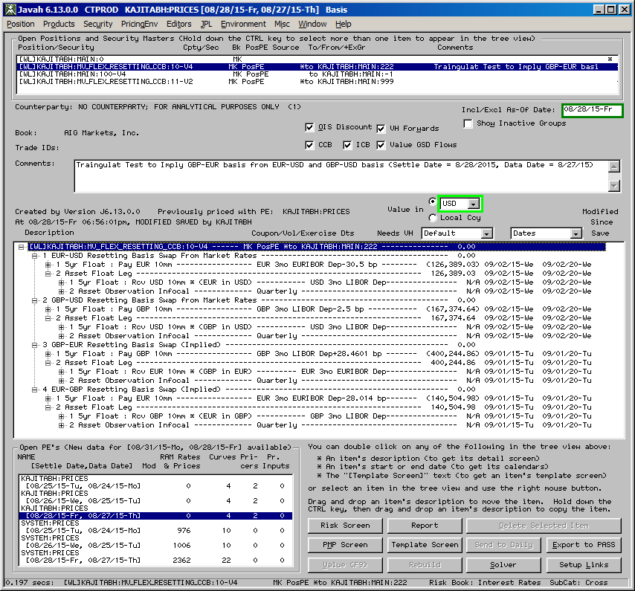

**Test of “LIBOR Discounting”:**

Please see section 4.1.2.7 for an explanation of what it means to have “LIBOR discounting” instead of OIS discounting (i.e. when the switch “OIS Discounting” is turned OFF).

We tested the implementation of “LIBOR Discounting” (as described in 4.1.2.7) through an independent spreadsheet-based model in the case of EUR, GBP and JPY (Appendix 4). We were able to reproduce the results up to a very small numerical noise.

## Sensitivity/Stress/Back-testing

**8.1.1 Sensitivity Tests**

As mentioned in section 4.1.2.8, *Javah Flex Interest Rate Curves* model is used called in the calculation of the interest rate risk sensitivities. Section 4.1.2.8 provides the details of the methodology. Appendix 5 lists the spreadsheets which contain the tests to verify that the sensitivities are calculated correctly, as per the methodology. These tests involved checking all interest rate risk sensitivities for a couple of sample positions produced by Javah against the ones produced in Excel (with the Acme add-in) by manually applying bumps to the curves. All results in Javah matched the ones computed “by hand” using Excel add-in.

The tests were done for the following two positions:

* Position 1:

A fixed vs. float swap in EUR where the floating index is 1m EURIBOR. Note that the floating index was taken to be a 1m EURIBOR (rather than the benchmark 6m EURIBOR), in order to make it more interesting in terms of the risk sensitivities. Indeed, this meant that the position was exposed to an intra-currency basis risk between 1m EURIBOR vs. 6m EURIBOR. The other EUR risk sensitivities in this position are those with respect to vanilla EUR instruments (deposits and swaps), OIS basis swaps (EONIA vs. 3 EURIBOR), intra-currency basis swaps 3m EURIBOR vs. 6m EURIBOR) and cross-currency basis swaps.

* Position 2:

A cross-currency swap involving two floating legs: a 3m USD LIBOR leg vs. a 6m EUR EURIBOOR leg. Again, this position has multiple interest rate risk sensitivities, namely: USD vanilla instruments (deposits and swaps), USD OIS basis swaps (OIS vs. 3 LIBOR), EUR vanilla instruments (deposits and swaps), EUR OIS basis swaps (EONIA vs. 3 EURIBOR), intra-currency basis swaps 3m EURIBOR vs. 6m EURIBOR, and cross-currency basis swaps.

Please note that the tests were done in both (a) the old version of the cross-currency basis model submitted and validated in 2014 and (b) the new version of the cross-currency basis model submitted here. The spreadsheets mentioned in section A of Appendix 5 are with the old model, and those in section B with the new model. Needless to say, in the old (resp. new) model, the sensitivities with respect to cross-currency instruments are those against non-resetting (resp. resetting) cross-currency basis swaps. In both cases, results in Javah matched the ones computed “by hand” using Excel add-in.

Here are some of the details of the test. In each spreadsheet the “Base” tab builds the base (un-perturbed) curves using the same inputs as the Javah curves and calculates the base value of the respective position by independent calculations using Excel add-in. There are multiple other tabs in each spreadsheet to build bumped curves (in cumulative fashion) and calculate the bumped values of the position. For example, a tab called “EUR.DISC.2D” will bump the 2D bucket on the EUR vanilla instrument set of deposits and swaps, rebuild the curves and recalculate the value of the position; whereas the next tab called “EUR.DISC.7D” will bump both the 2D and 7D buckets on the EUR vanilla instrument set, rebuild the curves and recalculate the value. All bumps are by +1 basis point. The last tab called “Javah” in each spreadsheet provides the screens showing Javah sensitivities, and compares them with Excel sensitivities. For example, consider the test for Position 2 under the new cross-currency model which corresponds to spreadsheet 2 in Appendix 5-section B. The following sample pictures taken from the “Javah” tab of that spreadsheet show the Excel/Acme sensitivities (in blue) and Javah sensitivities (in yellow) with respect to EUR OIS, USD OIS and cross-currency basis instruments:

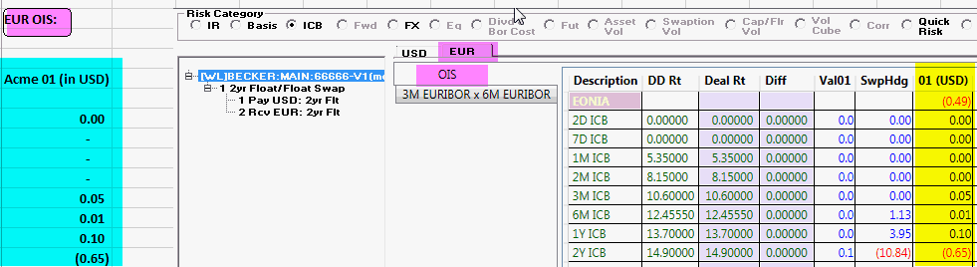

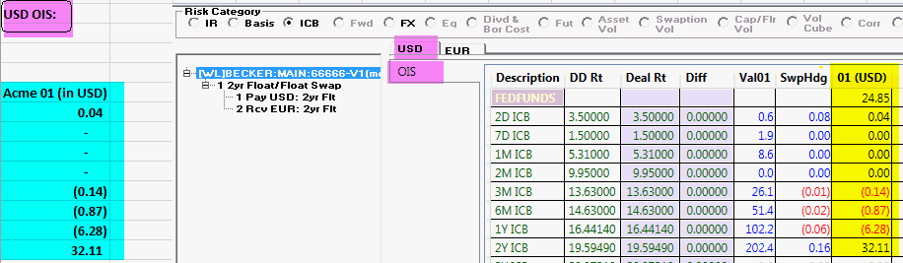

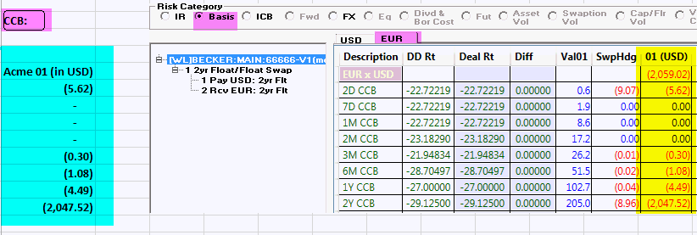

**8.1.2 Stability Tests**

Appendix 6 lists the scenario and various stability tests as requested by the IVG. These tests involved various ways of checking the following aspects:

* ***Robustness Test****:*

This involves tests to check that the input instruments re-price to rates used in the curve building.

* ***Smoothness Test****:*

This involved testing that the solved curve using flat forward interpolation is not far from a smooth fitting such (as using cubic spline).

The minimum and maximum difference in the zero factors for different forwarding curves over a 50 year daily dates between flat forward and cubic splines are shown in the following table:

|  |  |  |  |  |
| --- | --- | --- | --- | --- |
|  | 1LIBOR | 3LIBOR | 6LIBOR | 12LIBOR |
| MIN DIFF | -0.001198 | -0.001147 | -0.001173 | -0.00116 |
| MAX DIFF | 0.000758 | 0.0007 | 0.000646 | 0.000629 |

* ***Locality******Test****:*

This is to ensure that change in one bucket of the input curve affects the other buckets as expected.

* ***Continuity Test:***

This is to ensure that the OIS curve behaves reasonably well across Fed meeting dates.

* ***P&L attribution Test:***

This is to ensure that the change in value of a swap between two scenarios is explained reasonably well by first order interest rate risk sensitivities.

**8.1.3 Regression Tests**

We are also running regression test on a daily basis meant to capture the impact on the values and risk sensitivities for all positions in the official portfolio by switching from the interest rate curves model in Current Javah to the new *Javah Flex Interest Rate Curves* model (which uses OIS discounting, cross-currency and intra-currency). Please see Appendix 8 for some test cases.

Note that earlier (in 2014) we were running three sets of regression to capture the impact of switch to cross-currency (but no intra-currency or OIS), switch to cross-currency and intra-currency (but no OIS) and switch to all three (OIS discounting, cross-currency basis and intra-currency basis). A sample of the regression results (“Before and After”) for these tests are in the first three spreadsheets in Appendix 8.

Recently, we have been running just one regression on a daily basis, namely to capture the impact of the switch to all three (OIS discounting, cross-currency basis and intra-currency basis). A sample of the regression results (“Before and After”) for these tests are in the fourth spreadsheet in Appendix 8.

**8.1.4 Stress / CCAR Tests**

The *Javah Flex Interest Rate Curves* model will be used for stress tests under various scenarios. The usage of model in stress tests would be via any call to discounting or forwarding curves, especially via the individual pricers that are called during the stress tests for the valuation or risk calculation. The stress tests for OIS and intra-currency were done in 2014 as part of the original model and can be seen in the validation report [13]. The stress tests for cross-currency have been added as part of this re-validation. For this purpose, we have used CCAR-type scenarios. To be clear, in an actual CCAR run, the model would accept scenarios for various basis but the scenario generation team currently does not provide the basis shocks. The CCAR-type scenarios used in these tests were provided by ERM for testing purposes. The scenarios are stored in this spreadsheet:

[\\usapps\prod\release\mv\Flex IR Curve Tests\Resetting CCB Model\CCAR FedAdverse Stress Scenarios with Basis Curves Shocks.xlsx](file:///\\usapps\prod\release\mv\Flex%20IR%20Curve%20Tests\Resetting%20CCB%20Model\CCAR%20FedAdverse%20Stress%20Scenarios%20with%20Basis%20Curves%20Shocks.xlsx)

These include a base scenario and stressed scenarios for 9 quarters going forward. We proved that under each scenario the EUR cross-currency-adjusted discounting curve as solved by the model matched the curve derived using the independently spreadsheet model, up to a small numerical precision error. The test for each scenario was done in a separate spreadsheet. These spreadsheets are available under the \\usapps\prod\release\mv\Flex IR Curve Tests\Resetting CCB Model directory as shown in the picture below. The links to these can be found in the Appendix 6.

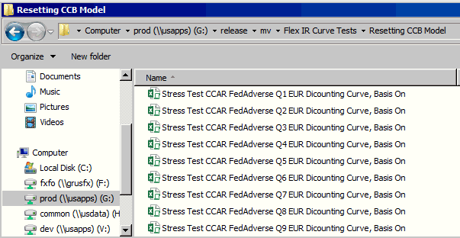

**8.1.5 Tests for Negative and Near Zero Rates**

The *Flex Interest Rate Curves* model supports the negative as well as near zero rates for deposits and swaps (in addition to the possible negative rates for the basis instruments). A couple of tests to confirm this are as follows. First, we provide a test via the AcmeFP Add-in to show that the model analytics is capable of handling negative and/or near zero rates. For this, please see the spreadsheet at

[\\usapps\prod\release\mv\Flex IR Curve Tests\Resetting CCB Model\Stress Test EUR Discounting Curve Basis On (Negative Rates).xlsm](file:///\\usapps\prod\release\mv\Flex%20IR%20Curve%20Tests\Resetting%20CCB%20Model\Stress%20Test%20EUR%20Discounting%20Curve%20Basis%20On%20(Negative%20Rates).xlsm)

As shown in the spreadsheet above, negative and near zero rates for certain instruments were used for EUR. These inputs are processed correctly by the model, which is confirmed by: (a) the re-pricing of the instruments in cells M80-M104 on the “EUR” tab and (b) implementation testing by solving the equations on the “Main” tab.

|  |  |  |  |  |
| --- | --- | --- | --- | --- |
|  |  | Input Rates | Calculated Rates | Diff |
| 2D | DEPO | -0.002 | -0.002 | -1.3E-14 |
| 7D | DEPO | -0.002 | -0.002 | 9.74E-15 |
| 1M | DEPO | -0.002 | -0.002 | -2.1E-16 |
| 2M | DEPO | -0.002 | -0.002 | 2.2E-16 |
| 3M | DEPO | -0.002 | -0.002 | 7.99E-16 |
| 6M | DEPO | 1E-10 | 1E-10 | 4.47E-16 |
| 1Y | SWAP | 1E-10 | 1E-10 | 8.62E-17 |
| 2Y | SWAP | 1E-10 | 1E-10 | 1.18E-16 |
| 3Y | SWAP | 1E-10 | 1E-10 | 1.22E-16 |
| 4Y | SWAP | 1E-10 | 1E-10 | 5.51E-17 |
| 5Y | SWAP | 1E-10 | 1E-10 | 2.23E-17 |
| 6Y | SWAP | 1E-10 | 1E-10 | 7.64E-18 |
| 7Y | SWAP | 1E-10 | 1E-10 | -1.2E-17 |
| 8Y | SWAP | 0.00138914 | 0.00138914 | -3.5E-17 |
| 9Y | SWAP | 0.00274473 | 0.00274473 | -4.6E-17 |
| 10Y | SWAP | 0.00398443 | 0.00398443 | -2.9E-17 |
| 12Y | SWAP | 0.00604373 | 0.00604373 | -3.3E-17 |
| 15Y | SWAP | 0.00827443 | 0.00827443 | -1.6E-17 |
| 20Y | SWAP | 0.01037443 | 0.01037443 | -2.8E-17 |
| 25Y | SWAP | 0.01126532 | 0.01126532 | -2.6E-17 |
| 30Y | SWAP | 0.01165443 | 0.01165443 | -2.4E-17 |
| 35Y | SWAP | 0.01192443 | 0.01192443 | -1.7E-17 |
| 40Y | SWAP | 0.01219443 | 0.01219443 | -1.4E-17 |
| 45Y | SWAP | 0.01225443 | 0.01225443 | -2.4E-17 |
| 50Y | SWAP | 0.01231443 | 0.01231443 | -1.1E-16 |

Second, to test that Javah accepts the negative rates, we enter negative rates for certain USD deposit and swap instruments on the Javah *Risk Screen* as shown in the snap below:

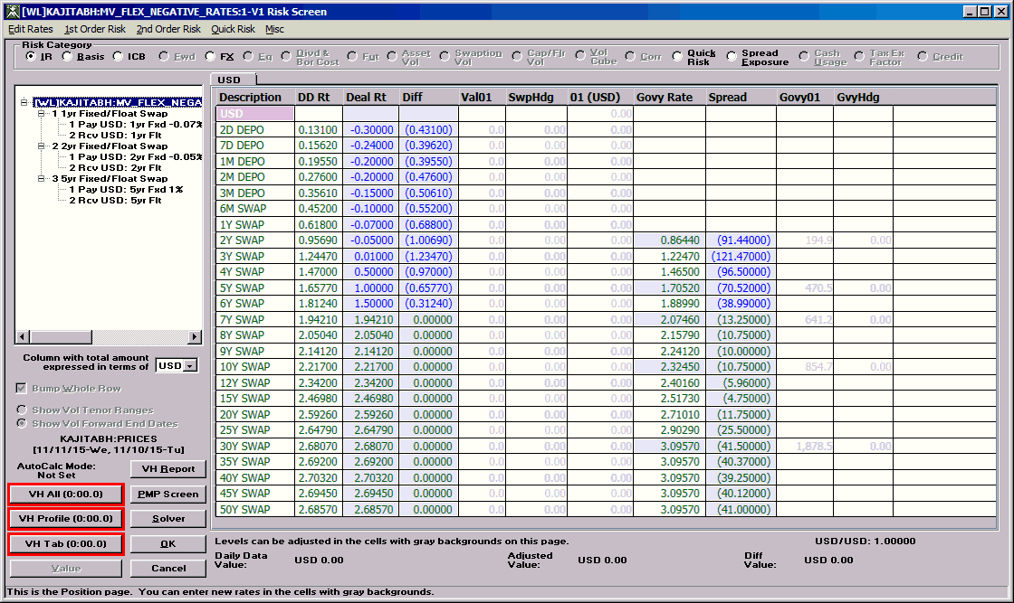

And the snap below to confirm that 1, 2 and 5 year swaps price back to their input rates of -0.07%, -0.05% and 1% respectively:

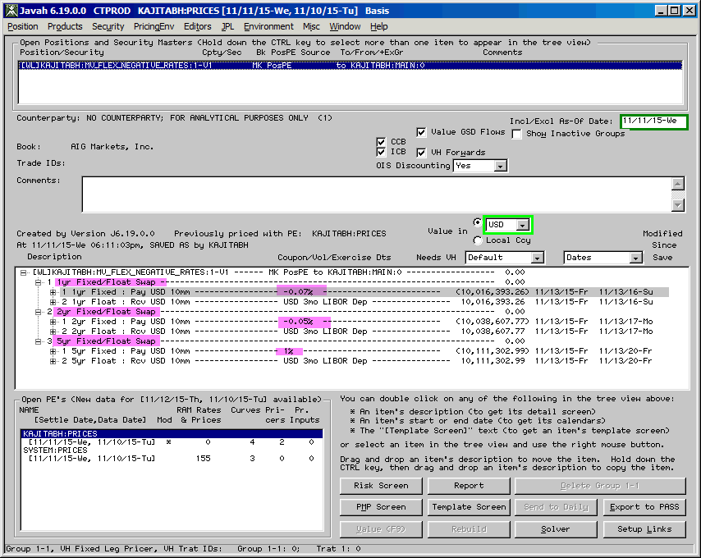

## Benchmarking

The model was compared against an independent spreadsheet-based model created by a business unit tester. The tests and the results are described in the earlier parts of this section. The test cases are also listed in Appendix 11.1.

Here is the brief description of the tests. Please note that in the following, “interpolated swaps” means that the model uses the interpolated swaps (as described in 4.3.2 and elaborated in Appendix 9) for the tenors 1.5y, 2.5y, 3.5y, 4.5y 5.5y, 6.5y, 7.5y, 8.5y and 9.5y.

**8.2.1 Tests for USD**

The following tests listed in Appendix 1 are done to compare (a) independent spreadsheet-based model and (b) Excel add-in interface of the implemented model for USD.

1. **USD OIS Tests\_Interpolated\_Swaps**: To test USD OIS discounting curve in case of using interpolated swaps
2. **USD OIS Tests\_Non\_Interpolated\_Swaps**: To test USD OIS discounting curve in case of not using interpolated swaps
3. **USD 1, 6, 12mo Forwards ICB Test\_Interpolated\_Swaps**: To test USD forwarding curves for 1m, 6m and 12m LIBOR indices in case of using interpolated swaps
4. **USD 1, 6, 12mo Forwards ICB Test\_Non\_Interpolated\_Swaps**: To test USD forwarding curves for 1m, 6m and 12m LIBOR indices in case of not using interpolated swaps
5. **USD 3mo Forwards Test\_Interpolated\_Swaps**: To test USD forwarding curves for 3m LIBOR index in case of using interpolated swaps
6. **USD 3mo Forwards Test\_Non\_Interpolated\_Swaps**: To test USD forwarding curves for 3m LIBOR index in case of not using interpolated swaps
7. **USD OIS Bloomberg Method Test\_Interpolated\_Swaps**: To test implementation with the Bloomberg approximation in case of using interpolated swaps
8. **USD OIS Bloomberg Method Test\_Non\_Interpolated\_Swaps**: To test implementation with the Bloomberg approximation in case of not using interpolated swaps
9. **USD OIS Special Test 1 (3m freq, non-Javah buckets, 7 Nov)**: To test implementation with non-standard market conventions
10. **USD OIS Special Test 2 (3m freq, non-Javah buckets Nov 28, 2013 holiday)**: To test implementation with non-standard market conventions and on a date that is a holiday.

The following tests listed in Appendix 1 were done to confirm that (b) the Excel add-in interface of the implemented model and (c) Javah interface of the implemented model produce the same results for USD.

1. **USD Javah vs. Acme Test\_Interpolated\_Swaps**: To test USD discounting and forwarding curves in case of using interpolated swaps
2. **USD Javah vs. Acme Test\_Non\_Interpolated\_Swaps**: To test USD discounting and forwarding curves in case of not using interpolated swaps.

All of the above tests for USD were successful, i.e., independent Excel calculations matched the Acme results.

**8.2.2 Tests for non-USD currencies (without cross-currency basis)**

The following tests listed in Appendix 2 were done to compare (a) independent spreadsheet-based model and (b) Excel add-in interface of the implemented model for EUR, GBP and JPY in the absence of cross-currency basis:

1. To test EUR OIS discounting curve.
2. To test EUR forwarding curves for 1m, 3m, 6m and 12m EURIBOR indices.
3. To test GBP OIS discounting curve in case of not using interpolated swaps.
4. To test GBP OIS discounting curve in case of using interpolated swaps.
5. To test JPY OIS discounting curve.
6. To test the Javah and Excel Add-in produce the same discounting and forwarding curves for EUR

All of the above tests were successful, i.e., independent Excel calculations matched the Acme results.

**8.2.3 Tests for non-USD currencies (with cross-currency basis)**

The tests listed in Appendix 3 were done to compare (a) independent spreadsheet-based model and (b) Excel add-in interface of the implemented model for the cross-currency-adjusted discounting curves for three major non-USD currencies

1. EUR discounting curve.
2. GBP discounting curve,
3. JPY discounting curve.

Please note that these tests were done with both the old cross-currency model submitted and validated in 2014 (which used non-resetting basis swaps) and the new model being submitted here (which uses resetting basis swaps). Section A (resp. section B) of Appendix 3 lists the spreadsheets used in the tests of the old (resp. new) cross-currency model. All of the above tests were successful, i.e., independent Excel calculations matched the Acme results.

**8.2.4 Tests for comparison between non-resetting vs. resetting cross-currency basis swaps**

In the case of cross-currency basis, it would be a natural question to compare the curves built using resetting basis swaps vs. non-resetting basis swaps. But, according to the traders, the quotes for non-resetting basis swaps are no longer available in the standard market. We can still do a sanity test in which we use the resetting basis swaps in curve building and imply the rates for the non-resetting basis swaps to compare the two. This test was done for a whole range of tenors and is described below.

Please see the position [WL]KAJITABH:MV\_FLEX\_RESETTING\_CCB:11 (screen shot attached below) where we created 12 non-resetting basis swaps of various tenors (from 1y to 50y). Valuation Date was 08/26/2015 and Data Date 08/25/2015. The rates for all these non-resetting basis swaps are implied (from using the resetting basis swap curves model). The comparison between the implied rates for the non-resetting and market rates for resetting is shown in the table below and, as expected, the “convexity” difference grows with the tenor but is always within a few basis points.

|  |  |  |  |  |  |  |
| --- | --- | --- | --- | --- | --- | --- |
| **EUR-USD Non-Resetting Basis Swap Rates Implied from Resetting Swaps** | | | | | | |
|  | | | |  |  |  |
| Tenor | | | | Non-Resetting | Resetting | Diff |
|  | | | | (Implied) | (Market) |  |
| (years) | | | | (bps) | (bps) | (bps) |
| 1 | | | | -22.7493 | -22.75 | -0.0007 |
| 2 | | | | -27.1585 | -27 | 0.1585 |
| 3 | | | | -28.9575 | -28.625 | 0.3325 |
| 4 | | | | -30.0279 | -29.5 | 0.5279 |
| 5 | | | | -30.7299 | -30 | 0.7299 |
| 7 | | | | -31.7186 | -30.625 | 1.0936 |
| 10 | | | | -31.5954 | -30 | 1.5954 |
| 15 | | | | -29.7682 | -27.5 | 2.2682 |
| 20 | | | | -28.1119 | -25.25 | 2.8619 |
| 30 | | | | -26.0085 | -22 | 4.0085 |
| 40 | | | | -30.9166 | -25.925 | 4.9916 |
| 50 | | | | -34.0336 | -27.0125 | 7.0211 |
|  |  |  |  |

Here is the Javah screen for non-resetting basis swaps implied from resetting:

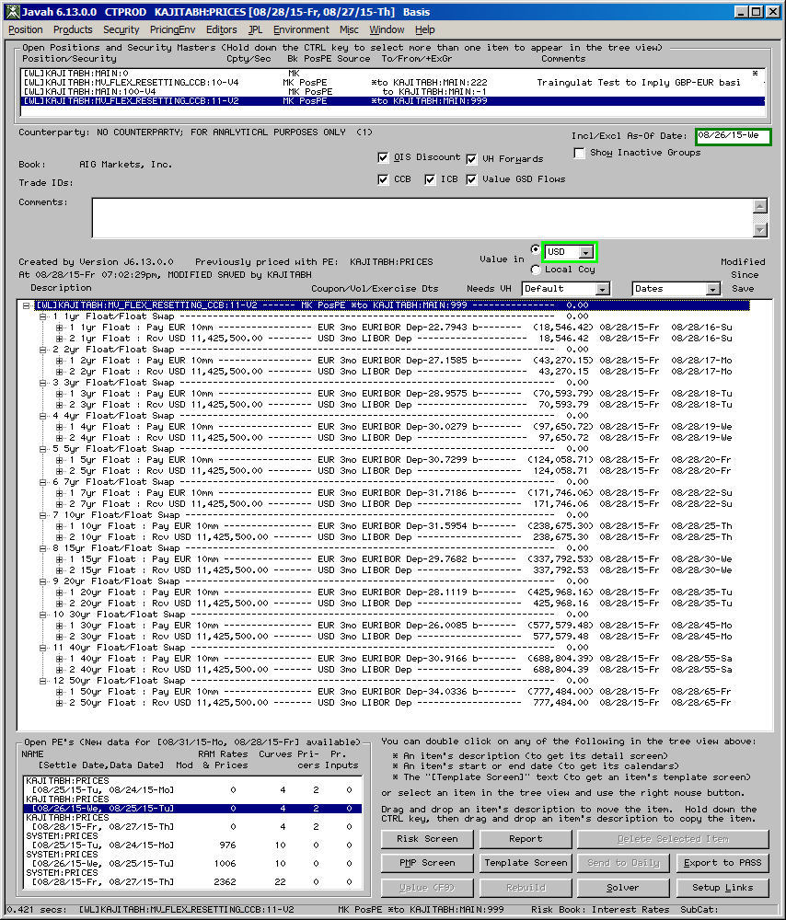

**8.2.5 Tests for usage of interpolated swaps**

As described in section 4.3.2.2, the model uses certain interpolated (synthetic) swaps, which can potentially make the solved curves erratic and lead to theoretical arbitrage. One of the alternatives to using interpolated swaps is to add some smoothness conditions on the discounting and forwarding curves being solved (in other words, interpolation should be embedded in the curves to be solved, not in the input swaps). In this regard, we have done a few tests to capture the impact of using interpolated swaps vs. replacing them by a smoothness condition (namely, cubic splines), and we have found that the impact is small, at least on the vanilla swaps. The tests are in the following spreadsheet:

[\\usapps\prod\release\mv\Flex IR Curve Tests\Resetting CCB Model\Tests for Interpolated vs. Non-interpolated USD.xlsm](file:///\\usapps\prod\release\mv\Flex%20IR%20Curve%20Tests\Resetting%20CCB%20Model\Tests%20for%20Interpolated%20vs.%20Non-interpolated%20USD.xlsm)

The tests were done for 7.5 year and 12.5 year USD swaps as of Settle Date = Friday, August 28th and Data Date = Thursday, August 27th. On one hand, USD curves were built using interpolated swaps with flat forward interpolation and the par rates for two swaps were computed. On the other hand, USD curves were built without interpolated swaps using cubic spline interpolation (as a smoothness condition) and the PV of the two swaps were calculated. In the second approach, the PV of 7.5 year is about 1.5 basis points and that of 12.5 year swap is less than a quarter of a basis point. This provides some comfort in the usage of the interpolated swaps.

## Statistical Measures of Model Goodness-of-Fit

This test is not truly applicable because the *Javah* *Flex Interest Rate Curves* model is not a predictive or forecasting model. It is a deterministic model whose outputs are deterministic functions of inputs. Nevertheless, one could state that the calibration error exhibited in the solution of a discounting or forwarding curve is the goodness-of-fit measure. As proxy for these calibration errors, one can take the errors (or differences) reported in the various benchmarking tests in sections 8.2.1 – 8.2.3 (with the corresponding spreadsheets in Appendices 1-3).

## Performance Testing

We intend to compare the curves from the *Javah* *Flex Interest Rate Curves* model with those from standard vendor platforms such as Bloomberg. Before going into production a full regression will be done to measure the impact on the value and risk sensitivities of the whole book in AIG Global Capital Markets. Some of the results will be compared against the marks from the counterparties or swap dealers.

# Model Limitations

## Methodological Limitations

The main limitations of the model methodology are as follows:

1. The model does not use interest rate futures which are highly liquid instruments and are important elements in the forwarding curves for the benchmark index in the near to medium term of the curve. The use of futures was considered but based on the estimate that substantially more infrastructure and system work would be required to support these instruments, the business decision was to drop these for now and consider adding them in a later phase of this model.
2. The model uses certain implied instruments (which are not market-traded), e.g., OIS-LIBOR basis swaps for tenor less than 3 months, and 6m implied swap for USD. As long as the rates for these instruments are implied from other market-traded instruments, this is not a severe limitation. The “implied” value makes it equivalent to using the original market instruments.
3. For the forwarding curves for the OIS index (e.g. Fed-Fund in USD) the model does not take into account the Fed-Fund futures or the meeting dates of the Fed.
4. The model uses the flat forward interpolation scheme, as opposed to some other more sophisticated smoothing schemes. However, a choice to use cubic splines is available in a spreadsheet Add-in version of the model and can be used as a part of the risk management procedures. Difference between flat forward and the cubic can be monitored on a periodic basis using this tool. In this regard, please see sections 8.1.2 and 8.2.5 for the cubic splines tests which were already done as part of this submission.
5. In the context of resetting basis swaps, “convexity” between resetting and non-resetting basis swaps, if any, is ignored. This means that the cross-currency-adjusted discounting curves for non-USD solved using the resetting basis swap model will be used as discounting curves uniformly for all purposes as long as the flag to use cross-currency basis is set to true.

## Process Limitations

The main limitations of the process are as follows:

* The market data capture process is not fully automated. It involves Front Office and Operations, rather than the automated feeds from the market. This is not a severe limitation because the official curve is stored only once a day rather than intra-day.
* There is no process to produce the curves for live or intra-day data in an automated fashion. Users can however create their personal curves to see the impact of intra-day changes.
* There is no mechanism to distribute the bootstrapped discounting and forwarding curves to clients who are not on the Javah or Acme platform. In future there is a plan to publish these curves via a web access tool.

# Fitness for Purpose Assessment

The interest rate curves model plays a central role in the Javah system. It will be called by almost any valuation or risk calculation in the system. The outputs of this model (discounting and forwarding curves) will be used for pricing and hedging of not just the interest rate products, but for almost all products in the system covering all asset types. The main business unit user of this model will be AIG Global Capital Markets which will use this model primarily for the valuation and risk management of their portfolio in the Javah system. The implemented model has undergone extensive testing by the business unit. The results of those tests indicate that the model has been implemented as per the methodology presented here. Subject to the limitations of the model mentioned in section 9, the model seems to be fit for the purposes mentioned above.

# Appendices

Please note that in the following, “interpolated swaps” means that the model uses the interpolated swaps (as described in 4.3.2 and further detailed in Appendix 9) for the tenors 1.5y, 2.5y, 3.5y, 4.5y 5.5y, 6.5y, 7.5y, 8.5y and 9.5y. **The hyperlinks provide the names and locations of the Excel test files.**

**Appendix 1 Repository of test cases for USD**

* **Tests for the XLL interface of the *Flex Interest Rate Curves* model vs. an independent spreadsheet-based model:**
* To test USD OIS discounting curve in case of using interpolated swaps.

[\\USAPPS.AIGFPC.COM\PROD\release\mv\Flex IR Curve Tests\USD OIS Tests\_Interpolated\_Swaps.xlsx](file:///G:\release\mv\Flex%20IR%20Curve%20Tests\USD%20OIS%20Tests_Interpolated_Swaps.xlsx)

* To test USD OIS discounting curve in case of not using interpolated swaps.

[\\USAPPS.AIGFPC.COM\PROD\release\mv\Flex IR Curve Tests\USD OIS Tests\_Non\_Interpolated\_Swaps.xlsx](file:///G:\release\mv\Flex%20IR%20Curve%20Tests\USD%20OIS%20Tests_Non_Interpolated_Swaps.xlsx)

* To test USD forwarding curves for 1m, 6m and 12m LIBOR indices in case of using interpolated swaps.

[\\USAPPS.AIGFPC.COM\PROD\release\mv\Flex IR Curve Tests\USD 1, 6, 12mo Forwards ICB Test\_Interpolated\_Swaps.xlsx](file:///G:\release\mv\Flex%20IR%20Curve%20Tests\USD%201,%206,%2012mo%20Forwards%20ICB%20Test_Interpolated_Swaps.xlsx)

* To test USD forwarding curves for 1m, 6m and 12m LIBOR indices in case of not using interpolated swap.

[\\USAPPS.AIGFPC.COM\PROD\release\mv\Flex IR Curve Tests\USD 1, 6, 12mo Forwards ICB Test\_Non\_Interpolated\_Swaps.xlsx](file:///\\USAPPS.AIGFPC.COM\PROD\release\mv\Flex%20IR%20Curve%20Tests\USD%201,%206,%2012mo%20Forwards%20ICB%20Test_Non_Interpolated_Swaps.xlsx)

* To test USD forwarding curves for 3m LIBOR index in case of using interpolated swaps.

[\\USAPPS.AIGFPC.COM\PROD\release\mv\Flex IR Curve Tests\USD 3mo Forwards Test\_Interpolated\_Swaps.xlsx](file:///G:\release\mv\Flex%20IR%20Curve%20Tests\USD%203mo%20Forwards%20Test_Interpolated_Swaps.xlsx)

* To test USD forwarding curves for 3m LIBOR index in case of not using interpolated swaps.

[\\USAPPS.AIGFPC.COM\PROD\release\mv\Flex IR Curve Tests\USD 3mo Forwards Test\_Non\_Interpolated\_Swaps.xlsx](file:///G:\release\mv\Flex%20IR%20Curve%20Tests\USD%203mo%20Forwards%20Test_Non_Interpolated_Swaps.xlsx)

* To test implementation with the Bloomberg approximation in case of using interpolated swaps.

[\\USAPPS.AIGFPC.COM\PROD\release\mv\Flex IR Curve Tests\USD OIS Bloomberg Method Test\_Interpolated\_Swaps.xlsx](file:///G:\release\mv\Flex%20IR%20Curve%20Tests\USD%20OIS%20Bloomberg%20Method%20Test_Interpolated_Swaps.xlsx)

* To test implementation with the Bloomberg approximation in case of not using interpolated swaps.

[\\USAPPS.AIGFPC.COM\PROD\release\mv\Flex IR Curve Tests\USD OIS Bloomberg Method Test\_Non\_Interpolated\_Swaps.xlsx](file:///G:\release\mv\Flex%20IR%20Curve%20Tests\USD%20OIS%20Bloomberg%20Method%20Test_Non_Interpolated_Swaps.xlsx)

* To test implementation with non-standard market conventions.

[\\USAPPS.AIGFPC.COM\PROD\release\mv\Flex IR Curve Tests\USD OIS Special Test 1 (3m freq, non-Javah buckets, 7 Nov).xlsx](file:///G:\release\mv\Flex%20IR%20Curve%20Tests\USD%20OIS%20Special%20Test%201%20(3m%20freq,%20non-Javah%20buckets,%207%20Nov).xlsx)

* To test implementation with non-standard market conventions and on a date that is a holiday.

[\\USAPPS.AIGFPC.COM\PROD\release\mv\Flex IR Curve Tests\USD OIS Special Test 2 (3m freq, non-Javah buckets Nov 28, 2013 holiday).xlsx](file:///G:\release\mv\Flex%20IR%20Curve%20Tests\USD%20OIS%20Special%20Test%202%20(3m%20freq,%20non-Javah%20buckets%20Nov%2028,%202013%20holiday).xlsx)

* **Tests for the Javah vs. XLL interface of the *Flex Interest Rate Curves* model:**

The following tests were done to confirm that the Javah interface of the implemented model and the XLL interface of the implemented model produce same results.

* To test USD discounting and forwarding curves in case of using interpolated swaps.

[\\USAPPS.AIGFPC.COM\PROD\release\mv\Flex IR Curve Tests\USD Javah vs Acme Test\_Interpolated\_Swaps.xlsx](file:///G:\release\mv\Flex%20IR%20Curve%20Tests\USD%20Javah%20vs%20Acme%20Test_Interpolated_Swaps.xlsx)

* To test USD discounting and forwarding curves in case of not using interpolated swaps.

[\\USAPPS.AIGFPC.COM\PROD\release\mv\Flex IR Curve Tests\USD Javah vs Acme Test\_Non\_Interpolated\_Swaps.xlsx](file:///G:\release\mv\Flex%20IR%20Curve%20Tests\USD%20Javah%20vs%20Acme%20Test_Non_Interpolated_Swaps.xlsx)

Appendix 2 Repository of test cases for non-USD

[No cross-currency basis]

Please note that using interpolated swaps in EUR does not make sense because fixed leg payment frequency is annual but it does make sense in GBP.

**Tests for the XLL interface of the model vs. independent spreadsheet-based model:**

* To test EUR OIS discounting curve.

[\\USAPPS.AIGFPC.COM\PROD\release\mv\Flex IR Curve Tests\EONIA discount curve Basis Off.xlsx](file:///G:\release\mv\Flex%20IR%20Curve%20Tests\EONIA%20discount%20curve%20Basis%20Off.xlsx)

* To test EUR forwarding curves for 1m, 3m, 6m and 12m EURIBOR indices.

[\\USAPPS.AIGFPC.COM\PROD\release\mv\Flex IR Curve Tests\EURIBOR 6M 1M 3M 12M Forwards Jul 17 20114.xlsx](file:///\\USAPPS.AIGFPC.COM\PROD\release\mv\Flex%20IR%20Curve%20Tests\EURIBOR%206M%201M%203M%2012M%20Forwards%20Jul%2017%2020114.xlsx)

* To test GBP OIS discounting curve in case of not using interpolated swaps.

[\\USAPPS.AIGFPC.COM\PROD\release\mv\Flex IR Curve Tests\GBP SONIA Discounting Curve, Non-Interpolated, Basis Off.xlsx](file:///G:\release\mv\Flex%20IR%20Curve%20Tests\GBP%20SONIA%20Discounting%20Curve,%20Non-Interpolated,%20Basis%20Off.xlsx)

* To test GBP OIS discounting curve in case of using interpolated swaps.

[\\USAPPS.AIGFPC.COM\PROD\release\mv\Flex IR Curve Tests\GBP SONIA Discounting Curve Interpolated Basis Off.xlsx](file:///G:\release\mv\Flex%20IR%20Curve%20Tests\GBP%20SONIA%20Discounting%20Curve%20Interpolated%20Basis%20Off.xlsx)

* To test JPY OIS discounting curve.

[\\USAPPS.AIGFPC.COM\PROD\release\mv\Flex IR Curve Tests\JPY TONAR Discount Curve Basis Off JPY 3mo LIBOR vs TONAR.xlsx](file:///G:\release\mv\Flex%20IR%20Curve%20Tests\JPY%20TONAR%20Discount%20Curve%20Basis%20Off%20JPY%203mo%20LIBOR%20vs%20TONAR.xlsx)

**Tests for the Javah vs. XLL interface of the *Flex Interest Rate Curves* model:**

The following test was done to confirm that the Javah interface of the implemented model and the XLL interface of the implemented model produce same results for EUR discounting and forwarding curves:

[\\USAPPS.AIGFPC.COM\PROD\release\mv\Flex IR Curve Tests\AcmeJavahComparison\_EUR.xlsx](file:///\\USAPPS.AIGFPC.COM\PROD\release\mv\Flex%20IR%20Curve%20Tests\AcmeJavahComparison_EUR.xlsx)

Appendix 3 Repository of test cases for non-USD

[With cross-currency basis]

1. Model using non-resetting basis swaps

The following spreadsheets provide the tests for cross-currency-adjusted discounting curve for three major non-USD currencies in the 2014 version of the cross-currency model which used non-resetting basis swaps:

* To test EUR OIS discounting curve in case of cross-currency basis.

[\\USAPPS.AIGFPC.COM\PROD\release\mv\Flex IR Curve Tests\EONIA OIS Dicounting Curve, Basis On.xlsx](file:///G:\release\mv\Flex%20IR%20Curve%20Tests\EONIA%20OIS%20Dicounting%20Curve,%20Basis%20On.xlsx)

* To test GBP OIS discounting curve in case of cross-currency basis.

[\\USAPPS.AIGFPC.COM\PROD\release\mv\Flex IR Curve Tests\GBP SONIA OIS Discounting Curve Basis On, Interpolated.xlsx](file:///G:\release\mv\Flex%20IR%20Curve%20Tests\GBP%20SONIA%20OIS%20Discounting%20Curve%20Basis%20On,%20Interpolated.xlsx)

* To test JPY OIS discounting curve in case of cross-currency basis

[\\USAPPS.AIGFPC.COM\PROD\release\mv\Flex IR Curve Tests\JPY TONAR OIS Discounting Curve, Basis On.xlsx](file:///G:\release\mv\Flex%20IR%20Curve%20Tests\JPY%20TONAR%20OIS%20Discounting%20Curve,%20Basis%20On.xlsx)

1. Model using resetting basis swaps

The following spreadsheets provide the tests for cross-currency-adjusted discounting curve for three major non-USD currencies in the new version of the cross-currency model submitted here, which uses resetting basis swaps:

* To test EUR OIS discounting curve in case of cross-currency basis.

[\\USAPPS.AIGFPC.COM\PROD\release\mv\Flex IR Curve Tests\Resetting CCB Model\R EONIA OIS Dicounting Curve, Basis On.xlsm](file:///G:\release\mv\Flex%20IR%20Curve%20Tests\Resetting%20CCB%20Model\R%20EONIA%20OIS%20Dicounting%20Curve,%20Basis%20On.xlsm)

* To test GBP OIS discounting curve in case of cross-currency basis.

[\\USAPPS.AIGFPC.COM\PROD\release\mv\Flex IR Curve Tests\Resetting CCB Model\R GBP SONIA OIS Discounting Curve Basis On, Interpolated.xlsm](file:///G:\release\mv\Flex%20IR%20Curve%20Tests\Resetting%20CCB%20Model\R%20GBP%20SONIA%20OIS%20Discounting%20Curve%20Basis%20On,%20Interpolated.xlsm)

* To test JPY OIS discounting curve in case of cross-currency basis

[\\USAPPS.AIGFPC.COM\PROD\release\mv\Flex IR Curve Tests\Resetting CCB Model\R JPY TONAR OIS Discounting Curve, Basis On.xlsm](file:///G:\release\mv\Flex%20IR%20Curve%20Tests\Resetting%20CCB%20Model\R%20JPY%20TONAR%20OIS%20Discounting%20Curve,%20Basis%20On.xlsm)

Appendix 4 Tests for “LIBOR Discounting”

* To test EUR “LIBOR discounting” curve in case of cross-currency basis.

[\\USAPPS.AIGFPC.COM\PROD\release\mv\Flex IR Curve Tests\EONIA LIBOR Dicounting Curve, Basis On.xlsx](file:///G:\release\mv\Flex%20IR%20Curve%20Tests\EONIA%20LIBOR%20Dicounting%20Curve,%20Basis%20On.xlsx)

* To test GBP “LIBOR discounting” curve in case of cross-currency basis.

[\\USAPPS.AIGFPC.COM\PROD\release\mv\Flex IR Curve Tests\GBP SONIA LIBOR Discounting Curve Basis On, Interpolated.xlsx](file:///G:\release\mv\Flex%20IR%20Curve%20Tests\GBP%20SONIA%20LIBOR%20Discounting%20Curve%20Basis%20On,%20Interpolated.xlsx)

* To test JPY “LIBOR discounting” curve in case of cross-currency basis.

[\\USAPPS.AIGFPC.COM\PROD\release\mv\Flex IR Curve Tests\JPY LIBOR Discounting, Basis On.xlsx](file:///G:\release\mv\Flex%20IR%20Curve%20Tests\JPY%20LIBOR%20Discounting,%20Basis%20On.xlsx)

Appendix 5 Sensitivity tests

1. Model using non-resetting basis swaps

The following spreadsheets provide the sensitivity tests in the 2014 version of the cross-currency model which used non-resetting basis swaps:

* To test risk sensitivity (01) for a fixed vs. float EUR swap with cumulative bumping

[\\USAPPS.AIGFPC.COM\PROD\release\mv\Flex IR Curve Tests\Sensitivity Test cumulative EUR vanilla.xlsm](file:///G:\release\mv\Flex%20IR%20Curve%20Tests\Sensitivity%20Test%20cumulative%20EUR%20vanilla.xlsm)

* To test risk sensitivity (01) for a fixed vs. float EUR swap with non-cumulative bumping

[\\USAPPS.AIGFPC.COM\PROD\release\mv\Flex IR Curve Tests\Sensitivity Test nonparallel EUR vanilla.xlsm](file:///G:\release\mv\Flex%20IR%20Curve%20Tests\Sensitivity%20Test%20nonparallel%20EUR%20vanilla.xlsm)

* To test risk sensitivity (01) for a cross-currency USD vs. EUR swap with cumulative bumping

[\\USAPPS.AIGFPC.COM\PROD\release\mv\Flex IR Curve Tests\Sensitivity Test cumulative USD3L v EUR6E.xlsm](file:///G:\release\mv\Flex%20IR%20Curve%20Tests\Sensitivity%20Test%20cumulative%20USD3L%20v%20EUR6E.xlsm)

* To test risk sensitivity (01) for a cross-currency USD vs. EUR swap with non-cumulative bumping

[\\USAPPS.AIGFPC.COM\PROD\release\mv\Flex IR Curve Tests\Sensitivity Test nonparallel USD3L v EUR6E.xlsm](file:///G:\release\mv\Flex%20IR%20Curve%20Tests\Sensitivity%20Test%20nonparallel%20USD3L%20v%20EUR6E.xlsm)

1. Model using resetting basis swaps

The following spreadsheets provide the sensitivity tests in the new version of the cross-currency model being submitted here, which uses resetting basis swaps:

* To test risk sensitivity (01) for a fixed vs. floating EUR swap with cumulative bumping

[\\USAPPS.AIGFPC.COM\PROD\release\mv\Flex IR Curve Tests\Resetting CCB Model\Sensitivity Test cumulative EUR vanilla.xlsm](file:///G:\release\mv\Flex%20IR%20Curve%20Tests\Resetting%20CCB%20Model\Sensitivity%20Test%20cumulative%20EUR%20vanilla.xlsm)

* To test risk sensitivity (01) for a cross-currency USD vs. EUR swap with cumulative bumping

[\\USAPPS.AIGFPC.COM\PROD\release\mv\Flex IR Curve Tests\Resetting CCB Model\Sensitivity Test cumulative USD3L v EUR6E.xlsm](file:///G:\release\mv\Flex%20IR%20Curve%20Tests\Resetting%20CCB%20Model\Sensitivity%20Test%20cumulative%20USD3L%20v%20EUR6E.xlsm)

Appendix 6 Stress and Stability tests

* For the **stress** **test**, we used CCAR-type scenarios using a base and 9 quarters of stresses. The data for these scenarios are stored here:  
  [\\usapps\prod\release\mv\Flex IR Curve Tests\Resetting CCB Model\CCAR FedAdverse Stress Scenarios with Basis Curves Shocks.xlsx](file:///\\usapps\prod\release\mv\Flex%20IR%20Curve%20Tests\Resetting%20CCB%20Model\CCAR%20FedAdverse%20Stress%20Scenarios%20with%20Basis%20Curves%20Shocks.xlsx)

The tests for 9 quarters are stored in 9 different spreadsheets which are here:

[\\USAPPS\PRODrelease\mv\Flex IR Curve Tests\Resetting CCB Model\Stress Test CCAR FedAdverse Q1 EUR Dicounting Curve, Basis On.xlsm](file:///G:\release\mv\Flex%20IR%20Curve%20Tests\Resetting%20CCB%20Model\Stress%20Test%20CCAR%20FedAdverse%20Q1%20EUR%20Dicounting%20Curve,%20Basis%20On.xlsm)

[\\USAPPS\PRODrelease\mv\Flex IR Curve Tests\Resetting CCB Model\Stress Test CCAR FedAdverse Q2 EUR Dicounting Curve, Basis On.xlsm](file:///G:\release\mv\Flex%20IR%20Curve%20Tests\Resetting%20CCB%20Model\Stress%20Test%20CCAR%20FedAdverse%20Q2%20EUR%20Dicounting%20Curve,%20Basis%20On.xlsm)

[\\USAPPS\PRODrelease\mv\Flex IR Curve Tests\Resetting CCB Model\Stress Test CCAR FedAdverse Q3 EUR Dicounting Curve, Basis On.xlsm](file:///G:\release\mv\Flex%20IR%20Curve%20Tests\Resetting%20CCB%20Model\Stress%20Test%20CCAR%20FedAdverse%20Q3%20EUR%20Dicounting%20Curve,%20Basis%20On.xlsm)

[\\USAPPS\PRODrelease\mv\Flex IR Curve Tests\Resetting CCB Model\Stress Test CCAR FedAdverse Q4 EUR Dicounting Curve, Basis On.xlsm](file:///G:\release\mv\Flex%20IR%20Curve%20Tests\Resetting%20CCB%20Model\Stress%20Test%20CCAR%20FedAdverse%20Q4%20EUR%20Dicounting%20Curve,%20Basis%20On.xlsm)

[\\USAPPS\PRODrelease\mv\Flex IR Curve Tests\Resetting CCB Model\Stress Test CCAR FedAdverse Q5 EUR Dicounting Curve, Basis On.xlsm](file:///G:\release\mv\Flex%20IR%20Curve%20Tests\Resetting%20CCB%20Model\Stress%20Test%20CCAR%20FedAdverse%20Q5%20EUR%20Dicounting%20Curve,%20Basis%20On.xlsm)

[\\USAPPS\PRODrelease\mv\Flex IR Curve Tests\Resetting CCB Model\Stress Test CCAR FedAdverse Q6 EUR Dicounting Curve, Basis On.xlsm](file:///G:\release\mv\Flex%20IR%20Curve%20Tests\Resetting%20CCB%20Model\Stress%20Test%20CCAR%20FedAdverse%20Q6%20EUR%20Dicounting%20Curve,%20Basis%20On.xlsm)

[\\USAPPS\PRODrelease\mv\Flex IR Curve Tests\Resetting CCB Model\Stress Test CCAR FedAdverse Q7 EUR Dicounting Curve, Basis On.xlsm](file:///G:\release\mv\Flex%20IR%20Curve%20Tests\Resetting%20CCB%20Model\Stress%20Test%20CCAR%20FedAdverse%20Q7%20EUR%20Dicounting%20Curve,%20Basis%20On.xlsm)

[\\USAPPS\PRODrelease\mv\Flex IR Curve Tests\Resetting CCB Model\Stress Test CCAR FedAdverse Q8 EUR Dicounting Curve, Basis On.xlsm](file:///G:\release\mv\Flex%20IR%20Curve%20Tests\Resetting%20CCB%20Model\Stress%20Test%20CCAR%20FedAdverse%20Q8%20EUR%20Dicounting%20Curve,%20Basis%20On.xlsm)

[\\USAPPS\PRODrelease\mv\Flex IR Curve Tests\Resetting CCB Model\Stress Test CCAR FedAdverse Q9 EUR Dicounting Curve, Basis On.xlsm](file:///G:\release\mv\Flex%20IR%20Curve%20Tests\Resetting%20CCB%20Model\Stress%20Test%20CCAR%20FedAdverse%20Q9%20EUR%20Dicounting%20Curve,%20Basis%20On.xlsm)

* To test the **robustness** (re-pricing), **smoothness** (vs. cubic spline) and **continuity** (comparison with Fed Meeting dates)

[\\USAPPS.AIGFPC.COM\PROD\release\mv\Flex IR Curve Tests\james scenario1-2.xlsm](file:///G:\release\mv\Flex%20IR%20Curve%20Tests\james%20scenario1-2.xlsm)

* To test the **locality of curve**

[\\USAPPS.AIGFPC.COM\PROD\release\mv\Flex IR Curve Tests\james scenario3.xlsm](file:///G:\release\mv\Flex%20IR%20Curve%20Tests\james%20scenario3.xlsm)

* To test the **P&L attribution**

[\\USAPPS.AIGFPC.COM\PROD\release\mv\Flex IR Curve Tests\James 1.14.xlsx](file:///\\USAPPS.AIGFPC.COM\PROD\release\mv\Flex%20IR%20Curve%20Tests\James%201.14.xlsx)

Appendix 7 Re-pricing tests

Here we enclose a sample of the re-pricing tests from Javah. All tests were done recently using current production version of Javah (version 6.10.0.0) as of Settle Date = 07/01/2015 and Data Date = 06/30/2015, except for the non-resetting basis swaps which were done in 2014 with the old model for cross-currency basis (that used non-resetting basis swaps) as of Settle Date = 07/07/2014 and Data Date = 07/03/2014. We include that test just for completeness, although this submission overrides the old cross-currency basis model by the new (which uses resetting basis swaps).

* **USD Vanilla Fixed vs. Float swaps:**

Please see KAJITABH:MV\_FLEX\_REPRICING\_TEST:1-3 (Figures 5 and 6 in Appendix 10) in which USD vanilla deposits/swaps are pricing to zero with their rates set to market rates. Figure 7 in Appendix 10 provides the market rates for these swaps.

* **Non-resetting cross-currency basis swaps:**

Please see [CTFLEX]KAJITABH:MV\_FLEX\_CURVES:1 (Figure 8 in Appendix 10) in which USD vs. JPY cross-currency basis swaps are re-pricing when cross-currency basis switch (CCB), OIS Discounting and Intra-currency basis (ICB) switches are all ON. As mentioned above, these tests were done in 2014 with the old model for cross-currency basis (that used non-resetting basis swaps) as of Settle Date = 07/07/2014 and Data Date = 07/03/2014. We include that test just for completeness. Note that these non-resetting basis swaps will not re-price (value to zero) in the new model which uses resetting basis swaps in the instrument set.

* **Intra-currency basis swaps:**

Please see KAJITABH:MV\_FLEX\_REPRICING\_TEST:4 (Figure 9 in Appendix 10) in which 3m EURIBOR vs. 6m EURIBOR intra-currency basis swaps are re-pricing when cross-currency basis switch (“CCB”) is OFF, but “OIS Discount” and Intra-currency basis (“ICB”) switches are ON.

* **OIS (EONIA vs. EURIBOR) basis swaps:**

Please see KAJITABH:MV\_FLEX\_REPRICING\_TEST:5 (Figure 10 in Appendix 10) in which EONIA vs. 3m EURIBOR basis swaps are re-pricing when cross-currency basis switch (“CCB”) is OFF, but “OIS Discount” and Intra-currency basis (“ICB”) switches are ON.

* **Resetting cross-currency basis swaps:**

These include the tests on all three major non-USD currencies that the business is exposed to.

Please see the positions KAJITABH:FLEX\_RESETTING\_CCB:1-3 (Figure 11 in Appendix 10) which contain GBP resetting basis swaps with various tenors ranging from 3m to 50 years, and spreads set to the market rates, as shown in Figure 12 in Appendix 10.

Similarly, the positions KAJITABH:FLEX\_RESETTING\_CCB:4-6 (Figure 13 in Appendix 10) contain EUR resetting basis swaps with various tenors ranging from 3m to 50 years, and spreads set to the market rates, as shown in Figure 14 in Appendix 10.

Finally, the positions KAJITABH:FLEX\_RESETTING\_CCB:7-9 (Figure 15 in Appendix 10) contain JPY resetting basis swaps with various tenors ranging from 3m to 50 years, and spreads set to the market rates, as shown in Figure 16 in Appendix 10.

All of the above resetting basis swaps value to zero when “CCB”, “ICB” and “OIS Discount” flags are ON. See Figures 11, 13 and 15 in Appendix 10.

Appendix 8 Regression tests

The following three spreadsheets contain the results for three different regression tests, namely the impact on the values and risk sensitivities for all positions in the whole official portfolio by switching from the interest rate curves model in Current Javah to cross-currency (but no intra-currency or OIS), to cross-currency and intra-currency (but no OIS) and to all three (OIS discounting, cross-currency basis and intra-currency basis). These tests were done with the original model in 2014.

[\\USAPPS.AIGFPC.COM\PROD\release\mv\Flex regression example\CCB\7.9\Copy of jtraded\_1129\_ra (3).xls](file:///G:\release\mv\Flex%20regression%20example\CCB\7.9\Copy%20of%20jtraded_1129_ra%20(3).xls)

[\\USAPPS.AIGFPC.COM\PROD\release\mv\Flex regression example\CCB + ICB\7.9\Copy of jtraded\_1158\_ra.xls](file:///G:\release\mv\Flex%20regression%20example\CCB%20+%20ICB\7.9\Copy%20of%20jtraded_1158_ra.xls)

[\\USAPPS.AIGFPC.COM\PROD\release\mv\Flex regression example\all-in\7.9\Copy of jtraded\_1322\_ra.xls](file:///G:\release\mv\Flex%20regression%20example\all-in\7.9\Copy%20of%20jtraded_1322_ra.xls)

Recently, we have been running just one regression on a daily basis, namely to capture the impact on the values and risk sensitivities for all positions in the whole official portfolio by switching from the classical LIBOR-based curves model to the Flex model submitted here with all three flags (for OIS discounting, cross-currency basis and intra-currency basis) ON. A sample of the regression results (“Before and After”) for these tests is here:

[\\USAPPS.AIGFPC.COM\PROD\release\mv\Flex IR Curve Tests\REGRESSION\_20150714.XLS](file:///G:\release\mv\Flex%20IR%20Curve%20Tests\REGRESSION_20150714.XLS)

**Appendix 9 Interpolated / Synthetic Swaps**

As we described the usage of the interpolated/synthetic swaps in section 4.3.2.2, we mentioned that their usage is optional. The way it works is as follows. Please see the 5th column in the curve (instrument set) editor below called “Interp” which indicates which instruments are interpolated, e.g. 18m, 30m etc in the picture below. If you don’t want them, you can delete them by pressing the “Delete” in the last column (in blue).

When we go to production, it is expected that the official curve will have the interpolated swaps. Someone can still have personal curves without them. The general logic regarding the interpolated swaps is that they are used between 1 and 10 years and vary according to the pay frequency on the fixed leg.  USD has 18M, 30M, 42M, 54M, 66M, 78M, 90M, 102M, and 114M, as do GBP, JPY, etc., EUR, which is annual, has none, MXN is monthly (so 13M-23M, 25M-35M, etc), AUD is quarterly out to 3 years and semi thereafter.

A full list of interpolated swaps is available at

[\\USAPPS.AIGFPC.COM\PROD\release\mv\Flex IR Curve Tests\list of non-hedge instruments in Javah.xlsx](file:///G:\release\mv\Flex%20IR%20Curve%20Tests\list%20of%20non-hedge%20instruments%20in%20Javah.xlsx)

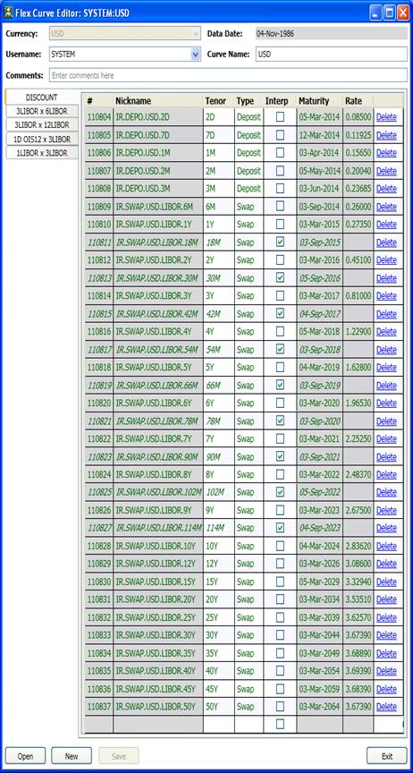

**Appendix 10 Figures**

**Figure 1. Accessing “*FPC Calculator*” tool in Javah from *Misc* Menu**

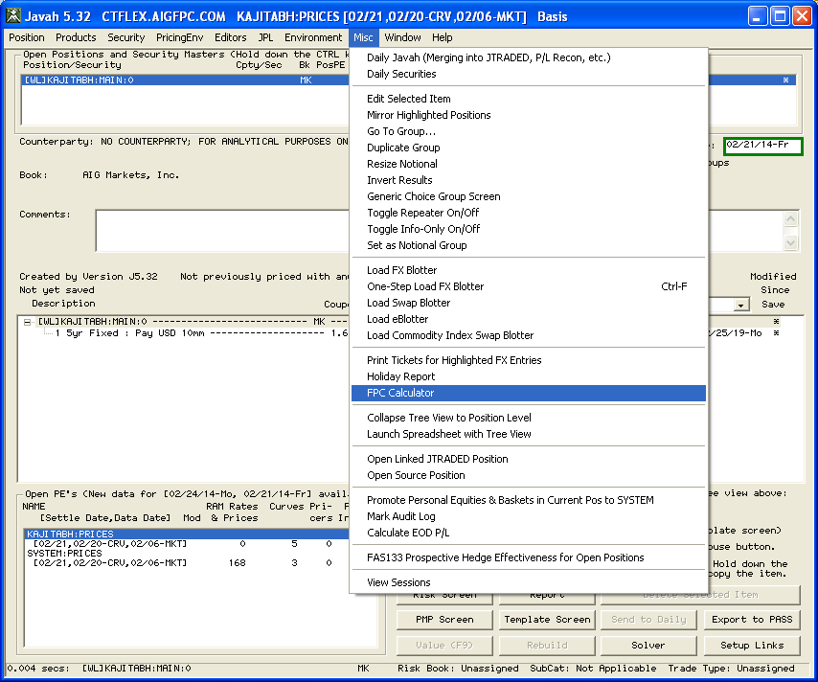

**Figure 2. The “*FPC Calculator*” screen in Javah**

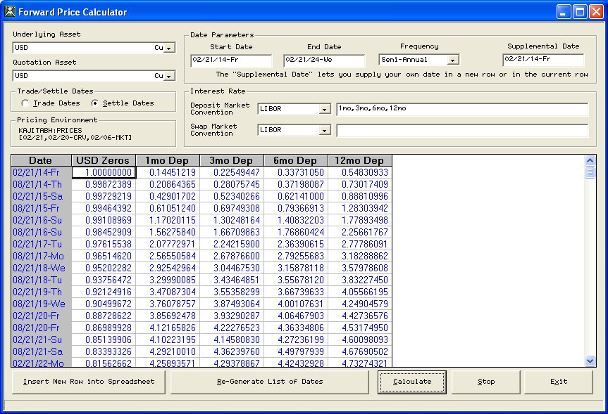

**Figure 3. The Excel add-in function” ACCreateFlexYCurve**

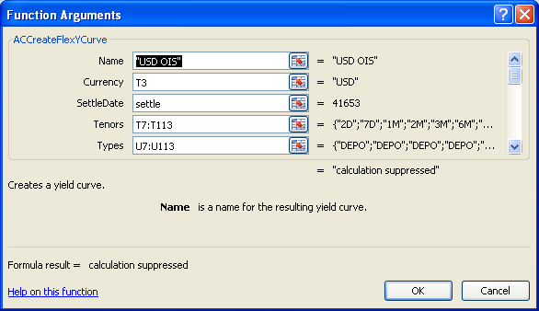

**Figure 4. The call to ACCreateFlexYCurve()**

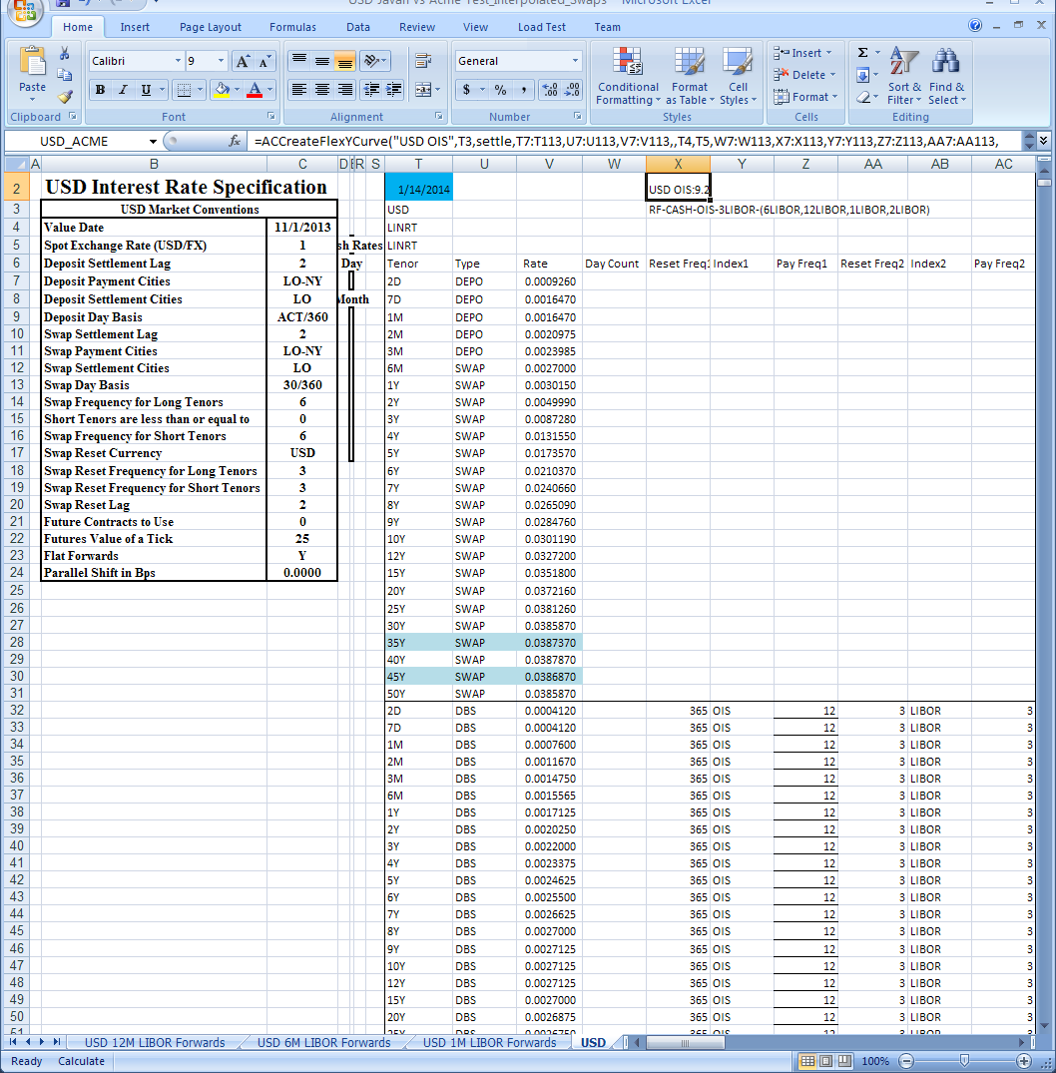

**Figure 5. Javah position to test re-pricing of USD deposits/swaps**

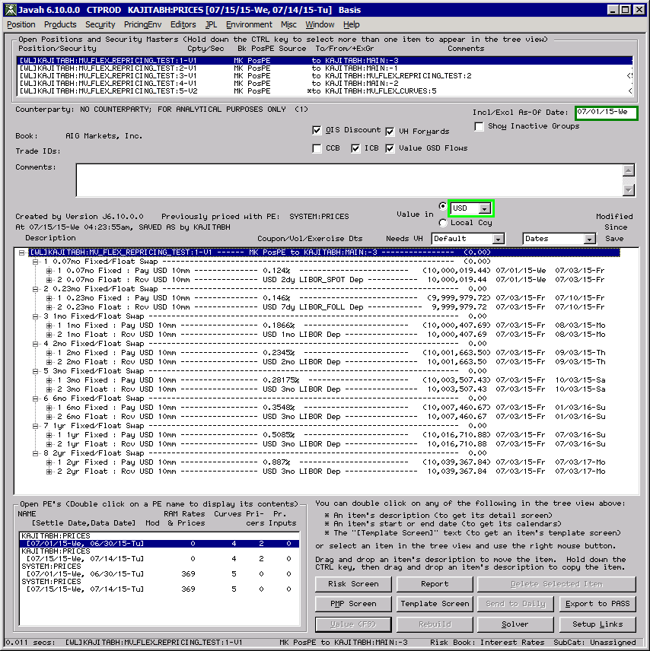

**Figure 6. Vanilla Fixed vs. Float swaps in Javah to test re-pricing**

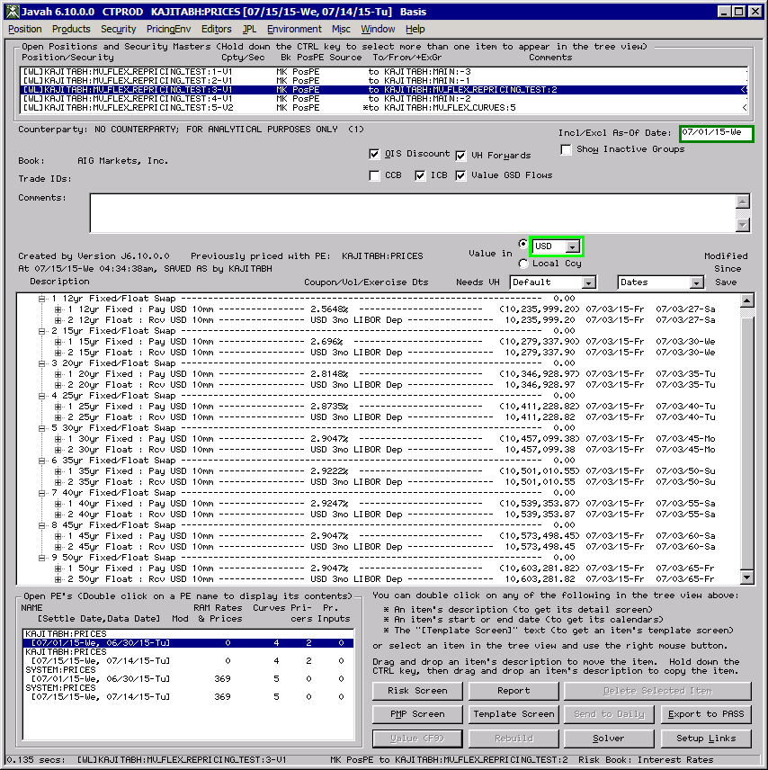

**Figure 7. The market rates used in Javah to test re-pricing in Figures 5 and 6**

# 

**Figure 8. Cross-currency basis swaps in Javah to test re-pricing**

**Cross-currency switch (“CCB”) must be ON**

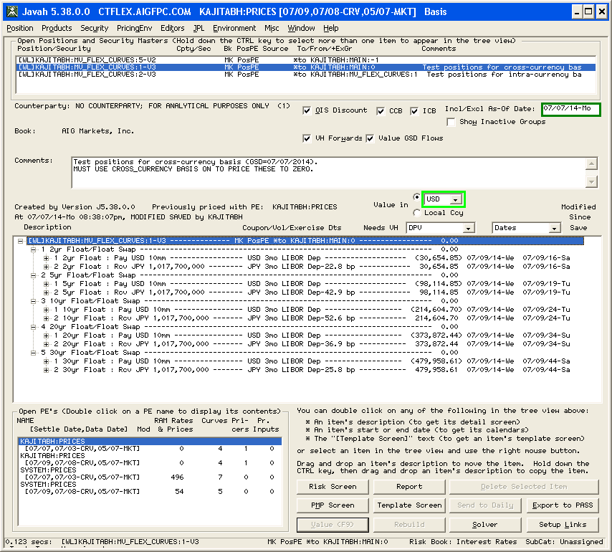

**Figure 9. Intra-currency basis swaps in Javah to test re-pricing**

**Cross-currency switch must be OFF and intra-currency switch must be ON.**

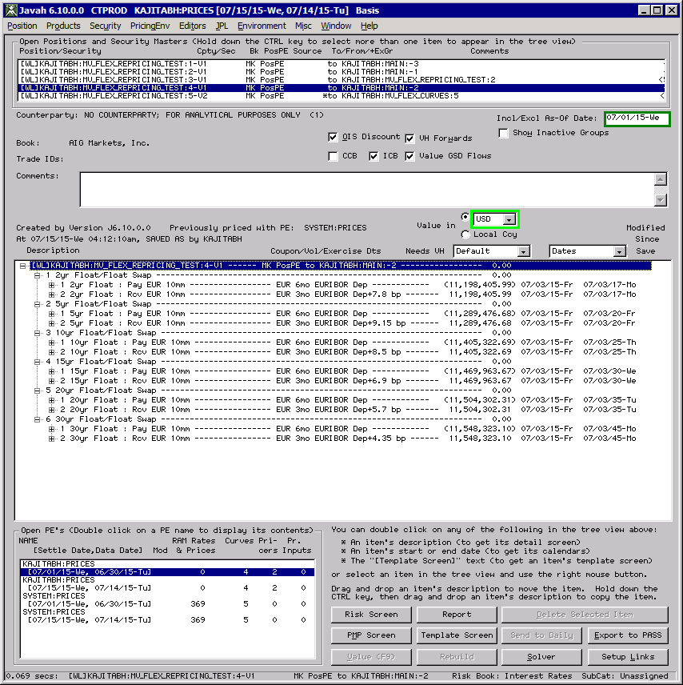

**Figure 10. OIS basis swaps (EONIA vs. 3m Euribor) in Javah to test re-pricing**

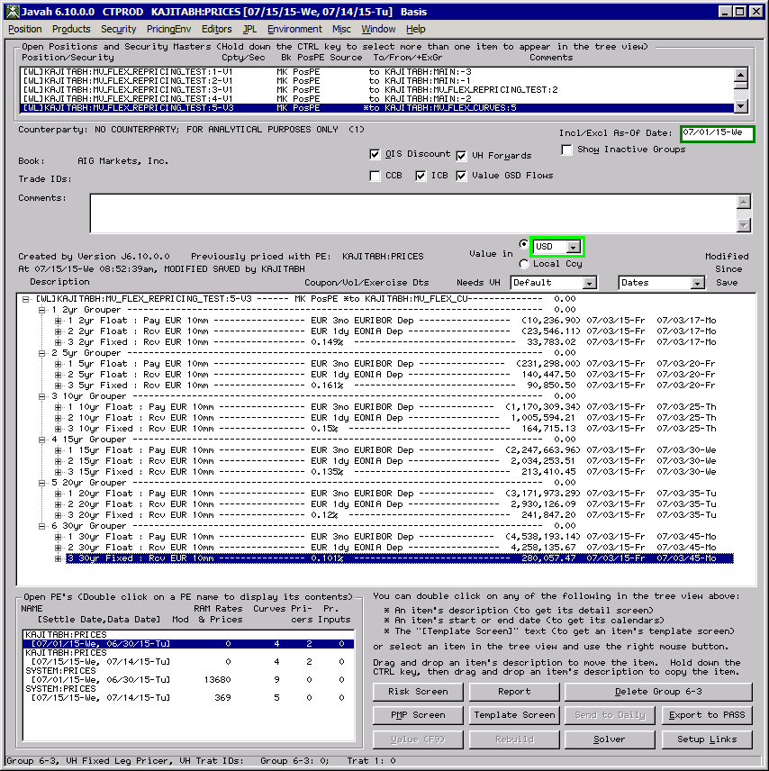

**Figure 11. GBP-USD resetting cross-currency basis swaps in Javah to test re-pricing**

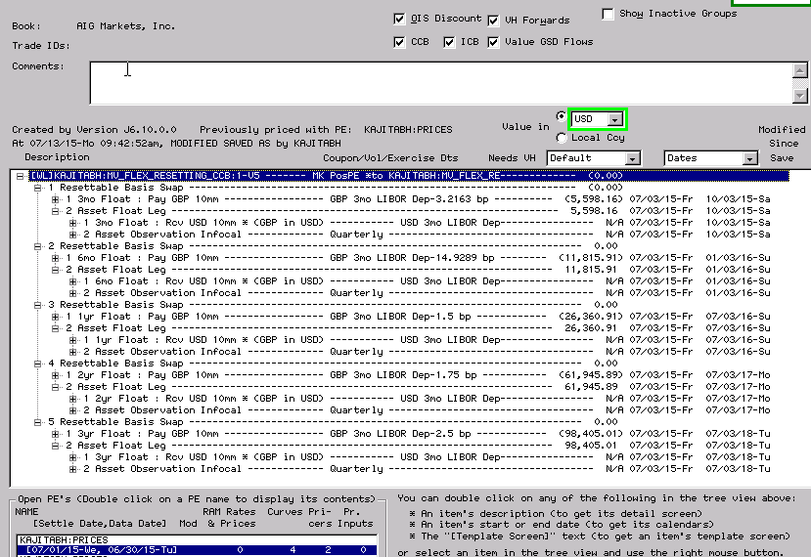

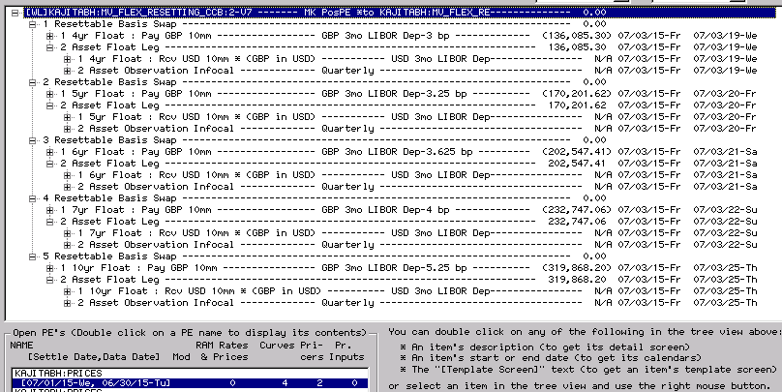

**Figure 11. GBP-USD resetting cross-currency basis swaps in Javah to test re-pricing (contd.)**

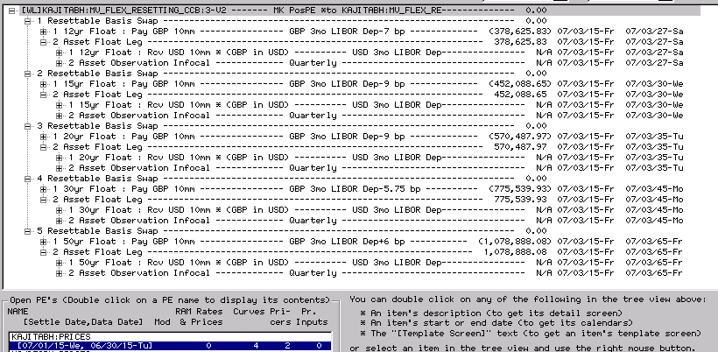

**Figure 12. Market rates for the GBP-USD resetting basis swaps in Figure 11**

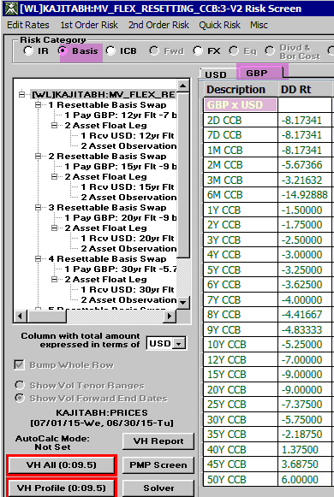

**Figure 13. EUR-USD resetting cross-currency basis swaps in Javah to test re-pricing**

# 

# 

**Figure 13. EUR-USD resetting cross-currency basis swaps in Javah to test re-pricing (contd.)**

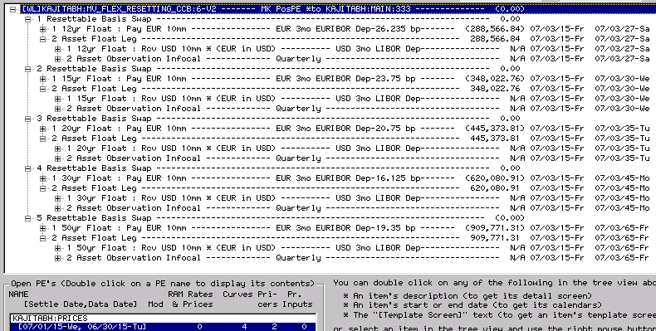

**Figure 14. Market rates for the EUR-USD resetting basis swaps in Figure 13**

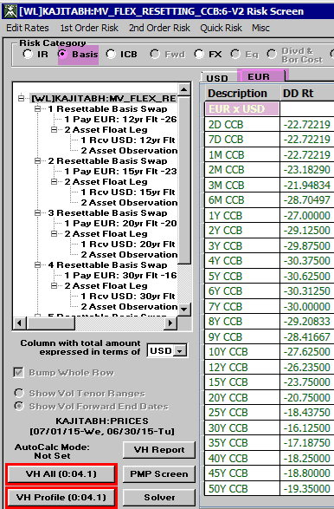

**Figure 15. JPY-USD resetting cross-currency basis swaps in Javah to test re-pricing**

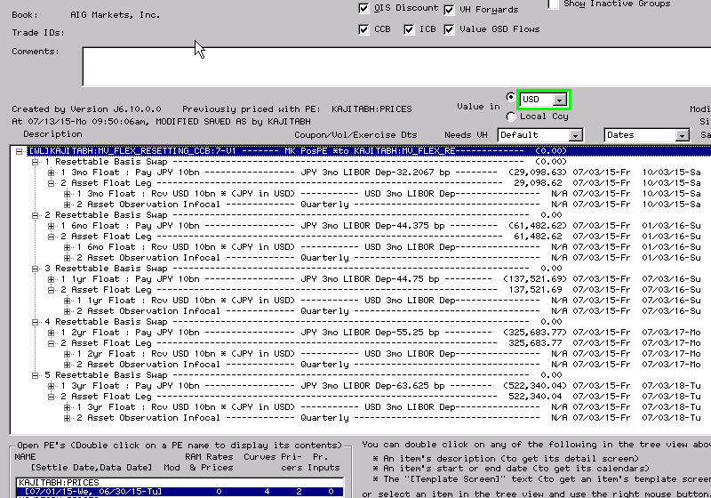

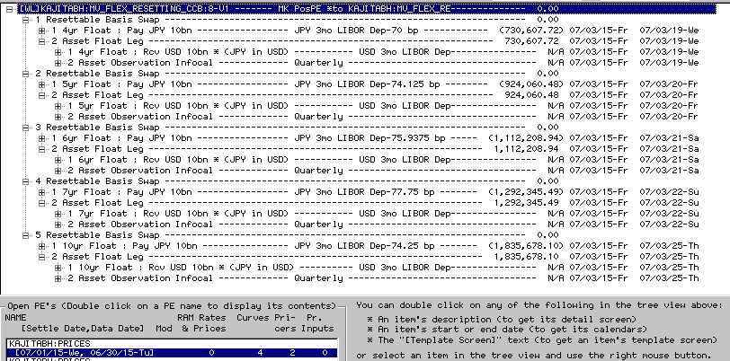

**Figure 15. JPY-USD resetting cross-currency basis swaps in Javah to test re-pricing (contd.)**

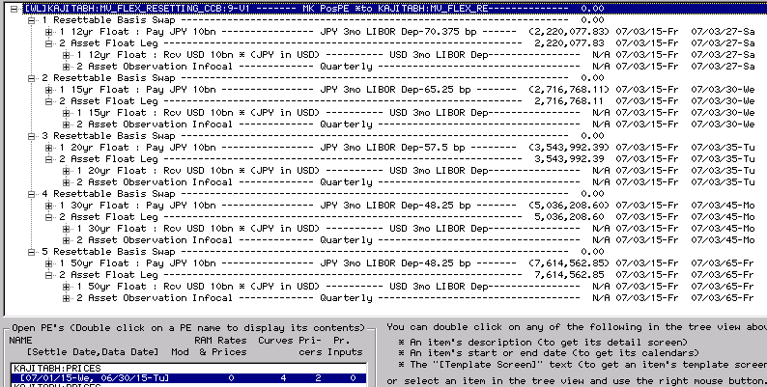  
 **Figure 16. Market rates for the JPY-USD resetting basis swaps in Figure 15**

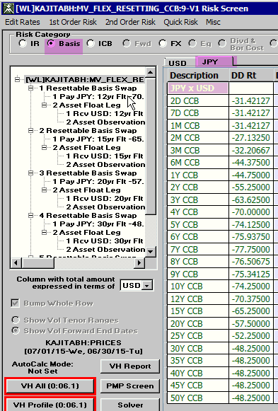

**Appendix 11 Market Quotes for cross-currency basis**

The following Bloomberg screens show the bid and ask quotes for resetting cross-currency basis swaps for some currencies, as of September 01, 2015. According to the traders, in the actual market the quotes are somewhat tighter in terms of bid-ask spread.

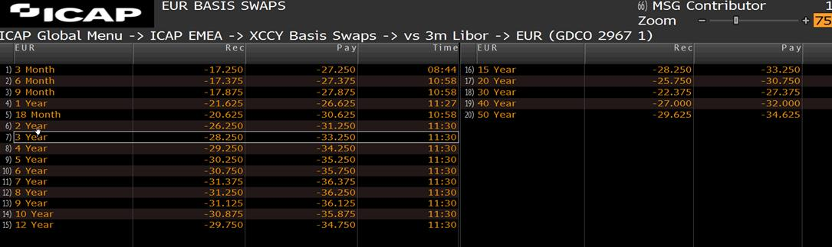

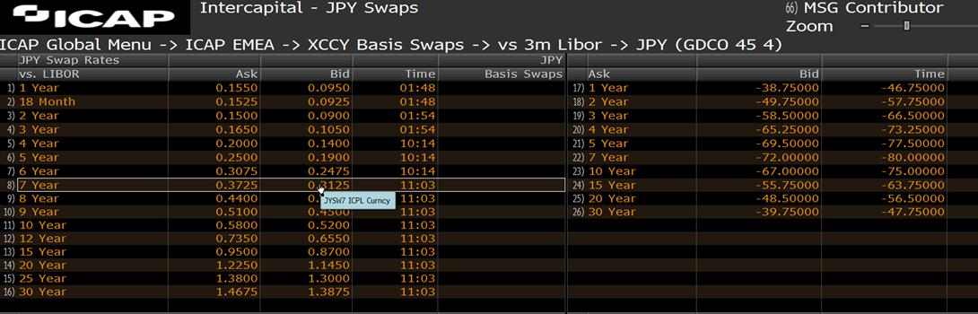

**Appendix 12 Interest Rate Risk Exposure Profile for GCM**

In order to provide a measure of the business impact of the *Flex Interest Rate Curves* model on GCM, we provide below the figures which capture the risk exposure profile in terms of various sensitivities (01’s).

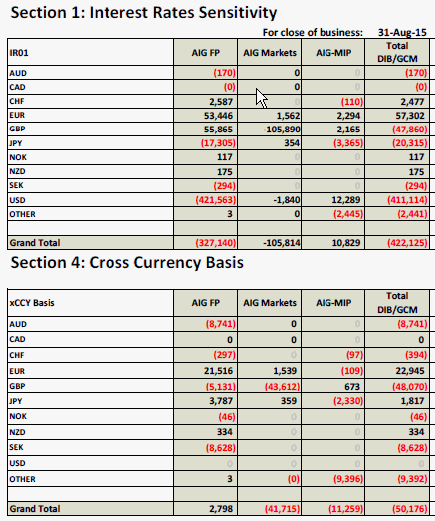

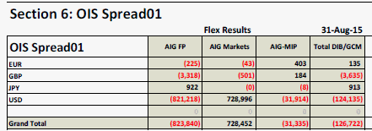

# 

**Appendix 13 List of Instruments used in the Model**

This appendix lists the instruments used by the *Flex Interest Rate Curves* model in the construction of various discounting and forwarding curves in USD and a non-USD currency. The market rates for various instruments are as of Data Date = Wednesday, September 01, 2015.

* **Instruments for USD**

In USD, the instruments used in OIS discounting curve and forwarding curves (for OIS, 1m, 3m, 6m and 12m LIBOR) are vanilla deposits/swaps, OIS-LIBOR basis swaps and various intra-currency basis swaps. The complete list is given below.

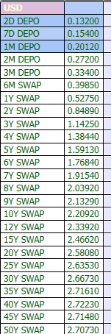 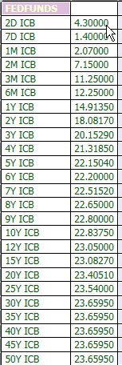

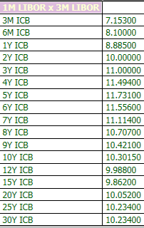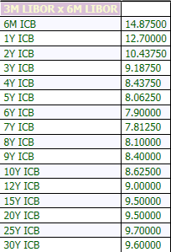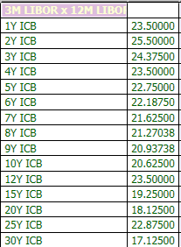

* **Instruments for non-USD**

In a non-USD currency, the instruments used in discounting curve and forwarding curves depend on the currency because OIS and/or cross-currency basis is not supported in every currency. To get a generic picture, however, we list the instruments for EUR which has both OIS and cross-currency basis. First, in the presence of the cross-currency basis, the model uses discounting curve and 3m LIBOR forwarding curve for USD, which means the model needs the deposits/swaps and OIS-LIBOR basis swap instruments from USD, which are listed in the pictures provided above. Next, for EUR forwarding curves, EUR domestic instruments used are vanilla deposits/swaps, OIS-LIBOR basis swaps and various intra-currency basis swaps. And, finally, for cross-currency basis adjustment to EUR discounting curve, EUR-USD resetting cross-currency basis swaps are used. The complete list is given below.

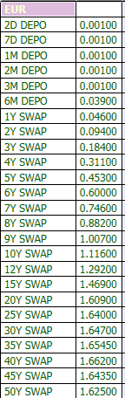 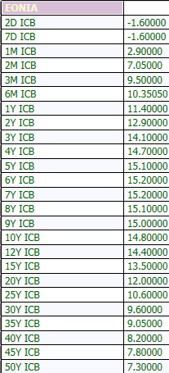 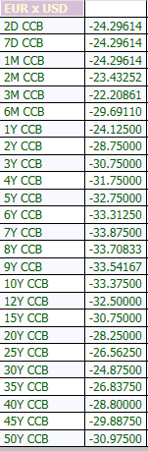

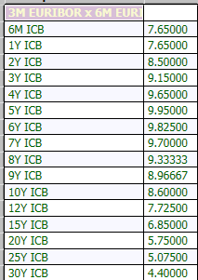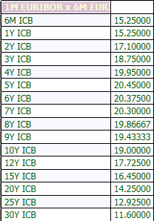 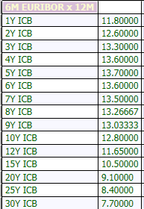

# References

[1] Kaushal Ajitabh and Abdi Farah, *Intra-currency Valuation and Hedging in JAVAH: Implementation Proposal*, AIG Global Capital Markets note, January 2013.

[2] Kaushal Ajitabh and Abdi Farah, *OIS Discounting in JAVAH: Implementation Proposal*, AIG Global Capital Markets note, April 2013.

[3] Marco Bianchetti; *Two Curves, One Price: Pricing & Hedging Interest Rate Derivatives, Decoupling Forwarding and Discounting*, Risk Magazine, August 2010.

[4] John Hull and Alan White, *LIBOR vs. OIS: The Derivatives Discounting Dilemma*, January 2013.

[5] Fabio Mercurio, *Interest Rates and the Credit Crunch: New Formulas and Market Models*, July 2009.

<http://ssrn.com/abstract=1332205>

[6] Bloomberg Document, *Extending USD OIS Curves using FED FUNDS basis swap quotes.*

[7] Bloomberg Document, *OIS versus Cross Currency Basis Implied Discount Curves,* October 2011.

[8] Katsumi Takada, *Valuation of Arithmetic Average of Fed Funds Rates and Construction of the US dollar Swap*

*Yield Curve, September 30, 2011.*

[9] Nashikkar, Amrut, *Understanding OIS Discounting*, Barclays Capital Interest Rate Strategy, February 24, 2011.

[10]West, *Graeme, Post Crisis Methods of Bootstrapping the Yield Curve*, May 1, 2011 (available at <http://www.finmod.co.za/>)

[11] Kaushal Ajitabh, *Model Development Document: Javah Flex Interest Rate Curves*, Quantitative Development Group, AIG, 2014.

[12] Kaushal Ajitabh, *Model Implementation Document: Javah Flex Interest Rate Curves*, Quantitative Development Group, AIG, 2014.

[13] James Turetsky, *Independent Validation Report: Javah Flex Interest Rate Curves – OIS and ICB Curves,* Independent Validation Group, AIG, 2014.

[14] Patrick Zhou, *Independent Validation Report: Javah Flex Interest Rate Curves – Cross-currency Curves,* Independent Validation Group, AIG, 2014.

[15] J. Turetsky, *Cumulative Bumping*, Internal Report, AIG Independent Validation Group, 2015.

1. Please note that the “Liquidity Management Tool” has been validated separately. In addition, the cash flow generation for a product which feeds into the “Liquidity Management Tool” is being validated separately as part of the model validation for that product. [↑](#footnote-ref-1)
2. The “Liquidity Management Tool” has been validated separately. [↑](#footnote-ref-2)
3. This is true since (a) the forwarding curve for the OIS rates is the same as and (b) the compounding frequency of floating payments is the same as the tenor of the OIS rates. [↑](#footnote-ref-3)